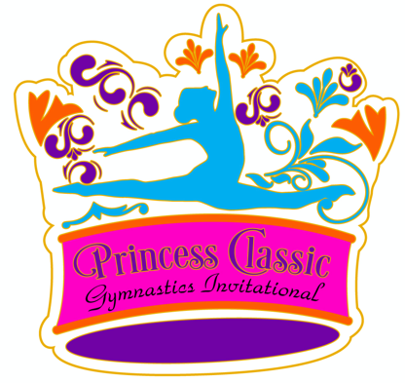

2021 Princess Classic Schedule-Gymnastics

Friday, February 5

Session 1 AAU Level 1, AAU XCEL Bronze
Stretch 5:30 pm
Warm up 5:45 pm
Competition 5:55 pm
Awards 7:15 pm

Saturday, February 6

Session 2 USAG Level 1, 2, 3, XCEL Bronze, XCEL Silver
Stretch 8:00 am
Warm up 8:20 am
Competition 8:30 am
Awards 10:15 am

Session 3 USAG Level 4, USAG Level 5
Stretch 10:30 am
Warm up 10:50 am
Competition 11:00 am
Awards 1:00 pm

Session 4 USAG Level 6
Stretch 1:15 pm
Warm up 1:35 pm
Competition 1:50 pm
Awards 4:30 pm

Session 5 USAG Level 7, 8, 9, 10, XCEL Diamond
Stretch 4:45 pm
Warm up 5:05 pm
Competition 5:20 pm
Awards 8:00 pm

Sunday, February 7, 2021

Session 6 USAG XCEL Platinum, USAG XCEL Gold (Birthdays between 1/1/2000 to 6/17/2008)
Stretch 8:00 am
Warm up 8:20 am
Competition 8:35 am
Awards 11:35 am

Session 7 USAG XCEL Gold (Birthdays 6/18/2008 to 12/31/20)
Stretch 11:50 am
Warm up 12:10 pm
Competition 12:20 pm
Awards 2:05 pm

Session 8 AAU Level 2, AAU Level 3
Stretch 2:20 pm
Warm up 2:35 pm
Competition 2:45 pm
Awards 4:15 pm

Session 9 AAU XCEL Silver
Stretch 4:30 pm
Warm up 4:45 pm
Competition 4:55 pm
Awards 6:20 pm

Session 10 AAU Level 4, AAU Gold, AAU XCEL Platinum
Stretch 6:35 pm
Warm up 6:50 pm
Competition 7:00 pm
Awards 8:45 pm

