Meanwhile back at our Rectory Office work continues as normal (well it does for the Secretary Bird) with so much to do that it is difficult to know where to start! Adam Pinder (our Deputy Treasurer) has kindly taken time off work to make a start on the preparation of the Annual Accounts before we engage our Auditor to check that all is in order and issue the annual statement. All this must be done before the Parochial Church Council (PCC) can meet to accept the accounts and the Annual Parochial Church Meeting (APCM) is allowed to take place.

The PCC have however agreed that the APCM will take place on Sunday, 14th April commencing after the morning service at 12.00 noon. More information will be made available nearer the time and the required notice will be posted at Church in due course, when all necessary documentation will be made available.

What we will be doing very soon is to make contact with everyone on the present Electoral Roll (and make it known generally) that this year we are required to prepare a new Electoral Roll (rather than update the present one). This means that everyone who wishes (and who qualifies) to be included will need to complete a new application form. Our Electoral Roll Officer (Margaret Forster) we ensure that you all know what to do, and when to do it, in order for her to prepare the new Electoral Roll in accordance with regulations.

**On a lighter note, at least I hope the pancake batter will be light – please note in your diary our “Pancake Party” on Shrove Tuesday (12th February) at St Mary’s Rectory. Pancakes will tossed between 6pm – 8pm. This is a social event to bring us together whilst we are away from St Mary’s – everyone welcome.**

A reminder that our Tuesday services will be held at St Peters – Holy Communion at 10.00am and the Lunch-time service at 12.15pm on the 5th and 12th February. We look forward to returning to St Mary’s on Tuesday, 19th February and our Sunday congregation meeting again on the 24th February with stories to tell of visits to other churches whilst St Mary’s was closed.



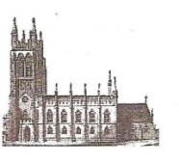 St Mary’s in the Marketplace. .  
 **Securing the future for the next 100 years**

News from St Mary’s  
[incorporating Building News No 29] 3rd February 2013

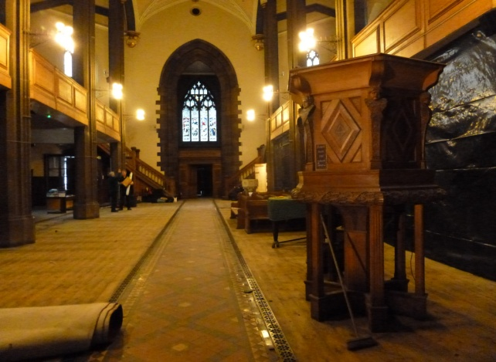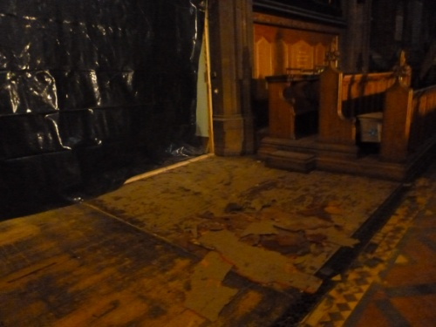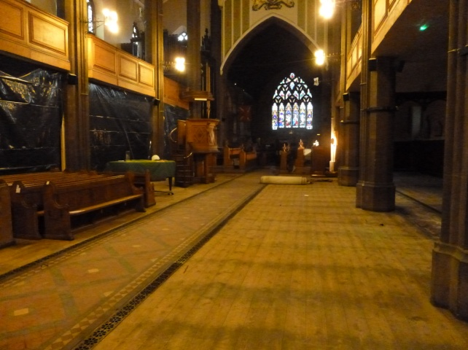It didn’t take long after we had vacated St Mary’s for as much floor area as possible to be cleared in preparation for the sanding of the floor. It took several hours of hand-scraping to remove the old floor coverings near the pulpit and organ console, but they have gone revealing the wooden floor boards. It is amazing just how big the church looks when clear of the Nave pews and what a wonderful canvass we will have to work with when they have all gone.

The sale of pews (both those held at St Mary’s and St Mark’s, Edgeley) remains a priority as we appreciate that the clock is ticking. We have a number sold already (most awaiting collection) with “sales pending” for many of the others at St Mary. We are talking to Lambert Walker as to the possibility of cutting some down – making available “made to measure” pews, as we appreciate that the longer pews are just a bit too long for the modern home and garden. Transport is another issue which we are now addressing for those without their own vehicle. There will, of course, be an additional charge (to be added to the pew sale price of £100) for those wanting a “bespoke” pew and for transportation.

Walking out of Church with a 10ft + pew can be done as we witnessed when Andy and Paul came up from Coventry to collect one. They decided that the best route was out of the south door and to carry the pew up to the car park – taking several breaks on the way! I assume that our pew is now safely “sat” in Andy’s conservatory. He was certainly delighted with his purchase – thanks to “gumtree” internet advertising!

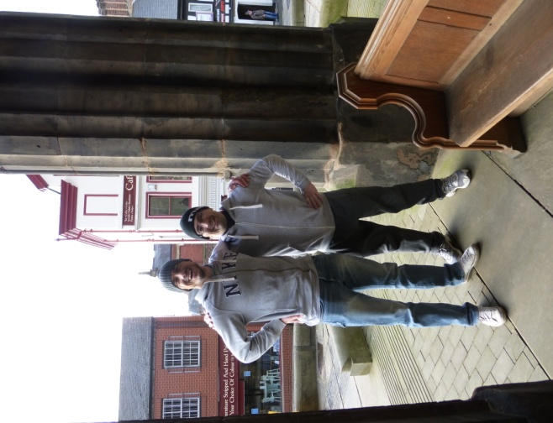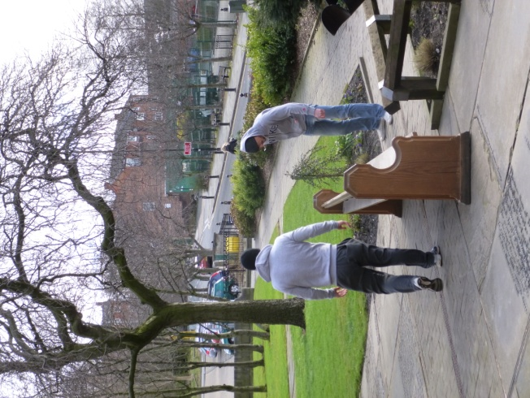

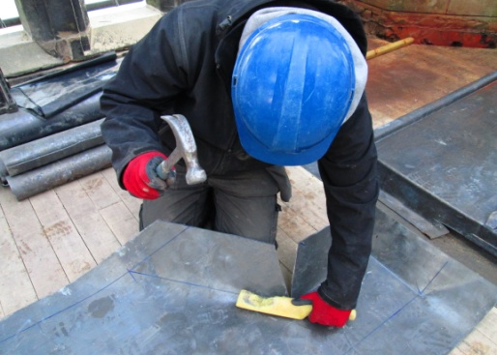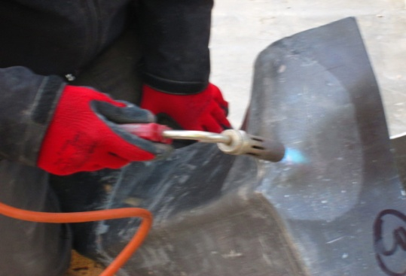 The latest photographs taken from the top of the Tower show that the “roof covering” is no longer stored in rolls but is being fitted and taking shape (literally) as it is being put in place.

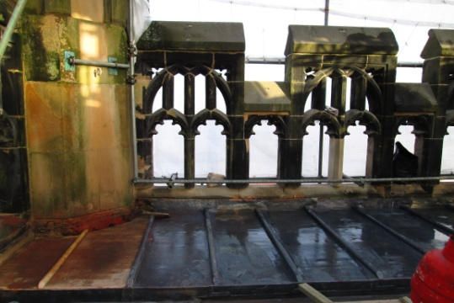

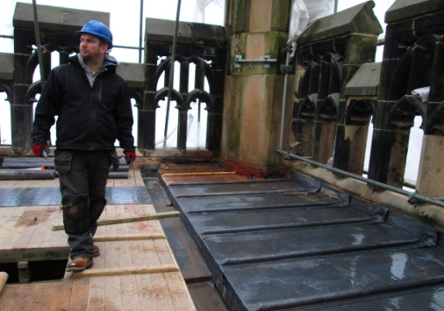

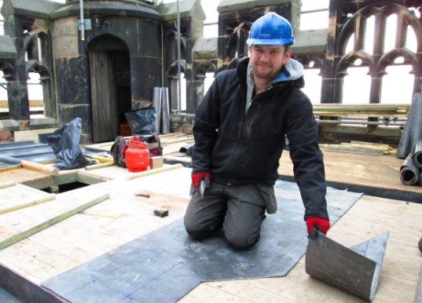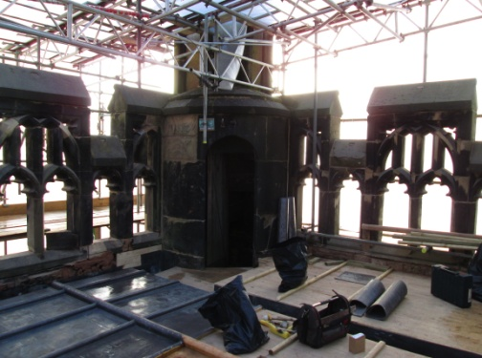

The scaffolding will start to be reduced as work is completed, then we eagerly await the return of the clock face – which is ready and waiting to be brought back. Not forgetting of course – the new flag pole, which will be fitted as soon as possible – our Rector having already bought St Mary’s a present - a new flag!