A Charter School Principal’s Story: A View from the Inside
Barbara J. Smith, PhD.

Sense/Brill Publishers

 | 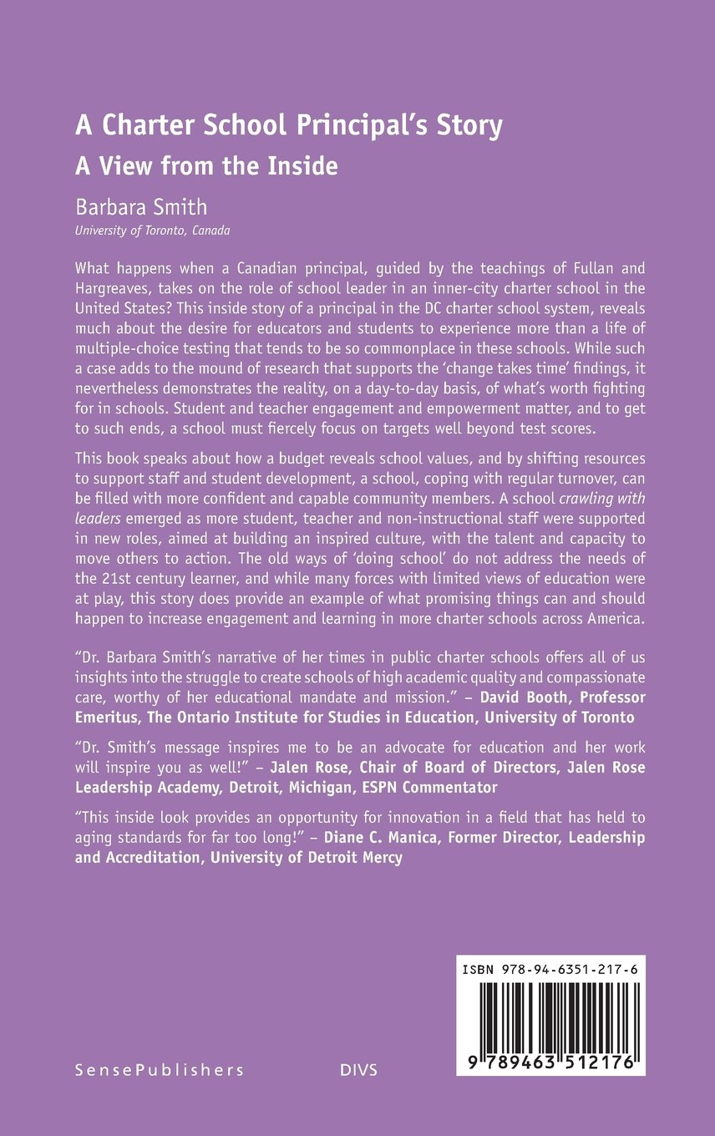

https://www.amazon.ca/Charter-School-Principals-Story-Inside/dp/9463512179

