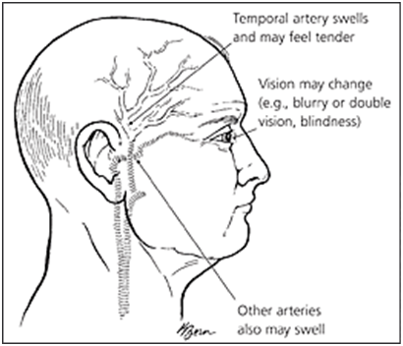
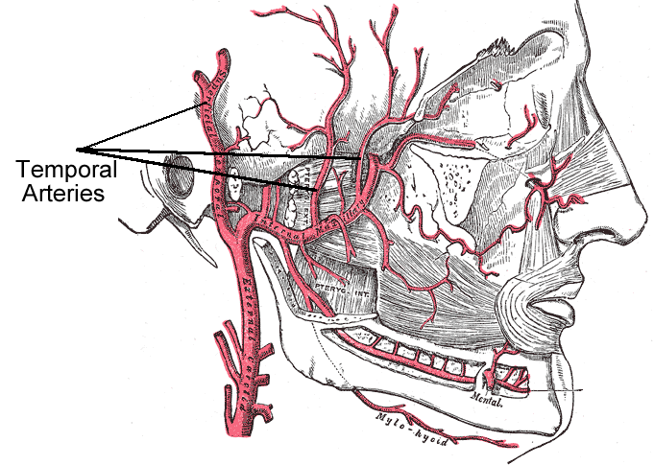

Temporal Arteritis

- Temporal arteritis is a serious disorder that causes chronic inflammation of the large and medium arteries of the head, which supply oxygenated blood to portions of the head and brain. This inflammatory disease results in an inadequate supply of oxygen and nutrients in the brain and head areas.
- Temporal arteritis is believed to be an autoimmune disorder in which the body’s immune system mistakenly attacks normal healthy cells and tissues, causing inflammation.
- Temporal arteritis often affects the temporal arteries, which run over the temple areas next to the eye, but can also affect other arteries throughout the body. Temporal arteritis can cause a wide variety of symptoms that may affect the eyes, head, face and body in general.
- Temporal arteritis is the most frequent cause of vasculitis (an inflammation of the blood vessels).
- Temporal arteritis is also called giant cell arteritis and cranial arteritis.
- Temporal arteritis is more common in people older than age 50, and it affects women more often than men
- Temporal arteritis may be related to or triggered by Polymyalgia rheumatica (PMR), another autoimmune condition that involves muscle discomfort, soreness, and stiffness in the neck, shoulders, upper arms, hips, and upper thighs. The cause of PMR may be related to a viral illness that may cause the immune system to increase inflammation..

Symptoms:
- Blurred vision or double vision
- Cough
- Excessive sweating
- Fatigue and weakness
- Fever
- Hip pain, shoulder pain and other joint pain
- Jaw pain with chewing
- Poor appetite and weight loss
- Scalp pain or sensitivity
- Throat pain or tongue pain
- Headache, especially on one side of the head or back of the head

Several blood tests can be useful in diagnosing temporal arteritis, including the following:
- A hemoglobin test measures the amount of hemoglobin, or oxygen-carrying protein, in your blood.
- A hematocrit test measures the percentage of your blood that is made up of red blood cells.
- An erythrocyte sedimentation rate (ESR) test measures how quickly your red blood cells collect at the bottom of a test tube over one hour. A high ESR result means that there’s inflammation in your body.
- A C-reactive protein test measures the level of a protein, made by your liver, that’s released into your bloodstream after tissue injury. A high result indicates that there’s inflammation in your body.
Inflammation anywhere in the body must be treated or it can lead to other destructive disorders. Temporal arteritis is treatable. If this inflammatory condition is ignored, it can lead to serious complications including vision loss, blindness, stroke, inflammation and damage to other blood vessels in the body, development of aneurysms, including aortic aneurysms, and eye muscle weakness.

Traditional Treatment
Your health care provider will usually prescribe oral corticosteroids. Corticosteroids can be very effective at reducing the inflammation in your body, but they do not address the root cause of the inflammation. Corticosteroids also increase your risk of developing certain medical conditions such as: osteoporosis, high blood pressure, muscle weakness, glaucoma, and cataracts. Other potential side effects include weight gain, increased blood sugar levels, thinning skin, increased bruising, decreased immune system function, difficulty sleeping at night & restlessness.

Some People Prefer a more Drug-Free Approach
In lieu of the fact that corticosteroids do not address the cause, only the symptoms, and because of the many side effects, many people prefer to pursue a more drug-free approach, seeking to address the root causes for the inflammation and the autoimmune response in their body.
- For Inflammation:
- Alfalfa: used abundantly (30+ per day) ... contains natural saponins which reduce inflammation in the body and alkalize the bloodsteam
- Vivix: powerful antioxidants that are very anti-inflammatory
- OmegaGuard: A Omega 3 Complex containing all 7 of the Omega 3 essential fatty acids ... very anti-inflammatory
- GLA: Omega 6 Essential Fatty Acids, which are nick-named nature's steroids
- Vitamin D3: Optimize your levels ... very supportive to the anti-inflammatory responses throughout the body
- For Immune System Regulation:
- Shaklee Life Shake: Optimize your intake of plant-based protein. This provides the nine essential amino acids that are essential in the production of balanced antibodies in the body
- NutriFeron: An immune system modulator.
- Probiotics: included in the Shaklee Life Shake ... each scoop contains probiotics equivalent to 390 servings of yogurt
- Follow the anti-inflammatory diet guidelines

Inflammation Food Guidelines

- Turmeric: Every day take one teaspoon of turmeric (just stir it into an ounce of tomato juice and swallow it quickly … the taste is not super great, but one ounce goes down in one swallow). It is very anti-inflammatory, and has been compared to potent drugs like hydrocortisone and Motrin. However, unlike the drugs which are associated with significant toxic effects (ulcer formation, decreased white blood cell count, intestinal bleeding, bone softening), turmeric produces NO TOXICITY OR SIDE EFFECTS

- Ground Flaxseed: Every day, consume 3 level tablespoons of ground flaxseed. It contains both Omega 3 and Omega 6 fatty acids that naturally lubricate the joints and reduce inflammation.

- Cinnamon: Have a teaspoon of cinnamon and a teaspoon of honey in warm water once or twice per day. It is very anti-inflammatory.

- Ginger: Ginger is another WONDERFUL natural anti-inflammatory remedy. At the end of the article you will see an excellent recipe for a ginger drink … it is a very wise choice!

- Diet:
- No red meat
- No sugar
- No coffee
- No white flour products
- Eat lots of greens
- Choose 75% alkaline foods / 25% acidic foods
- Get your allergies tested – remove offending foods
- NOTE: Many people have found that removing dairy products and gluten has made a significance in their inflammatory response. You may be reacting to gluten … experiment with removing it from your diet (especially wheat), to see if this makes a difference for you.

Several people have made up this vegetable broth recipe below and found it to be very helpful and drank if often …
VEGETABLE BROTH RECIPE:
- In a stainless steel pan add 1 ½ qts. water
- Add: 2 chopped potatoes, 1 cup each of shredded carrots & celery, + beet tops, turnips or onions
- Boil: turn down & simmer for 30 minutes
- Strain: drink broth warm or cooled. Can be refrigerated or rewarmed.
- Drink as much & as often as you like (reduces uric acid)

GINGER DRINK – this is great to drink first thing in the morning when you wake up
Make up a one week batch all at once and refrigerate.
- Add 2-4 tablespoons of finely grated ginger to 7 cups of purified water (simmer for 6 minutes – then drain)
- Optional: add 2 to 4 tablespoons of honey, maple syrup, or molasses for sweetening. (Molasses is an excellent choice, especially for people with blood sugar challenges.)
- Every morning take 1 cup of this liquid & add 2 tablespoons of lemon juice & a pinch of cayenne pepper.
- Drink chilled or warmed. (Make sure you add the lemon juice and cayenne to it fresh daily.)

This FLUSH below is another very helpful tip to reduce inflammation …

GASTROINTESTINAL FLUSH – Celery Flush
(The following flush has done wonders for many people. For example, people with arthritic joint pain, achy muscles, or gout, have reported much relief.)

Step 1: First thing in the morning: Drink 16 oz of prune juice with 3 tablespoons
of lemon juice and take 4 Shaklee EZ-Gest.

Step 2: Thirty minutes later do the following, and repeat every 30 minutes
(approximately twelve times, based on your body weight – see below)

- Drink fresh pressed celery juice (12 oz for 100 – 200 lbs / or 16 oz.
for 200+ lbs of body weight) and take 2 EZ-Gest
- Do this every half hour until you’ve taken enough ounces to cover your body weight (eg: 100 lb = 100 oz)

Step 3: For a thorough cleansing, do this six weeks in a row only once a week. Set one day a week (the same day each week is best). You will be amazed how much better you will feel the second and third week.

This is a tissue flush that helps alleviate the proteins stuck to the wall of the
gastrointestinal tract. The enzymes, with the celery juice, break down and
pull undigested protein (i.e. cheese products stuck to the intestinal walls). You will
release an incredible amount of acid from your system which can cause a burning in the
rectal area. For this reason, you are wisely advised to use Vaseline as a skin protector
in the rectal and surrounding cheek area prior to flushing.

