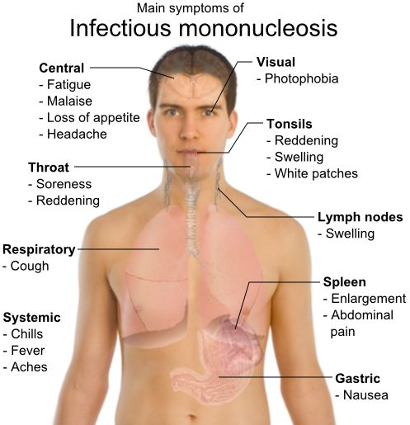
Mononucleosis (Mono)
... is an infectious viral disease.
The vast majority of cases of mono are caused by the Epstein-Barr Virus (EBV), a member of the herpes virus family.
More rarely, it may be caused by cytomegalovirus (CMV).
Once the virus enters the body, it multiplies in lymphocytes (white blood cells).
There can be many symptoms, many of which are listed in the diagram to the right.
The virus that causes mono is contagious, and can be transmitted from person to person by close contact such as sharing food or utensils or kissing. It can also spread during sexual contact or through the air like the common cold.

The incubation period of mononucleosis is about 10 days in children and 30 to 50 days in adults. Mononucleosis is often mistaken for influenza because the symptoms are often so similar. However, with mono, the symptoms tend to be more persistent. Swollen lymph nodes are a very common symptom.
- The acute symptoms usually last from 2 to 4 weeks
- Fatigue can persist for 3 to 8 weeks, even after the symptoms have subsided.
- Some individuals may experience a more chronic form, in which symptoms persist for months or even years.

Drug-Free Natural Health Support Options:
- Pre- and Probiotics: 70% of our immune power is based in the “gut” ... it is essential to optimize the “friendly flora” in the bowel. Shaklee Optiflora (part 1 & 2) are recommended.
- Vitamin C & Vitamin D3: Optimize both of these Vitamins. Vitamin C strengthens the immune system and helps destroy the virus (3,000 to 5,000 mg of Vitamin C ... and 5000 I.U. of Vitamin D3 daily are wise options) . Of course, a premium quality multi-vitamin (Shaklee Vita-Lea) is recommended daily.
- Shaklee DR and Garlic: These two herbal products act like natural antibiotics, and support the immune system in its battle against the virus. Shaklee NutriFeron would also be a wise choice.
- Shaklee Soy Protein: Since the building blocks of antibodies are protein amino acids, there is great benefit in providing a daily smoothie containing at least 3 tablespoons of Shaklee Soy Protein (a guaranteed supply of the nine essential amino acids required to manufacture antibodies).
