Fire Drill and Evacuation Policy
2018+

Board of Management Scoil Bhríde Nurney
2018+
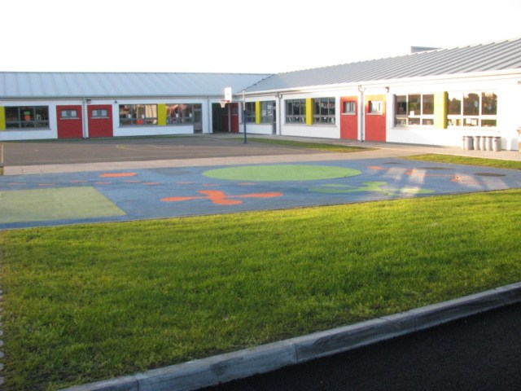

Scoil Bhríde

Fire Drill and Evacuation Policy

Introduction:
The fire drill/evacuation policy of Scoil Bhríde has been produced following a collaborative consultation process by staffs in response to changing circumstances in the school.

Aims:
This policy aims to;

- Enable the school to provide for the immediate needs of students, staff and visitors in the event of a fire
- Have in place appropriate safety procedures which comply with the Health, Safety and Welfare at Work Act
- Ensure a safe school environment for all

School Ethos:
The school is committed to the care of the whole school community and the provision of a safe and secure environment for learning. This policy is in keeping with those ideals.

Objectives:
- To utilize outside agencies (local fire station, fire officer) for training and staff development, so as to enhance safety procedures
- To develop a tried and trusted framework which will ensure the safety of all school personnel in the event of a fire

Internal Procedures:
In the event of a fire, the following steps must be taken;

- Activation of fire alarm
- Extinguish the fire using an extinguisher or any other means if they consider they can do so
- On hearing the alarm each teacher will inform his/her class to prepare to leave the building and assemble at its assembly point
- In all classroom/resource areas, children are to stand up, push their chairs under the tables and calmly walk in a single file to the door
- All teachers must check the class toilets before vacating the room
- The teacher will stand at the door, select the exit route (away from the fire) and direct the class out
- When all pupils have left the classroom the teacher will close the door
- All classes will leave their rooms through the nearest Fire Exit and walk to the Fire Assembly point at the front of the building
- Each class is to assemble at the allocated fire assembly point
- Each teacher will take the clipboard roll book of their own individual class with them and call the roll on reaching the fire assembly point. If the teacher was unable to access their clipboard roll book the teacher will carry out a head count.
- Teachers will report the roll call to the Principal
- Pupils who are attending Special Education Teachers (SETs) will be escorted to their class assembly point by the SETs
- Pupils can only return to the classroom once permission has been given to do so
- The fire drill is be carried out once a term

Calling the Fire Brigade:
- In a ‘real’ fire situation the fire brigade should be called as soon as possible
- When the fire brigade arrives they will need to know
- Has everyone been evacuated
- The general location of the fire
- Water for firefight
- Special risks – Gas cylinders/electrical mains switch etc
- They should be met by the principal and briefed

Training and Audit/Maintenance Checks:
- Fire extinguishers, Fire alarms and Emergency lighting are checked annually (usually in Spring)
- Staff will receive training in the correct use of fire extinguishers every two years

Role and Responsibilities:
All teachers are responsible for the safety and well being of the pupils in their care. The Principal has overall responsibility for ensuring proper procedures are in place. Fire drill schedules are part of the post of responsibility within the in-school management structure of Scoil Bhríde.

Evaluation:

- Positive feedback from all stakeholders
- Maintaining safety standards
- Achieving a coordinated and orderly evacuation in the shortest time possible
- Yearly reviews

References:
- Fire safety in the home – National Safety Council
- Fire safety in the school – National Safety Council

Ratification of Fire Drill and Evacuation Policy

This policy was adopted by the Board of Management on _________________

Signed: _________________________ Signed: __________________________
Chairperson of Board of Management Principal

Date: __________________________ Date: __________________________

Date of next review: __________________

