Nutrition Plus, Inc.
Emily Roark Patti Brenn Susan Morrell
(620) 221-2777 (620) 218-1811 (785) 230-7441
roark2@cox.net pattibrenn@cox.net smorrell12@gmail.com
www.nutritionplusinc.com
October is:
4th National Taco Day
6th National Noodle Day
11th National Sausage Pizza Day
22nd National Nut Day
24th National Bologna Day
26th National Pumpkin Day
29th National Oatmeal Day

Important dates

October 30th - Checks/direct deposits go out

Healthy Birthday Choices

Here are some fun ways to celebrate birthdays!

Rainbow Pancakes 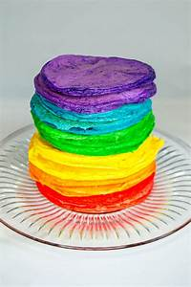Make pancake mix according to directions. Divide batter into 4-6 separate batches. Add a couple drops of food coloring into each batch to make a rainbow of colors. Lightly coat pan with cooking spray and heat on medium. Pour batter onto pan in 2 tablespoon pools for each pancake. Cook until the bubbles burst and edges look dry. Flip and cook for another 2 minutes then remove and stack like a rainbow.
October 2020
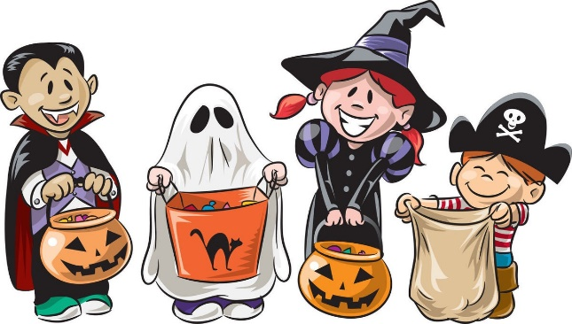

Fruity banana split
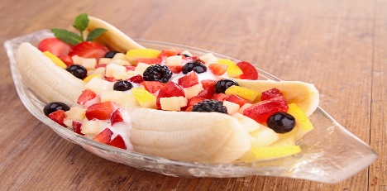You will need:
3 bananas, 1 ½ cups low-fat vanilla yogurt, 2 cups of cubed fruit and berries of choice (strawberries, blueberries, pineapple, peaches and blackberries…). Cut the bananas in half lengthwise and then half those slices to make 4 pieces out of each banana. Add a ¼ cup of yogurt to each bowl, and add a banana slice to each side. Top with fruit and enjoy!

Banana Muffins
You will need:
2 cups oats, 3 bananas, 2 eggs, ¾ pitted whole dates, 1 teaspoon baking soda. Preheat oven to 350°. Mix all ingredients in a blender or food processor until smooth. Pour into a greased muffin tin. Bake for 15-20 minutes. Top with candle!

Frozen berry pops
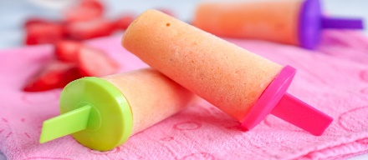You will need:
2 cups berries of choice (strawberries, blueberries, raspberries, blackberries…),
2 tablespoons of honey or agave, 2 cups of greek vanilla yogurt. Blend the fruit in a food processor or blender on high speed until nearly liquefied into a smoothie-like consisency. Pour into a large bowl. Stir in the honey or agave. Add the yogurt and very gently mix everything together. Pour mixture evenly into each popsicle mold. Freeze for 4-6 hours or overnight for best results.

Rainbow Waffles
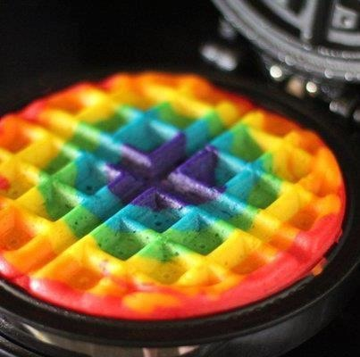You will need:
Waffle mix of choice, food coloring, ziploc bags (or piping bags but who actually has those on hand), clothes pins and cooking spray. Mix up waffle mix as directed. Separate the batter into different bowls. Add food coloring to each bowl until the it reaches the desired brightness. Transfer each colored batter into its own ziploc bag. Spray waffle maker and heat up. When ready, gather mix in corner of bag.
Start in center of waffle maker. Snip off the corner of bag (small snip to avoid a mess) and make a circle of batter. Pinch off flow with clothes pin and set aside. With the next color, make a circle on the outside of the previous color to enlarge the waffle. Repeat this process until the waffle is the size desired. This is a quick process so have the clothes pins ready and make the holes in the bags small enough that batter isn’t spewing out like a firehose! It’s ok if they don’t look perfect. I’m sure this takes practice to do well, but honestly, the kiddos will love the process and outcome regardless. Here are some other pictures of not-so-perfect outcomes.
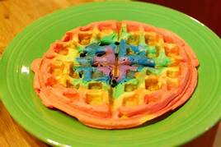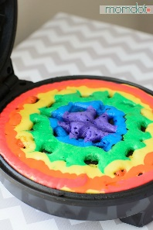

Frozen Watermelon Lemon Cream Tart
(This sounds fancy but is very simple)
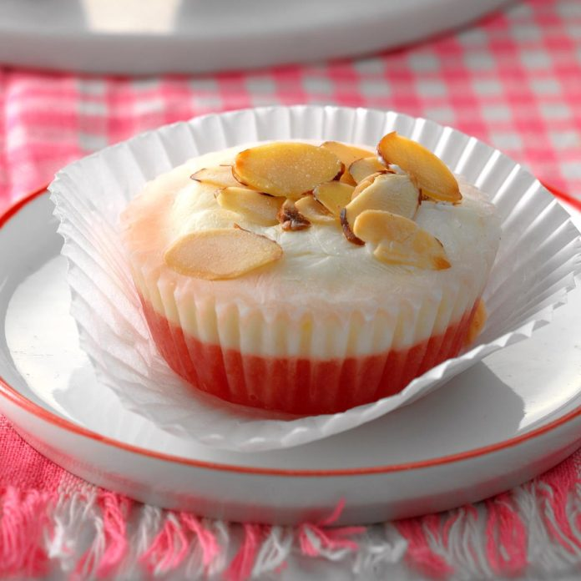You will need:
2 cups cubed seedless watermelon, 1 cup fat-free plain Greek yogurt, 2 tablespoons honey, 1-1/2 teaspoons grated lemon zest, 1 tablespoon lemon juice, 2 tablespoons sliced almonds (optional), toasted, Halved lemon slices (optional). Line eight muffin cups with paper liners. Puree watermelon in a food processor; divide among prepared cups. Freeze 1 hour.
Mix yogurt, honey, lemon zest and lemon juice; spoon over watermelon layer. Sprinkle with almonds if desired and no allergies prevent it. Freeze until firm, about 1 hour. If desired, top with lemon slices before serving (but really, why bother! The kids aren’t going to notice they’re missing! If you serve this to your fancy friends, add them though and impress them!)

We know this has been, and continues to be, a very trying year for you. Covid-19, grocery shortages, online schooling nightmares, isolation, the list could go on. You are doing great. We are here to support you. We believe in you. We appreciate everything you do for your kids and their parents. Know you are not alone.

