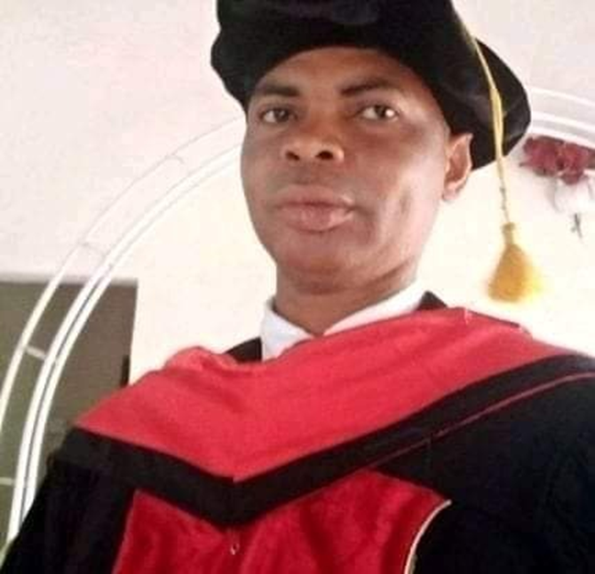
PROFILE OF PROF. PAUL ALLIEU KAMAR, G.C.E.O LEVELS, DHRCJ, B.A, MBAs, DCLD, PHD LDA AND LOD

Fields of studies: Philosophy; Journalism; Leadership Development; Business Administration; Christian Leadership and Curriculum Designing and Research Education Leadership and Organization Development
Years of experience: 18 years in Administration, Media, Teaching, and Ministering, of the word of God (Offices, Media, Classrooms Preaching).
Rev. Prof. Paul Allieu Kamara, G.C.E.O LEVELS, Ansaural Islamic Secondary School Makeni 1998 B.A (Philosophy Upper Division Two), Madonna University Okija Onitsha, Anambra, Nigeria 2002 DHRCJ, (Diploma in Human Rights and Civic Journalism Institute of Political Science University of Bordeaux and Campaign for Good Governance Mobile Campus Sierra Leone 2005. MBAs (Coaching, Mentoring and Leadership) Grace International Bible University Liberia-Maryland USA 2018 and in (Customer Relations Management Systems) Roehampton University England, United Kingdom) 2015.

Doctorate in Christian Leadership Development Grace International Bible Rudolph Kwanue University Liberia-Maryland USA 2020 PhD (Leadership Development and Administration) Rudolph Kwanue University Liberia-Maryland USA and International University of Management in the Republic of Benin and PhD, (Leadership and Organization Development) Global Interfaith University approved by the California University Delaware, California USA 2022 his currently a Professor of Leadership and Organization Development (Strategic Change Management) at the Global Interfaith University, Approved by California University, Grace International Bible University and Rudolph Kwanue University College, Liberia-Maryland, USA. A Professor of Leadership and Administration in Lawrence Bible University Sierra Leone on the 19th February 2022 Leadership Diploma Certificate Course, (LDC) Leadership Certificate Course (LCC) and Basic Certificate (BCC) conducted from the Word of Faith Bible Institute of Winners Chapel International Sierra Leone issued on 2013, 2014, and 2015. He is married to Deaconess Mrs. Alima Divine Kamara with three Children to God is all the glory.

He is a Senior Lecturer and Head of Department in the College of Philosophy and Leadership Rudolph Kwanue University College and GIBU College of Theology in Liberia-Maryland USA. In addition to his academic qualifications, he also holds various professional certifications in Human Rights, Leadership, Consultancy, Media coaching and Leadership from the Independent World Council of Pentecostal Communion in Nigeria 2022, Coaching and Pastoral Care from the Word of Faith Bible Institute in 2010 and International Kingdom University 2022. UNAMSIL Truth and Reconciliation Commission Report 2005, International Human Rights Law Group and National Forum for Human Rights on Human Rights Monitoring and Documentations 12-14 June 2002, Human Rights and Development Centre Care-Sierra Leone on Training of Trainers on Human Rights Monitoring 2-4th August 2005, International Rescue Committee on Communication Skills in Working with survivors 20-22 July 2004, Building Resources in Democracy Training of Trainers 8-12th September 2008, Ministry of Education, Youth and Sport and Western Area Rural District on Youth Entrepreneurship Development 27-28th August, 2010 UNAMSIL Monitoring, Reporting and Promoting Human Rights 16th December 2003, National Elections Watch National Election Domestic Monitoring 22nd May 2004, Rape Trauma, Sexual Abuse Counseling Training Course organized by Commonwealth 8th February 2002, CODEP AND LONDON MINING Build on Books Literacy Coordinator training on 10th -11th February 2011

COMPUTER TECHNOLOGY SKILLS
COMPUTER SKILLS PROGRAMMES
2007 MS Word, MS Publisher, MS PowerPoint, MS, Access MS, Excel MS, outlook and MS Word pad all of 2007 programs
OTHER MEDIA SKILLS ACQUIRED
Internet design, Website designed, face-back/blogs, paper design, Good Editorial skills, Newsletters, Magazine, use of videocassette Recorder, Projects use, Media Research-feed-back Recorders programs, budgeting, press releases, conduct of opinion polls, Audiotape, Video House Journal and Electronics Newspapers.
He is a Professional Leadership trainer and a Media Mentor of young leaders of the media in Waterloo, BO and Kenema including Pemdembu and Kalihun District and a Licensed Leadership and Organization Development Consultant in Global Interfaith University, Rudolph University College, Grace International Bible University and former Fatima Institute Catholic Mission Now UNIMAK Capacity Building Coordinator and Part time Lecturer in Human Rights, Peace Studies Conflict and Democracy 28th March 2008. Public Relations Officer Political Parties Registration Commission (PPRC) 1st July 2008, Administrative Specialist, Curriculum and Research Education and Fellow Dean of the College in Lawrence University 14th February 2022.
He is also a Licensed International Professional Leadership and Administrative Manager. He was awarded Honorary Doctor of Ministry in Pastoral Care for his experiential knowledge and impact in those areas of Care. For the past 18 years, he has taught more than ten different courses at Grace International Bible University, Rudolph Kwanue University and Lawrence Bible University Fatima Institute at both undergraduate and graduate levels in the Faculty of Leadership and Philosophy; and has supervised the research works of a number of students at both levels. At the Word of Faith Bible Institute, Sierra Leone, he facilitated several courses in the department of Leadership Development and Pastoral ethics prior to becoming the Head of Philosophy. He has rich Leadership coaching experience spanning a period of over 18 years at both Lower, Middle and Senior Management levels with headship of some branches and Offices as a Leadership and Organization Development practitioner.
Rev. Prof. Paul Allieu Kamara is a Fellow of Leadership and Organization Development (Global Interfaith University and California University) and also a Curriculum Specialist (International Kingdom University). His service on Board of Directors includes Obama Senior Secondary School (5 years) and currently, a Consulting Dean of Lawrence Bible University, (LBU), Freetown, Sierra Leone. He is also an Executive Council Member of the Independent World Council of Pentecostal (IWCPC) where he is the International Director of Media and Communication Agency. He membership of Professional Bodies in Sierra Leone Human Rights and Civil Society and the USA group of Leadership diagnostics Research (LDS). He further serves on the Research and Development Committees for the Independent World Council of Pentecostal (IWCPC) in Nigeria and the Global Journal in Sciences and Theology. As one that believing in hard-work for excellence, he started his academic journey with a GPA of 4.45 at the Bachelor’s and Master’s levels 3.43 and worked his way up to the Post-Doctorate at the Leadership School of Doctoral Studies, he received an International Honours Award in Pastoral Care by International Kingdom University (IKU), that is recognized by the Florida Department of Education. All his research works earned his straight ‘A’s at all the levels of education and adjudged the best. He is very resourceful and has several publications in the area of Leadership development to his credit. www.slidshare.net Paul Allieu Kamara // www. Academia Paul Allieu Kamara// www. Global Journal in Science and Theology Dr. Paul Allieu Kamara (www.gajst.org ) www.rkuc.org www.linkedlin.com /in /paul –allieu-kamara www.rkuclr.com facebook Paul Allieu Kamara Page.

PUBLICATIONS:
- Dissertation- Significance of Christian Leadership in the Contemporary Society (Case Study Sierra Leone)
- Research and Thesis Writing Subject: Principles of Research Methodologies
- Leadership vs Administration
- Old Testament Survey review Principle for Doctorate
- Curriculum for Ethical Practices for young Pastor
- What is Research and How Can Research Benefit Your
- Programme Specification- MBA in Executive Leadership and Management
- Organizational Behaviors
- Communicating your potential as a Leader
- Pastoral Ethics
- Understanding the Leadership in Organization Development
- Transformation Leadership and organizational Effectiveness
- Public Relations Strategies
- Business Plan Template
- Organization Development and Change Management
- Assessing the effect of social Media
- Rudolph Kwanue University College
- Teaching Methods
- Thanksgiving a price to be paid for life and Living

