**Use of Facility Request**

*(Electronic version is available at* [*www.turningpointrockvile.com*](http://www.turningpointrockvile.com)*)*

Thank you for choosing Turning Point Church! Please answer the questions listed below as best you can and feel to reach out to TPC if you have any questions.

**Purpose of Request (**check one**):**

**Wedding  Funeral  Church Event**

**Community Event  Family Event  Other** *(Describe in the box below)*

|  |  |
| --- | --- |
| **Other:** |  |

|  |  |
| --- | --- |
| **Proposed Date:** |  |

|  |  |
| --- | --- |
| **Name of Applicant:** |  |

|  |  |
| --- | --- |
| **Address of Applicant or Primary Contact:** |  |
|  |
|  |

|  |  |
| --- | --- |
| **Email:** |  |

|  |  |  |  |
| --- | --- | --- | --- |
| **Phone:** |  | **Cell:** |  |

|  |  |
| --- | --- |
| **Requested Date of event** |  |

|  |  |  |  |
| --- | --- | --- | --- |
| **Begin Time of Event:** |  | **End Time of Event:** |  |

|  |  |  |
| --- | --- | --- |
| **Requested time for Building to open** |  | |
| **Expected Date(s)** | |

**Begin Time: ____  am  pm End time (time church is restored): ____  am  pm**

**Please check all that apply:**

|  |  |  |  |
| --- | --- | --- | --- |
|  | | **Use of Sanctuary,** *Maximum capacity – 125* | **$500 for up 3 hours**  **$750 for up to 6 hours** |
|  | | *Includes :*   * *One microphone* * *Use of overhead AV* * *Use of musical instruments* |
|  | | **Use of Fellowship Hall,** *Maximum capacity – 100* |
|  | * *Warming trays are permitted* * *Use of Kitchen is permitted for warming only* * *Ice can be provided by TPC* * *There is no charge for parking*   **Not included:**   * Audio / Visual Equipment * Refreshments * Decorations * Setting up and arrangement of tables and chairs | |  |
| **TOTAL AMOUNT DUE:** | | | **$** |

***Payment is required in full prior to the event payable by certified check, money order or electronic payment.***

|  |  |
| --- | --- |
| ***Applicant Initials:*** |  |

***It is the responsibility of the applicant to ensure the TPC Facility is returned to its original condition after the event.***

|  |  |
| --- | --- |
| ***Applicant Initials:*** |  |

After a date has been reserved and paid, the TPC Council shall assign an individual(s) to work with clients on site and shall grant its representative full authority to make decisions, thereto during those events. (The Trustee or representative(s) shall be available on-site.)

The visiting representative of the event shall keep in touch with the TPC contact, by phone, email, in person, or on site as required (i.e. troubleshooting, moving furniture & equipment, overhead AV use, musical instrument use, etc.).

At the conclusion of the event, the applicant / primary contact (s) shall be responsible for ensuring all TPC property is replaced in the correct location and securing the building. A TPC representative will be on site to inspect the premises.

|  |  |
| --- | --- |
| Signed: |  |

|  |  |
| --- | --- |
| Date: |  |

|  |
| --- |
| **Other information from Applicant:** |
|  |

|  |
| --- |
| **Comments / Notes from TPC:** |
|  |

***Feel free to call if you have additional questions (240)855-2732.***

***Exterior lncludes ample parking, auxiliary parking and 3 acres of mainicured grass area***

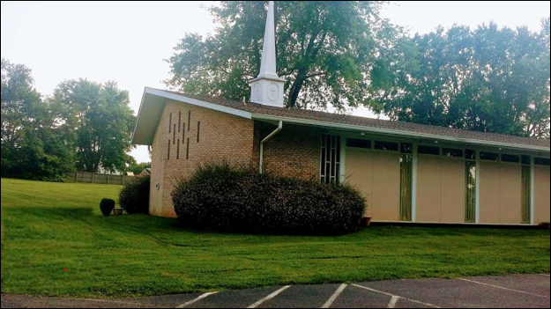

***Sactuary With Retractable Jumbo Screen (seating capacity 125-150)***

***Jumbo Screen Retracted***

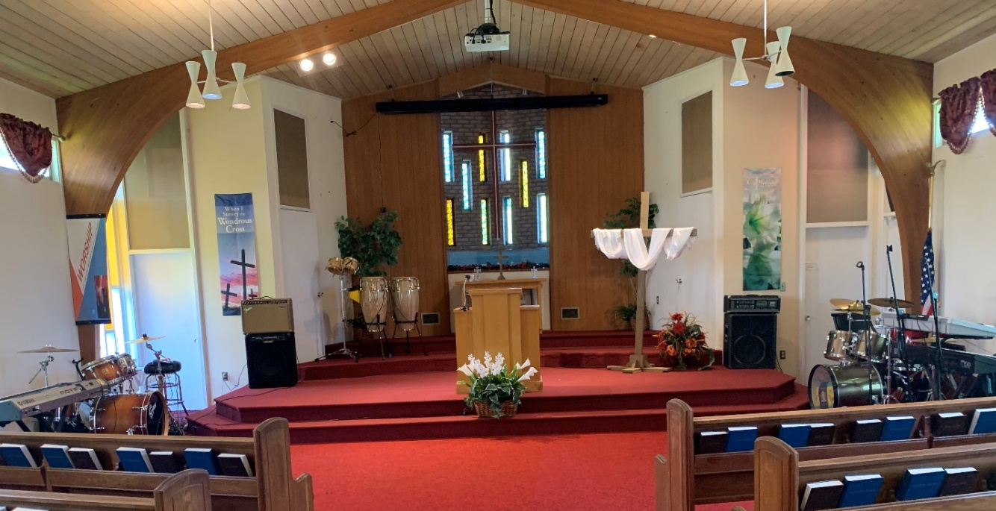

**The Fellowship Hall (seating capacity – 100)**

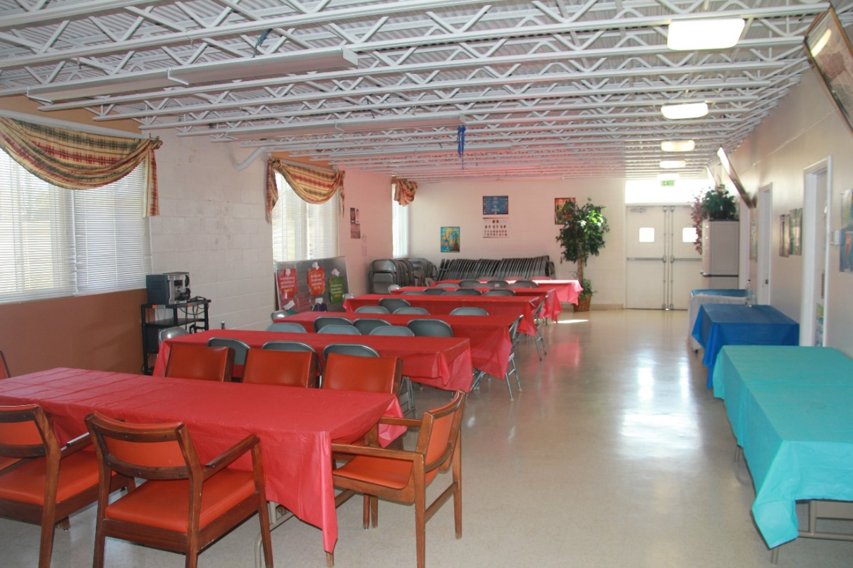

Not shown are three class-rooms and a conference room that convert into comfortable waiting areas or dressing rooms.

The facility includes 3 acres of manicured lawn, ample parking, and auxiliary parking (most evenings and weekends) at an adjacent school.

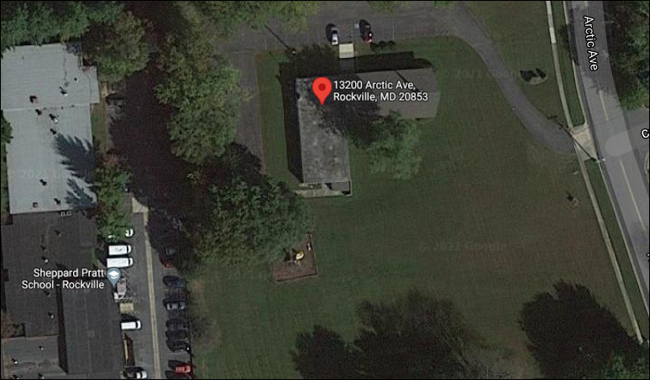

**Location**

