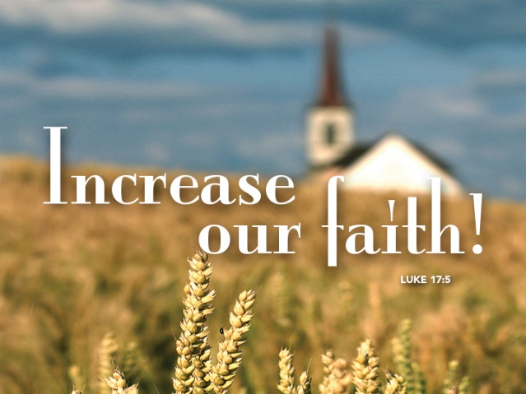

Everyday Faith
October 2, 2016
Luke 17:5-10
Grace and peace to you from God Our Father and from the One who gives and can certainly increase your faith, Jesus Christ Our Lord, amen.
I have to admit that I feel for the disciples, even more than usual, in today’s Gospel lesson. I wish there were some easy way to jump-start or grow my faith during trying times. I mean when I’m tired and can’t wake up in the morning I pour a large mug of extra strong coffee and BAM I’m ready for the day. Then, later in the afternoon when I start to feel run down I take out one of those little bottles of 5 hour energy and slug it down, because it tastes like cough syrup that has been left open on the sink counter for a couple of weeks, and BAM, I’m wide awake and full of enough energy to take on whatever challenges the afternoon and evening has in store. I wish faith worked like that. When I feel doubts or when the demands Jesus has placed on me are too much, if only I could drink a small vile of faith juice and BAM, I’d have the faith of Peter or Paul. Some of you are old enough to remember Popeye the Sailor Man. Whenever he got in trouble he pulled out a can of spinach and BAM he had the strength to defeat Brutus or whatever other dilemma the cartoon writers had in store for him.
It's not like that in real life. It apparently wasn’t that easy for Jesus’ disciples back in Bible times either. Today’s Gospel lesson is from chapter 17 and so far in Luke’s Gospel Jesus has been asking some fairly extraordinary things of His disciples and all those who he encountered – to give away their possessions, to forgive those who wrong you… Not once or twice, but countless times, to take up his cross, and so much more. It’s no wonder they finally break down and ask for more faith. They feel inadequate to the tasks around them, insufficient to the challenges, unable to imagine accomplishing any of what he is asking.
After a week like the one we just had – with shootings, stabbings, injustice, hacking, presidential debate mudslinging, a horrific train crash, and more – I suspect lots of us feel the same way. Like we need more faith…just to get through, let alone enough faith to actually make a difference. That’s when something interesting happens. When the disciples recognize their need and ask Jesus for help, for more faith, you’d think Jesus would both welcome and grant their request, but he doesn’t. Instead, he almost seems to rebuke them. “If you had even a speck of faith…,” he begins, implying that they actually don’t have faith even the size of a mustard seed. What kind of way is that to respond to the disciples’ and our earnest desire for more faith?
Consider this… I actually believe the disciples plea for more faith is earnest and heartfelt, but it’s also problematic, and maybe even a little wrong-headed? Jesus’ sharp reply was just what they needed – maybe just what we need – to orient them and us to the miraculous presence of God all around them and the totally-sufficient faith we already have.
Here’s the thing: servants aren’t invited to the table with the landowner; they eat when their work is done. We went to the Wernle Youth and Family Services annual charity fund raising ball last Thursday. It was a very fancy affair. Men in suits and women in fancy dresses. The meal was served by a professional staff. I noticed after we ate and I excused myself to use the men’s room there was a table in the back where the staff was eating their meal. They ate after all the guests were served and had finished our meal. The staff didn’t expect nor I suppose deserve great thanks simply for doing their job; they just did it pretty much unnoticed. That’s more what faith is like, Jesus seems to say – simply the willingness to do what needs to be done. Faith isn’t some kind of scarce resource that needs to be saved, spent, or added to. It’s not a commodity kept in a bottle you simple pour out when the need is urgent. Faith isn’t always heroic. In fact, it usually isn’t heroic. Instead it’s simply and humbly doing what needs to be done, big or small, great or mundane, just because it needs doing.
This isn’t the first time Jesus has hinted at this. At this point in Luke’s Gospel, Jesus has already named as faithful a woman’s desperate confidence that if she only touches him he will be healed (3:48), a centurion’s concern for a sick servant (7:9), and a woman’s gratitude at being forgiven (7:50). Pretty soon, later in this same chapter Jesus will also call faithful a Samaritan leper who returns to thank him for healing (17:19) and in chapter 18there’s the plea of a blind beggar for sight (18:42). So maybe it shouldn’t surprise us when Jesus challenges the disciples’ perception about faith by pointing them to the, far from illustrious or noteworthy, hard work of a servant. The servant performs his everyday duties without honor or fanfare. Faith is found not in the mighty or supernatural acts and miracles, but in the ordinary and everyday acts of doing what needs to be done. Responding to the needs around us, caring for the people who come our way, and forgiving each other as many as seven times each and every day; these are the outward signs that demonstrate faith.
So here’s my question, do you know and believe this? Do you believe Jesus would call so many of the unnoticed things you do each and every day faithful? Showing up for work and doing a good job. Listening when someone needs to talk. Getting the kids off to school. Sitting with someone in the cafeteria who looks like they could use a friend. Volunteering at a local food bank or the GRCC Soup Kitchen. Exercising your responsibility to vote, even if the field of candidates seems discouraging… I mean bigly discouraging… Faithfulness is balancing the books for your business or community group without cheating, writing a thank you note to someone who has done a kindness or a “Thinking of You” card to someone you miss at church. It looks like cooking supper for your family when you really feel like taking a nap. Faith is praying for a neighbor who is having a hard time. The list could go on and that’s exactly my point. None of these is any big deal, and yet it is just these kinds of acts we all do every day Jesus calls faith. I’ll bet most of you never stopped to consider all these things and the millions more you do every day are actually acts of faith.
Somehow, an “act of faith” seems like it needs to be significant or costly or even extravagant to merit God’s attention. At that charity fund raiser for Wernle we witnessed people donating tens of thousands of dollars to that worthy institution. As I sat there I wondered what difference all our work could possibly make when with one stroke of a pen a single donor gave more than we scrape together in several years. Then I re-read this lesson from Luke and I realized it’s not those heroic gestures Jesus calls true faith. It’s the everyday things we do when we donate a pair of socks, a gently used shirt or pair of jeans, or a specially made blanket like the ones made by our Confirmation Students for one of the young people being served at Wernle. I want to take a moment and ask you to think about just one helpful thing you did this week. Once you have that mental picture now imagine what the world would be like if none of the things you all are thinking about had been done. Pause to let that sink in… Now imagine what the world might look like next week if you offered even more simple acts of faith. It’s not the great and powerful or even the supernatural miracles Jesus recognizes, but the everyday faith of people doing everyday life. Martin Luther said what makes a Christian shoe maker isn’t putting little crosses on all his shoes, but rather making the very best shoes he possibly can every day. You still might need a little boost of energy every once in a while, but I pray you find your faith boosted in prayer and relationship with the God who loves you and not from a double shot espresso or a 5 hour energy drink.
May you realize the great impact you have in every environment where you live, work, go to school, and even where you play. May you be energized by the tiny speck of faith you possess to even greater simple acts of faith. May God continue to bless your everyday faith with joy and love. Amen.

