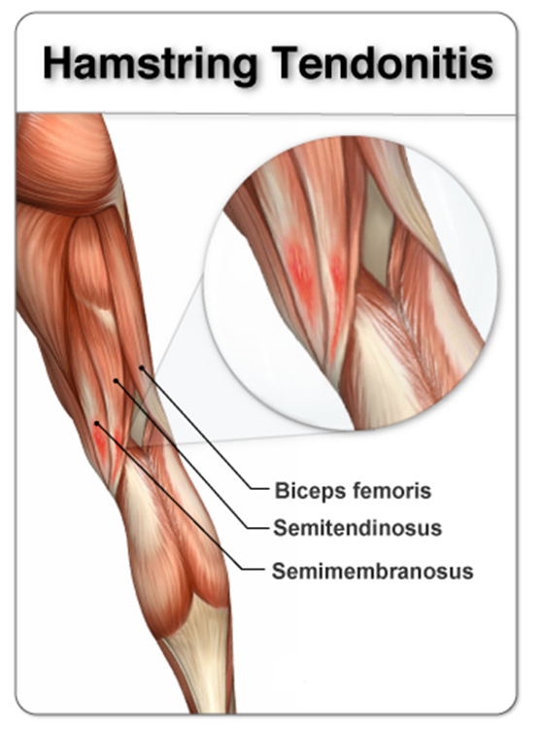
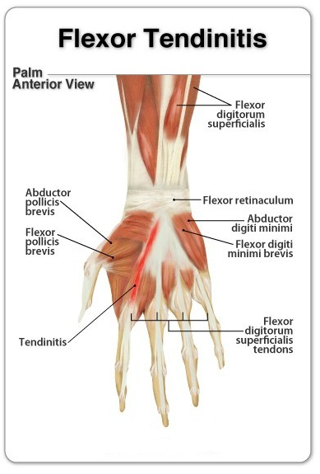
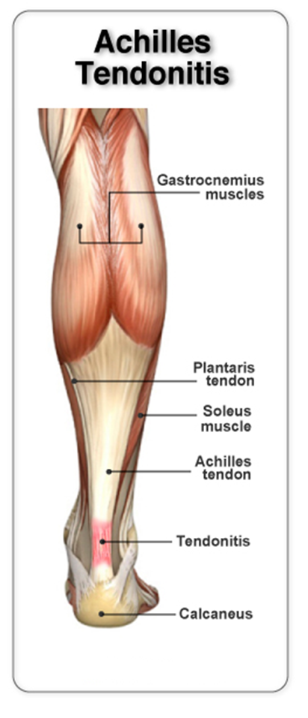
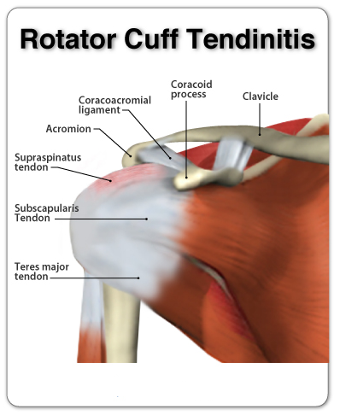
Tendonitis
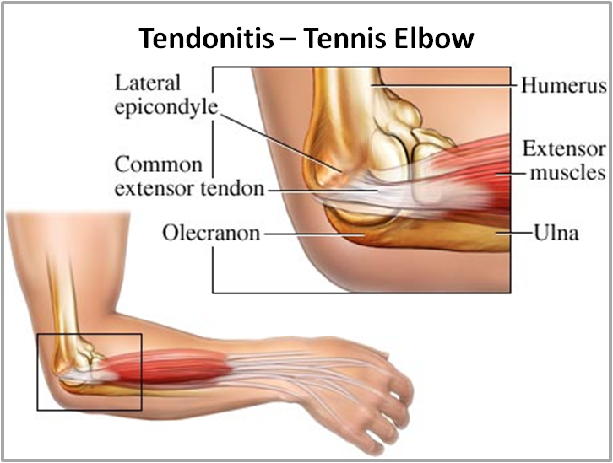
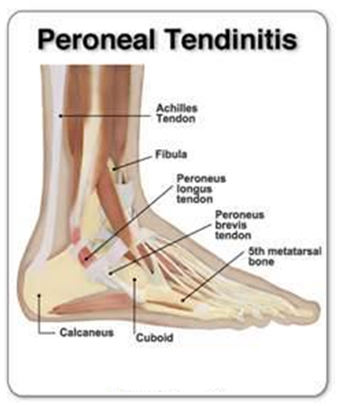

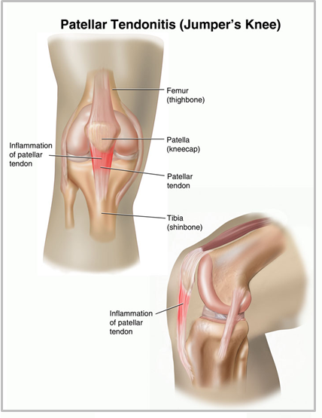

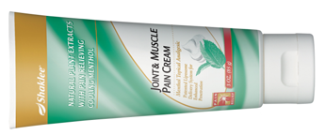
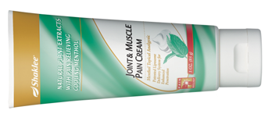
Joint & Muscle Pain Cream provides INSTANT relief, and can be applied as often as necessary. It does not “scald” the skin!

STEP 1: Advanced Joint Health Complex

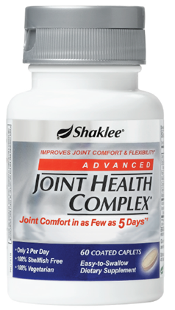
(Glucosamine Hydrochloride)
- Unlike medications that treat the symptoms, Joint Health Complex treats the cause. It reduces pain & joint tenderness, improves mobility and joint function, and stops destruction of cartilage, as well as helps regenerate new cartilage.
- 2 capsules each day is recommended until you experience relief … then you may be able to reduce to a maintenance level of 1. (It is 100% shell-fish free, and 100% vegetarian)
- Joint Health Complex is highly stable, is sodium-free, is purer and more bioactive than glucosamine sulphate (which is a larger molecule and is not as bioavailable)
- Joint Health Complex causes the body to make condroitin, which is another glucosamine compound.
- It contains Glucosamine Hydrochloride, Boswellia, Vitamin C, and trace minerals
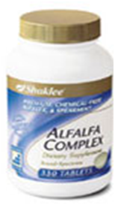
STEP 2: Alfalfa Tablets:

- Alfalfa is Nature’s Anti-inflammatory. It contains saponins, chlorophyll, and a smorgasbord of minerals that can reduce inflammation anywhere in the body.
- Eat it like green peas (about 4 or 5 per meal) … many have reported wonderful reduction in inflammation. Think about this: how often do you see a cow or horse with arthritis? … they eat LOTS of Alfalfa.
- Natural Pain-Relief: Many suffering with rheumatoid arthritis, gout, and rheumatism have experienced relief because alfalfa aids in regulation of the alkaline/acid balance in the body. It contains an anti-stiffness factor, which relieves stiff joints.

STEP 3: Diet Changes:
- Turmeric: Every day take one teaspoon of turmeric (just stir it into an ounce of tomato juice and swallow it quickly … the taste is not super great, but one ounce goes down in one swallow). It is very anti-inflammatory, and has been compared to potent drugs like hydrocortisone and Motrin. However, unlike the drugs which are associated with significant toxic effects (ulcer formation, decreased white blood cell count, intestinal bleeding, bone softening), turmeric produces NO TOXICITY OR SIDE EFFECTS
- Ground Flaxseed: Every day, consume 3 level tablespoons of ground flaxseed. It contains both Omega 3 and Omega 6 fatty acids that naturally lubricate the joints and reduce inflammation.
- Cinnamon: Have a teaspoon of cinnamon and a teaspoon of honey in warm water once or twice per day. It is very anti-inflammatory
- AVOID Coffee, Black Tea, and Sugar: We recommend medicinal teas instead (Shaklee Cinch Tea is perfect, and so easy to use
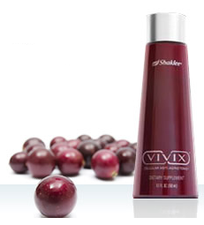
STEP 4: Raw, Unpasteurized Resveratrol Cellular Tonic: (Beyond Resveratrol)
Many people have reported amazing anti-inflammatory affects after using
Shaklee Vivix, a cellular tonic that in clinically tested to reduce the
inflammatory response in every cell in the body.

It contains 60,000 antioxidants, from a broad spectrum of over 15 polyphenols
including ellagitannins, one of nature’s most potent antioxidants. It contains
antioxidant properties of rare muscadine grapes, and has been shown to be
10x more powerful than resveratrol alone.
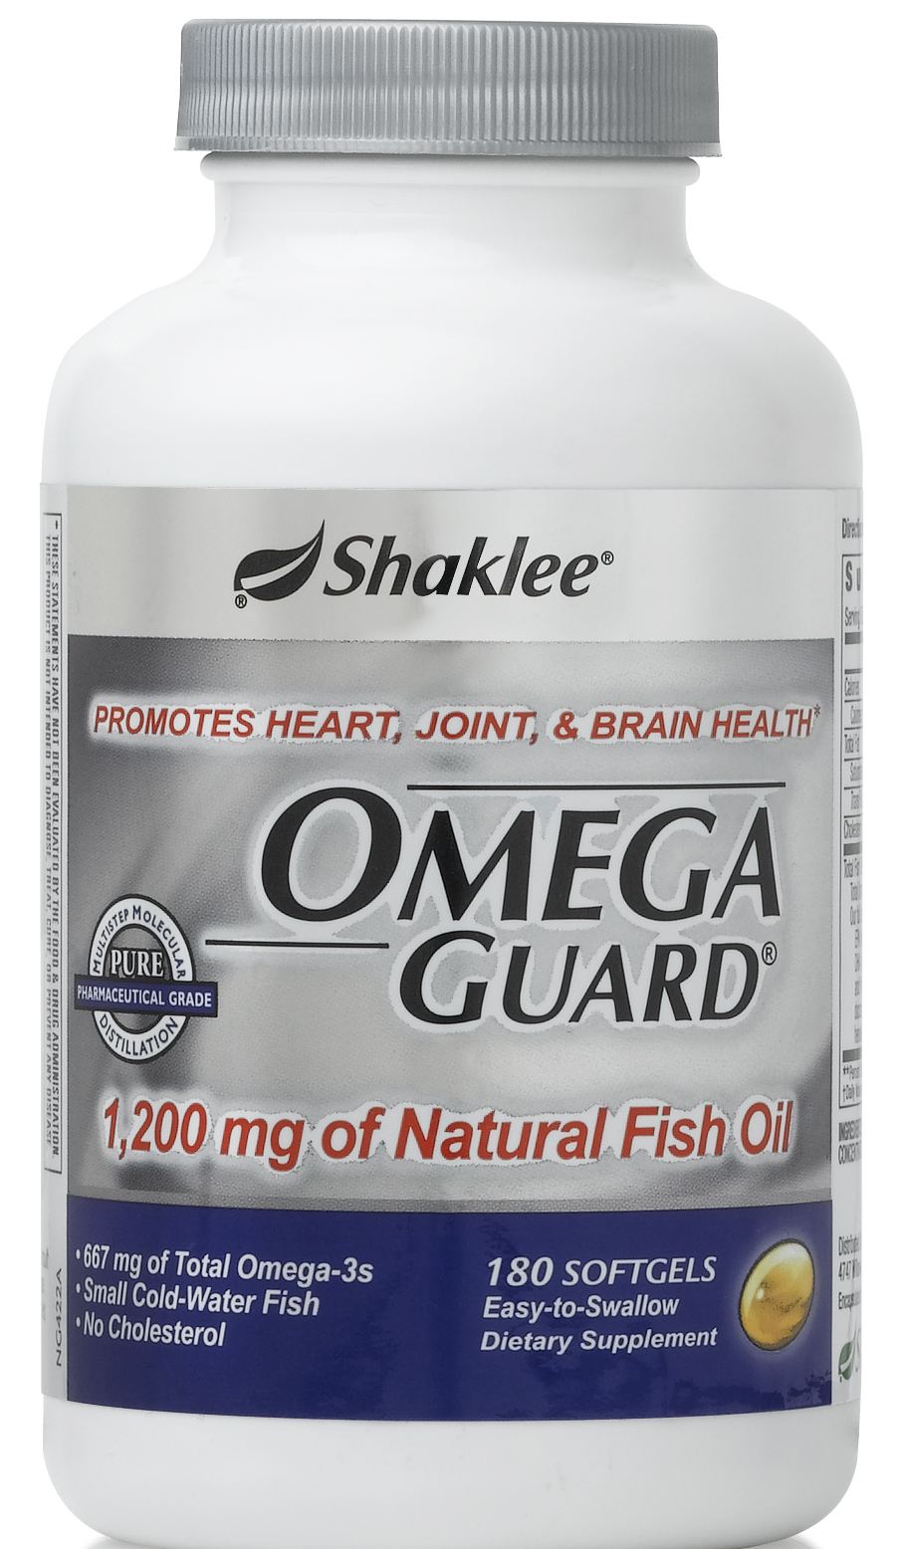
STEP 5: OmegaGuard (Fish Oil, containing 7 types of Omega 3 Fatty Acids)
... all of which are proven to reduce inflammation in all cellular tissue membranes.

STEP 6: Optimize Vitamin D3 Level
... according to the chart shown here ... aim for fantastic level
