Ordering and Uploading Flood Certificates
See the Screen Shots below to Order MI on Conventional Loans:
Step #1: Go to Order MI on navigation panel in MBOT
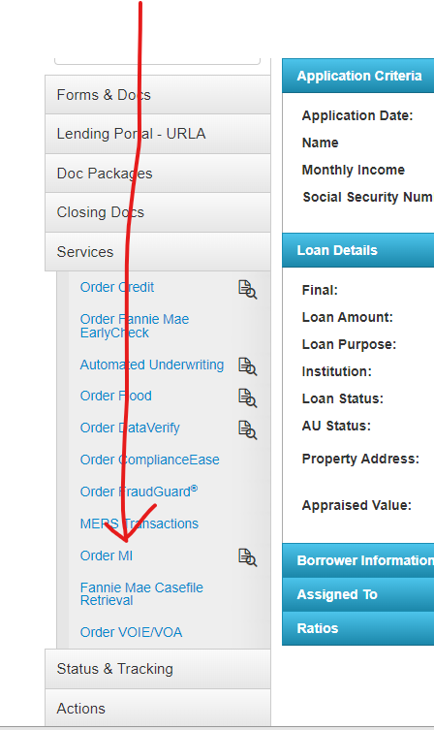
Step 2: Make sure that the below fields are filled in before you order and then submit.
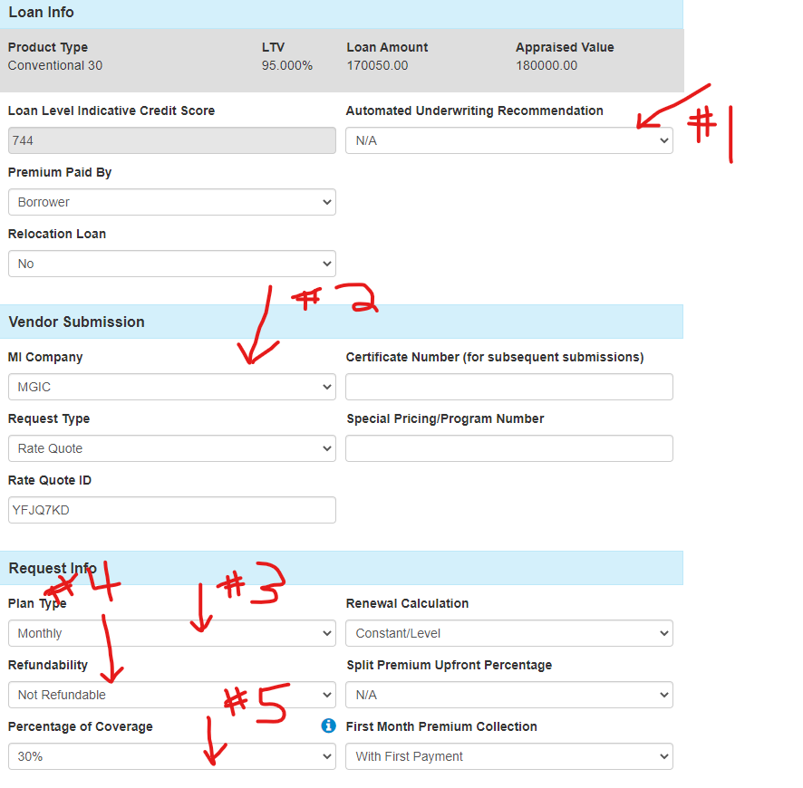

Step 3: Go to the Loan Estimate main tab under forms and docs and scroll down.
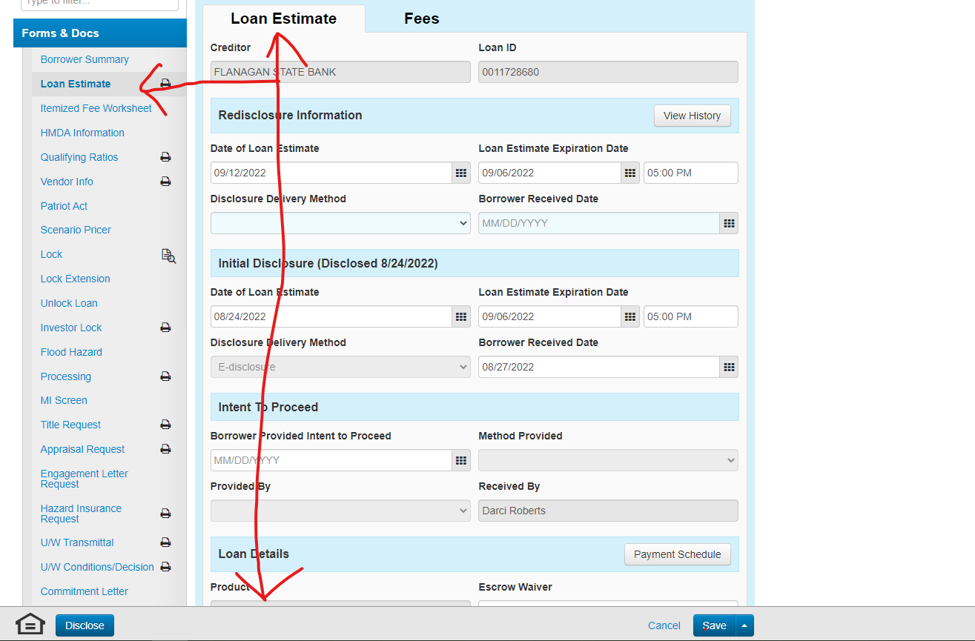

Step 4: Make sure to click the Mortgage Insurance Button.
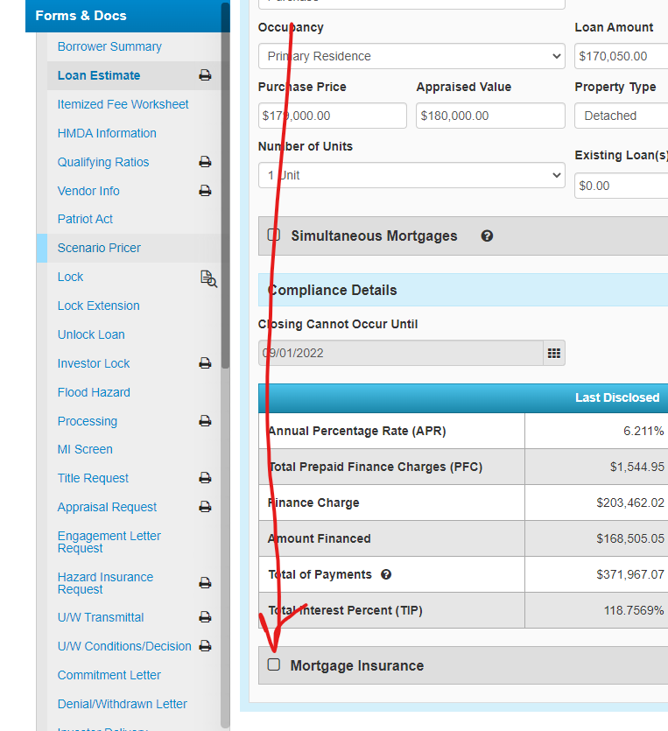

Step 5: Make sure that these fields pulled over from your order. If not, please fill in.
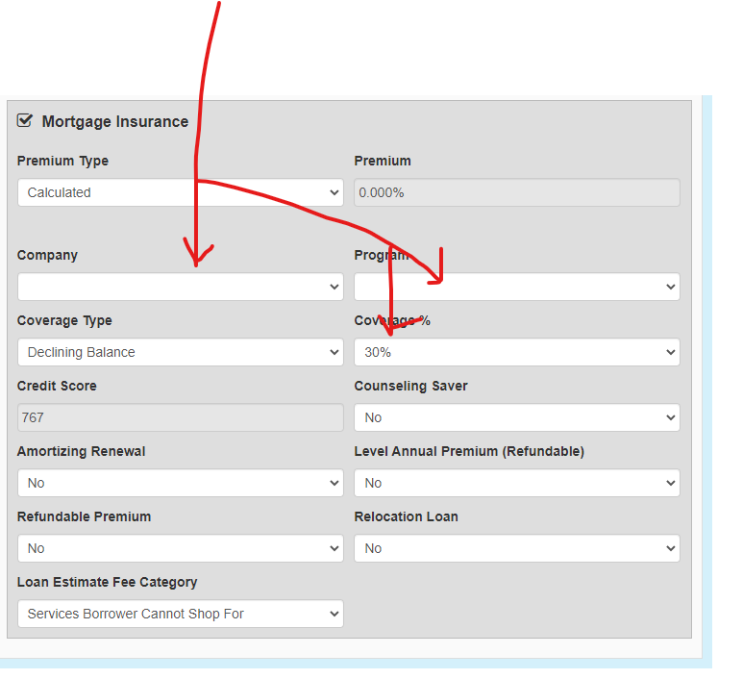

Step 6: Make sure to go to your Lock Screen.
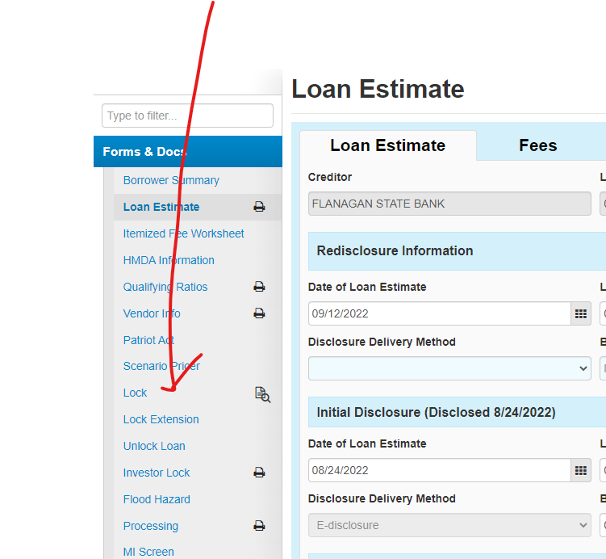

Step 7: Make sure your lock is confirmed with the correct MI Coverage.
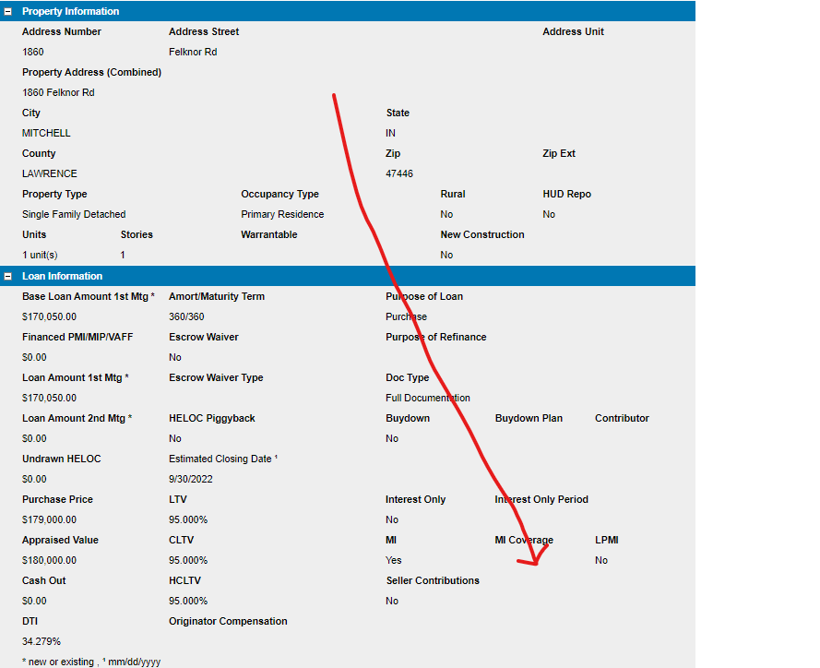

Step 8: Make sure the MI populates to the Loan Estimate Fee Tab. You may have to recalculate if it is not, to trigger the fee to show up.
