National Interpreting Agency 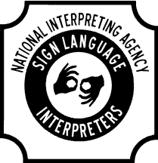
Gina D Asad
Executive Director
P.O. Box 35478
Cleveland, Ohio 44135
216-527-3400 office
216-527-4181 cell
330-975-4419 fax
N.Interpreting.A@aol.com
www.NationalInterpretingAgency.com
Booking Services Request Form
Thank you for expressing interest in booking services with National Interpreting Agency. Please fill out the below information and fax or email the completed form to Executive Director, Gina Asad at fax #330-975-4419 or N.Interpreting.A@aol.com.
Name: ________________________________________________________________________
Email and contact phone number:_____________________________________________________
Preferred method of contact (email or phone number):______________________________________
Best time to call (AM or PM):_______________________________________________________
Today’s date:___________________________________________________________________
Are requested services for an organization/company or private individual(s)? Yes or No:_____
Organization/Company Name:________________________________________________________________________
Organization/Company/Home Address:____________________________________________________________________________________________________________________________________________________
Service Interest (Please briefly explain the type of services you are requesting):__________________________________________________________________________________________________________________________________________________
Estimated service start date:_________________________________________________________
National Interpreting Agency will be in contact and looks forward to working with you!
Thank you for your time.

