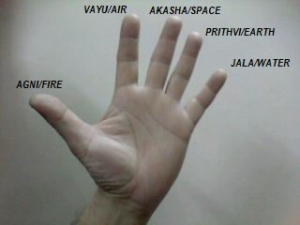
THE POWER OF HAND MUDRAS (Seals) AND THEIR MEANING: IMPROVING YOUR YOGA PRACTICE
Did you know that your hands hold an innate healing power that has been used for centuries for healing various ailments? ‘Mudra’, a Sanskrit word, means a symbolic hand gesture that has the power of producing joy and happiness. It has been proved that regular practise of mudras not only contribute to one’s overall good health but can be used as a preventive measure as well. Our hands define our karma and fingers being the power points, are a link between individual Pranic force and universal cosmic energy.
The position of our hands has the ability to influence energy of our physical, emotional and spiritual body. Mudras help to link the brain to the body, soothe pain, stimulate endorphins, change the mood and increase our vitality. They are used extensively in Yoga, meditation and dance. Across various disciplines it is said that there exist close to 399 mudras. Let’s have a look at the key mudras and how they can benefit us.

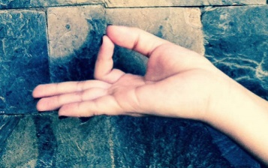
Gyan Mudra: The gesture of knowledge or wisdom
To perform this mudra, gently join the tip of thumb and the index finger, while the other three fingers are simply stretched out or free & slightly bent.
You can practice this mudra anytime during the day or while you are performing yoga postures or during meditation.
Gyan mudra helps to increase concentration, memory, reduces sleep disorders, helps to release stress and anger, eases depression and headache.
This mudra has been used extensively for thousands of years by yogis as it brings peace, calm, and spiritual progress.

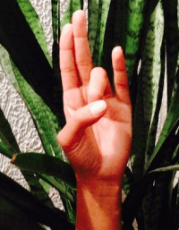
Prithvi Mudra: The gesture of the earth
Earth element is a vital component of bones, cartilage, skin, hair, nails, muscles, tendons, internal organs, etc. Practice of Prithvi mudra builds and invigorates these tissues and strengthens the bones. It produces stability, confidence and strength
To practice this mudra Sit down in lotus pose or easy pose to perform this mudra. Gently touch the tip of ring finger and thumb, while the other three are stretched or free.
This, if done 30-45 minutes every day (together or in 3 parts during the day), helps reduce stress, weakness, helps in weight gain, increases blood circulation & Kapha, boosts self esteem & confidence. Also, it increases determination and directs individuals towards spirituality. It improves digestive power, develops vitality and removes deficiency of vitamins.

Prana Mudra: The gesture of life
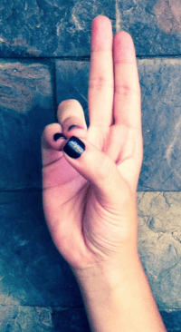
To perform this mudra place the ring finger and little finger at the tip of the thumb gently and keep the other two fingers stretched.
Prana mudra can be used whenever you feel drained or tired, and need an extra boost of energy. This mudra cleanses our aura due to its innate ability to control the subtle energies of our aura. It is considered beneficial or all types of diseases and is also said to impart special power to the eyes. Prana mudra is said to help activate the dormant energy in the body (chi or qui).

Suraya Mudra: The fire hand gesture
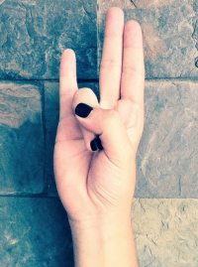
The fire element is associated with body-temperature and metabolism. Practice of Surya mudra helps to maintain the body-temperature and keeps the metabolism going. It is a very powerful mudra with significant healing capacity. It increases the fire element in the body and reduces the earth element.
It is advised that this mudra should be practiced only in a sitting position and on an empty stomach every day. Fold the ring finger and touch the tip at the base of the thumb while the tip of the thumb presses the second phalax bone of the ring finger.
If practiced 20 minutes every day, it helps dissolve excess fat in the body, reduce cholesterol, quickens digestion, boosts metabolism & immune system, controls low BP and regulates the thyroid gland.

Varun Mudra: The gesture for Water
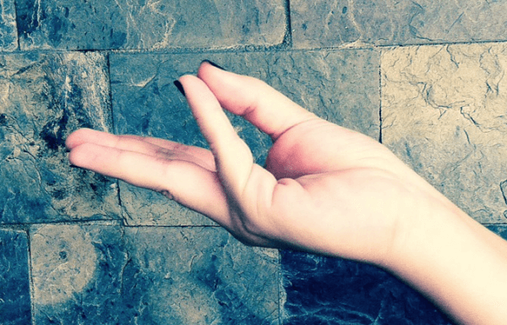
Water is the biggest element of the human body and that is what this mudra works on. It prevents all diseases which come due to the lack of water or any kind of dryness.
To perform this mudra sit in an easy pose or simply lie down and slightly touch the tip of the thumb with the little finger. The rest of the fingers can be left freely without any stress.
This mudra when performed anytime during the day helps balance the elements related to the tongue and taste. It eliminates skin diseases, increases blood flow, and reduces muscle aches.

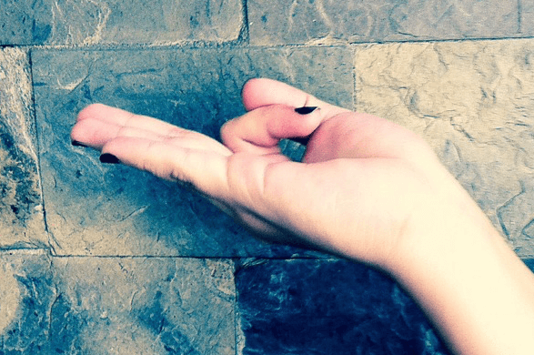
Vayu Mudra: The gesture of air
This mudra relates to the air element. It is great for the Vata body types and reduces any constrictions in the body due to excess air in the body.
To perform this mudra just fold the index finger, and press the second phalanx bone with the tip of the thumb, and the tip of the index finger should touch the base of the thumb.
When practiced regularly this mudra helps eliminate excess gas/air related problems like gout, flatulence, constipation. It helps in diseases like arthritis, neck pain, trembling in Parkinson’s disease, paralysis and cervical spondilytis.
The above give us an idea of how we have use our hands to control the 5 key elements of our body namely air, water, earth, fire and space. Try these during your practice (where it feels comfortable and easeful to do so), and in mediations, and see the benefit.
https://www.azulfit.com/hand-mudras-power-and-meaning/

