Somebody asked me when have I felt God the most so I am sharing this story..This all happened after I went into a time of fasting and prayer asking God to move me forward. It felt like a curse had been on me my whole life and I didn't understand it..not knowing it was because I am Chosen. I didn't want that for my children, but it looked like my life was heading that way, so I cried out to God...and he responded🙏🤲🙌
The Beginning......​

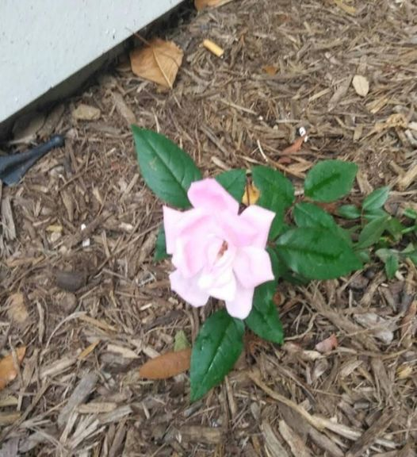
When God saw that I was serious about moving forward in my journey and that HE could trust me, HE started to lead me towards things that would heal me and my children. One of the first things God led me to was Ruqyah Water or Spiritual Cleansing Water. I learned how to make the water, and I would make it everyday. Let me tell you, drinking and bathing in this water changed our lives. It opened up so many doors that had been closed to us for so long. Not only did my life change, my finances increased, relationships got stronger, health improved drastically. It was like a veil was lifted from my eyes and I started to see everything clearly, even my enemies. And guess what the enemies that were most dangerous to me, were the closest to me...my family😱. I mean it was a miracle!! it was like the earth shifted. Just to show you how powerful this water is, I have to share a small part of the story. So, after me and my children would bathe in the water, we would take the remaining water and pour it into the dirt area close to my apartment. We did this because we didn't want the holy water pouring down the drain. Let me tell you, we were in the dead of winter at that time, and no flowers were in sight. But all of a sudden a beautiful flower ( actual picture below) appeared out of nowhere. Well guess what, my daughter finally revealed that when she would pour the water out, it would be in that very place everyday. We were all shocked by her confession! I quickly called my son and his wife over to see it and nobody could believe it. But, after that moment, everybody became believers. This led to the spiritual journey and healing not only for my children, but also my grandchildren. God showing us the power of prayer and the cleansing water set the stage for my family to move forward on our journey towards breaking generational curses and cleansing our bloodlines. It made my kids believe in the power of the Most High God like never before. All of my children now, are prayer warriors, and know that prayer and the power of Gods words can move mountains. They can even make the water all by themselves, imagine that!! There is nothing like Glad Tidings (Good News) reminding you that the Lord is with you and working on your behalf for you to be victorious on this earth. And, from this day, I knew I wanted to spread Glad Tidings to Gods believers no matter who they are and where they are, letting them know that God is with them, even when he seems silent, he is there.
https://shopgladtidings.com/prayer-request

