Trinity Times

Volume 10, Issue 7/8
July & August 2022

The Flavor of the Gospel
“You are the salt of the earth. But what good is salt if it has lost its flavor?” (Matthew 5:13, NLT). These words from Jesus might seem strange to us — can salt lose its flavor? But in New Testament times, most of the salt used as seasoning, preservative, medicinal aid and more came from the Dead Sea, where impurities often compromised its usefulness, especially its flavor. Jesus urges his disciples — including us — to not let the flavor of the gospel be suppressed in our lives.
What might do this? Teachings that treat patriotism, prosperity or any other value as equal to Jesus; the tendency to elevate one nation, church denomination, theological understanding or religious tradition above all others; such intense focus on the laws of ancient Israel that we neglect the superseding grace of God. But neither should we force the gospel on people, like overpowering their food by dumping in too much salt at once.

As followers of Jesus, we’re the salt of the earth. Let us use his good news to gently season others’ lives with service and love.
Reprinted from the “Newsletter Newsletter” July 2022 publication
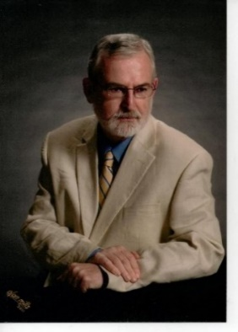
In Christ
Pastor doug.
.

Pastor Doug Benton

Trinity United Methodist Church
1160 Trinity Church Road
Newberry, SC 29108
803-276-1245 Office
www.trinityumcnewberry.net

Pastor Douglas Benton
803-543-0082 Pastor Cell
dobenton@umcsc.org

www.trinityumcnewberry.net
PLEASE VISIT OUR WEBSITE
AS OFTEN AS YOU CAN!

Peggy Bogart, Church Secretary
Head Usher: Harry Longshore
Choir Director: Needed
Organist: Eddie Welborn
Substitute Organist: Phyllis Sanders
Video Board: Josh Pitts,
Foster Senn, Bryan Waldrop
Acolytes/Cross Bearers Coordinator: Kelly Morris
Newsletter Editor: Harriet Stevenson

We are a caring church and want to share your concerns. Let us know if you or someone you know would like to share a prayer request with us. We will be happy to pray for you. Contact Peggy Bogart, Church Secretary, or Harriet Stevenson, Communications Chairperson, to add or remove names from the Church Prayer List.
Nursing Home: Rebecca Bundrick (White Oak)
Trinity Member Prayers: Shirley Berry, Boyd Hendrix, Robert Pollard, Jeannette Poag, Pastor Doug and Carrie, Faye Senn, Linda Rowe
Family and Friends of Trinity: Woody and Connie Kreuzinger (Carrie’s parents), Family of Sara Longshore(New Chapel), Freddie Bundrick, Doris Mohler, Rev. William Hightower, Jacob Welborn, Harriet Connelly
NACOM –
WHAT IS THAT?

For decades 13 churches in Newberry worked together to support local ministries and spread the Good News of God's grace in our community. This group is NACOM (Newberry Area Council on Ministries) and their mission is: "Bringing Newberry Area Methodists Together for Christ.”

Unfortunately, gathering together during the past two years has been all but impossible, and NACOM was no exception. Participation in the last meeting was so poor that NACOM's future looked bleak. Yet, hope springs eternal, and our community needs us now more than ever. Violence is on the rise. We have no homeless shelter in the area, and the recently formed O’Neal Street food pantry is facing huge demand. If we don't respond to our neighbors’ woes, who will?

So, let's take up our mats and walk together to the NACOM RALLY on Sunday evening, July 17, at 6:00 p.m. at The O'Neal Street UMC (501 O'Neal Street). We'll sing some hymns as in the past, say some prayers, have some fun, enjoy finger foods, and talk with one another about how we can make a difference together. This event is open to all United Methodists, clergy and laity alike.

Then on Thursday, August 25, at 7:00
p.m. at Central United Methodist Church
(1005 College Street), we will have another NACOM meeting and welcome every one back. So mark your calendars. Let’s work together to make NACOM once again a vital ministry in the Newberry area.

4 – C. J. Griffen
4 – James Marion Pitts 1 – Linda Lominack
7 – Denise Pitts 1 – Tony Pitts
8 – Taylor Bouknight 2 – Linda Rowe
9 – Dale Longshore 4 – Harry Longshore
12 – Austin Pollard 7 – Johnnie Pitts
14 – Hagen Waldrop 11 – Kelly Morris
14 – Matthew Pollard 16 – Mary Forrest
18 – William Johnson 16 – Ralph Waldrop II
29 – Alice Longshore 20 – Sharon Senn
30 – Beverly Pitts 24 – Shelbie Johnson

GOD’S ABUNDANCE FOR ALL PEOPLE
Located at O’Neal St. UMC

GAAP is a food pantry/clothes closet ministry
for people in need in the Newberry area. This ministry is now a partnering agency with
Harvest Hope Food Bank. Volunteers operate GAAP by serving folks who come to the
food pantry and also by delivering food to
those not able to travel. Stop by any Saturday
between 10 a.m. and 1 p.m. to drop off your
contributions, to just visit or to volunteer to
help. Trinity member, Sharon Baughman,
is a GAAP volunteer and is now collecting much needed donations during the month of July.

Monetary donations are also welcomed.
Donations can be used to purchase food items from the Harvest Hope Food Bank at a discount when supplies run low.

The Greenwood District has also made a SUMMER FOOD DRIVE as their Summer Mission Project so this will also count as our church’s mission project for the District. The District has asked that we keep a tally of the amount of food collected and report back to them by July 20 with the amount and where it went. Let’s do our part to help our neighbors in need.

Any and all donations will be greatly appreciated. Some suggestions are:

- Canned fruit, vegetables, meat or soup
- Peanut butter
- Cereals
- Bottled juices
- Shelf-stable milk
- Paper product

Personal items also needed are:
- Feminine products
- Diapers
- Soap and shampoo
- Lotion
- Toothpaste/toothbrushes
- Laundry detergent

Potluck Luncheon– July31
Anniversary Luncheon
After 11:00 a.m. service

Bring Your Favorite Side Dish
Or Dessert
Church will furnish the Meat
Sign-up sheet in Narthex of church

This will be our 5th Sunday Event.
Help us Celebrate Pastor Doug
and Carrie’s 1 Year Anniversary
with our Trinity Church family.
Food – Games - Prizes

August 7 – Back to School
Pizza/Ice Cream Social
5:30 – 7:30 p.m.

This Photo by Unknown Author is licensed under CC BY
This Photo by Unknown Author is licensed under CC BY-SA

Pizza and Ice Cream
Ice Cream Toppings Bar
School Giveaways to all Children
in Attendance!
Sign Up by July 31
We need ice cream makers!

Sponsored by Trinity UMC

JULY EVENTS
July 1 – Men/women needed to cut up meat
July 2 – Boston Butt and Turkey Hash Fundraiser – Pick up 8:00 a.m. - Noon
July 10 – MYF Meeting at church 5:00 – 6:30 p.m.
July 17 – NACOM Rally -O’Neal St. UMC – 6 p.m.
July 30 – MYF outing to Carowinds – leave church at 9:00 a.m.
July 31 – 5th Sunday – Covered Dish Potluck Luncheon and 1-Year Church Anniversary Celebration for Pastor Doug and Carrie

AUGUST EVENTS
Aug. 1 – Trinity Women’s Club Meeting – 5:00 p.m. – Fellowship Hall
Aug. 3 - Trinity Men’s Club Meeting – 7 :30 p.m.
Aug.7– Back to School Pizza/Ice Cream Social
Aug. 8 – Administrative Council – 6:30 p.m. – Fellowship Hall
Aug.10 – Silver and Gold Picnic – Lake Home of Jim and Dixie Waldrop- Lake Greenwood- 11:30 a.m.
Aug.14 – Back to School Blessing during 11:00 a.m. service
Aug.14 – MYF Meeting at church from 5:00 – 6:30 p.m.
Aug. 25 – NACOM meeting – Central UMC – 7 p.m
Aug. 26 – Shealy’s BBQ plates for sale.
Aug. 28 – MYF Spaghetti Fundraiser after 11:00 a.m. church service

NOTE: No meeting of Trinity Women’s Club, Silver and Gold or Administrative Council in July.

It’s time for Trinity to get back to music
each Sunday. We do not have a choir
director but we have some wonderful
singers who can certainly bring the joy
of music and fill our hearts with happiness.
We would like to try to get the choir together
on July 31. Phyllis Sanders will be playing and
we will be honoring Pastor Doug and
Carrie for their 1-year church anniversary.
Getting the choir together will be
a wonderful tribute to them. Please let
Phyllis know if you will be able to sing
in the choir on that Sunday. You will be
notified of a practice date. It may be that
we start off with 5th Sundays and go forward
from there. We look forward to hearing
The Voices of Trinity once again!
***********************************
Special thanks to Pastor Devon Ruth and
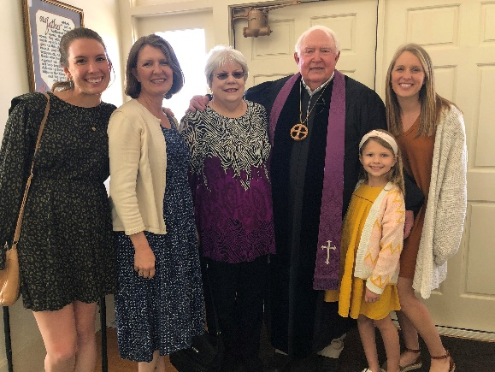
Pastor Vicki Hydrick for filling in for Pastor Doug
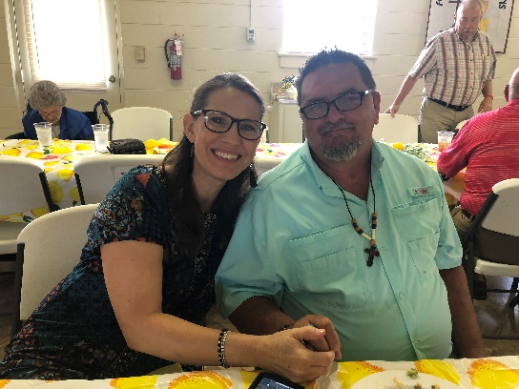
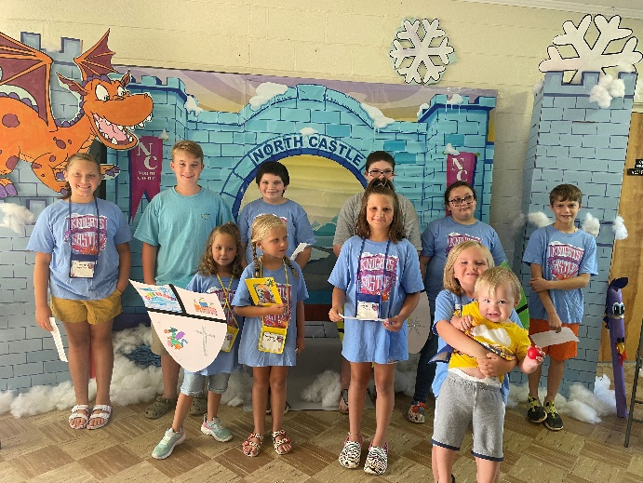
Very Front: Annabelle and Jake:2nd Row: Autumn Senn, Savannah Kesler, Riley Senn; Back Row:
Summer Kesler, Kruz Bouknight, CJ Griffen, Mackenzie Kneece, Paisleigh Eargle, and Wyatt Pitts.

Thanks to Lynn Mohler and Holly Hendrix Myers for doing such a great job of leading VBS this year. Ten + kids showed up each night and learned about Jesus and how to Be Strong in the Lord and in the Strength of his Power! Thanks to all the volunteers and those who provided food each night: Trinity Women’s Club, Senn Freight Lines, Wilson Tractor and Trinity Men’s Club. The program on Wednesday night was said to be
the best VBS program ever! 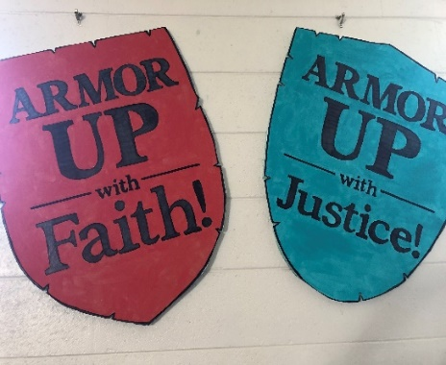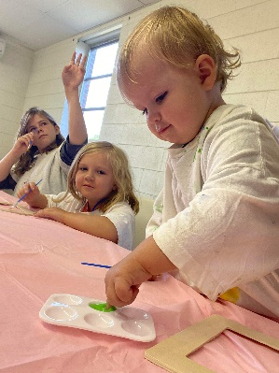

We had a hard working group show up for our Church Clean Up Day in May and we accomplished a lot!

Downstairs, we cleaned the Supply Room, the Flower Closet, the hallway closets, as well as cleaned up the kitchen and Playroom. Upstairs, we cleaned up the Acolyte Room.

Thank you so much to Betsy Black, Bridget and Taylor Bouknight, Clarissa Hendrix, Joan Morris, Beverly Pitts, Jane Pollard,
Harriet Stevenson and Dixie Waldrop. Special thanks to Jim and Dixie for purchasing the new carpet outside the Fellowship Hall door, the new rug inside the Fellowship Hall door, and the containers which were used in organizing the Supply Room.

Since that time, Lynn Mohler and Holly Myers have cleaned out the Vacation Bible School Room and it looks wonderful. They said that there were so many things in the VBS room that did not belong. Let’s try to keep all items in the correct place and in the proper rooms!

Also, Frances and Wade Pitts took down the old blinds throughout the church in preparation for our new windows.

We reached our goal of purchasing 33 new faux wood blinds to cover the new windows once they are installed. Thank you to all who contributed.

MYF SUMMER NEWS
MYF Leaders - Josh and Erin Pitts

The MYF will have meetings at the church on July 10th and August 14th from 5:00 – 6:30 p.m. The MYF will also have an outing to Carowinds on Saturday, July 30. Plan to the leave the church at 9:00 a.m. On August 28th, the MYF will hold their annual Spaghetti Fundraiser after the 11:00 a.m.
church service. Hope to see you in church and enjoy the rest of your summer!

Silver and Gold Kentucky Derby Luncheon
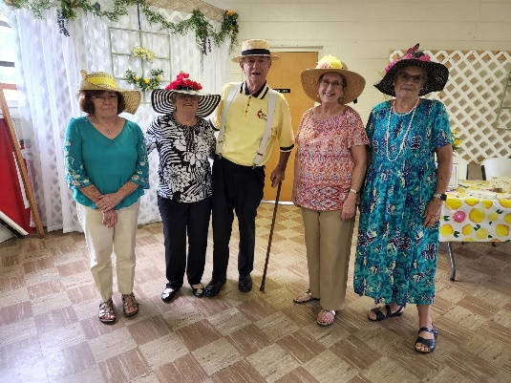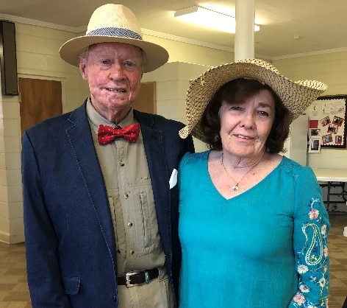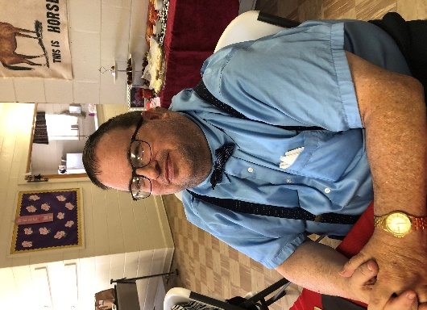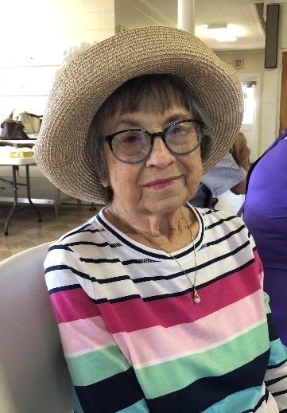

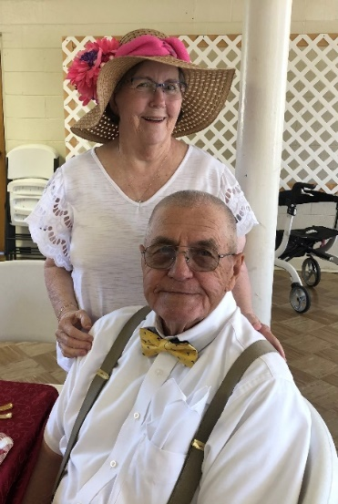

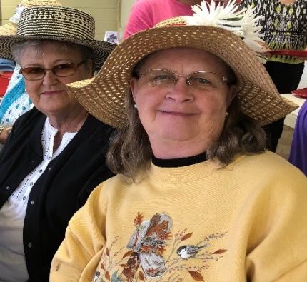
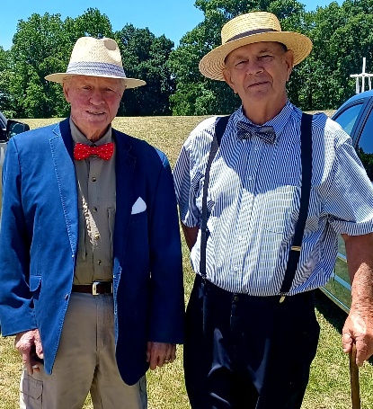
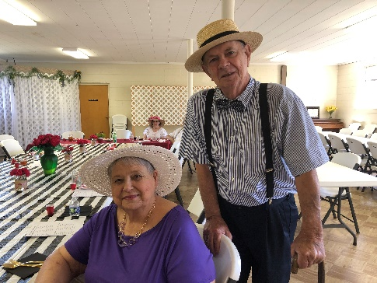

Authentic Kentucky Derby food was served including Derby Pie and other Derby favorites.

Nest Event: Picnic at the Lake Home of Jim and Dixie Waldrop on Wednesday, Aug. 10,
at 11:30 a.m.

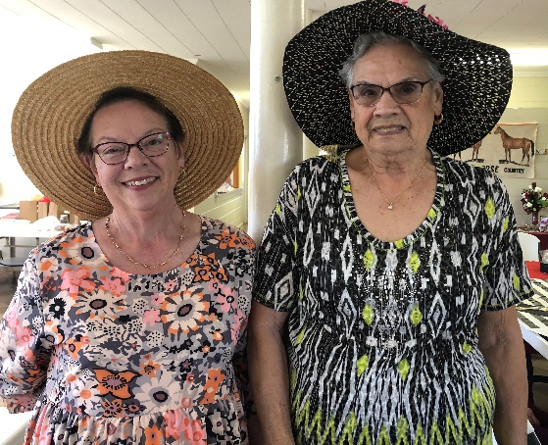

Everyone wore hats. Many made their own. The men wore bow ties compliments of Wilson Senn.

5th Sunday Luncheon in May

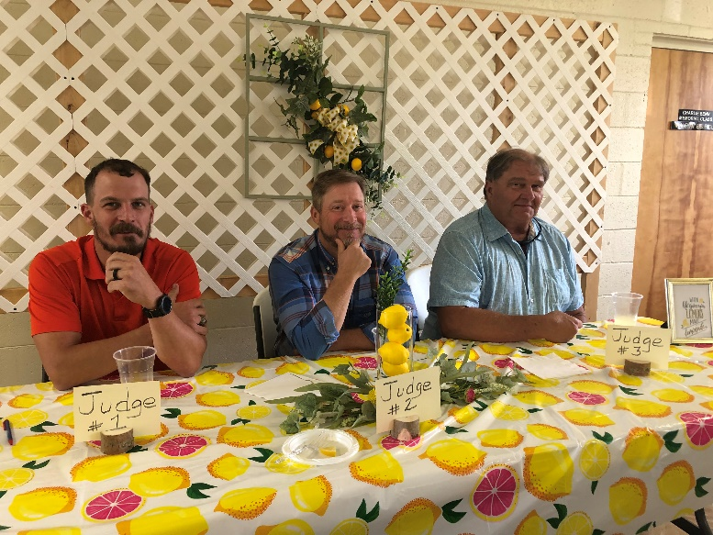
Dessert Contest Judges – Josh, Michael and Craig

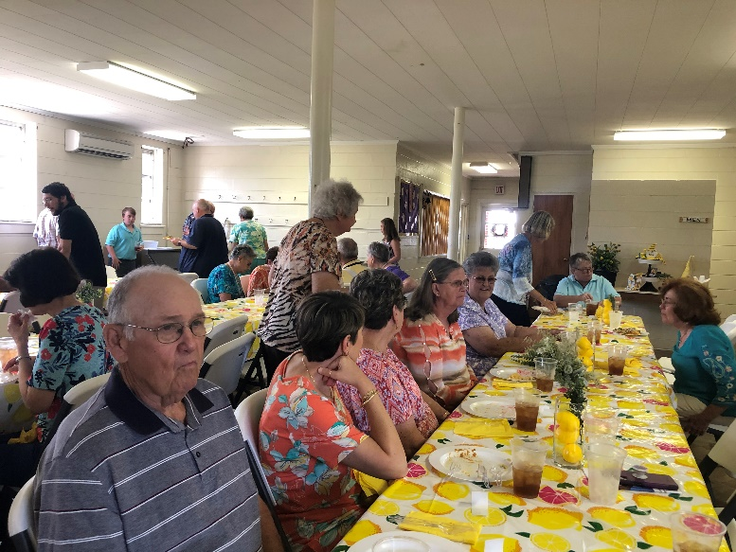
Great turn out for the luncheon

Thanks to Frieda Kesler and her helpers for
planning the 5th Sunday festivities. The decorations and food were wonderful. Next 5th Sunday event is July 31.

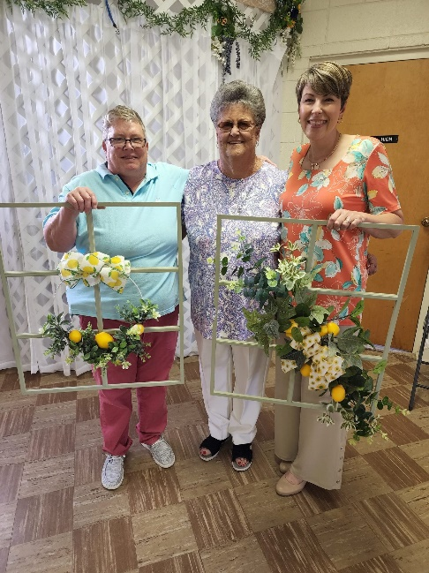
Winners of Dessert Contest
1st Place – Jane Pollard
T 2nd – Glynda Meadows and
Kelly Rogers

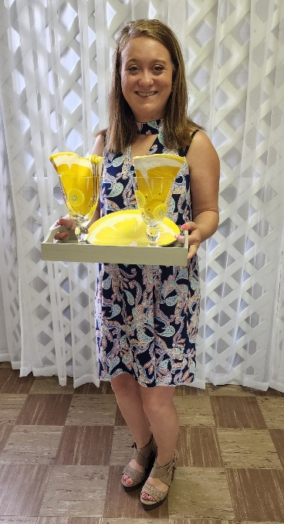
Taylor won the Door Prize

2022 Trinity High School Graduates
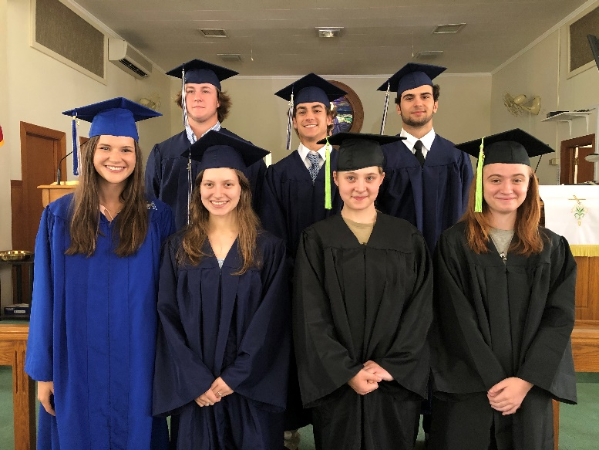
Caroline Senn, Laura Mohler, The Spicer girls, Emily and Laura.
Coye Cutshall, Noah Waldrop, Chesley Brehmer.

We are very proud of our graduates and wish them much future success. The graduates were recognized during the service on May 15th. Thank you to Kelly Morris for planning this recognition.

Graduate Proud Parents

Caroline Senn Foster and Sharon Senn
Laura Mohler Burt and Lynn Mohler
Emily and Laura Spicer Ray and Melissa Spicer
Coye Cutshall Mark and Ashley Cutshall
Noah Waldrop Bryan and Crystal Waldrop
Chesley Brehmer Steve and Beverly Brehmer

Trinity United Methodist Church
1160 Trinity Church Road
Newberry, SC 29108

