## IMG_2193.JPG

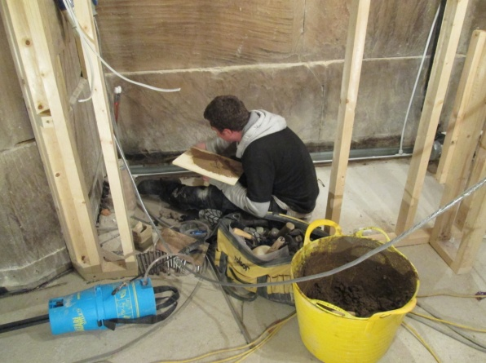Meanwhile inside and the cubicles for the toilets are taking shape and the walls finished off. It is all starting to look very impressive and with a little  
 imagination you can almost see  
 five-star facilities, but for awhile  
 longer it’s the outside loo!

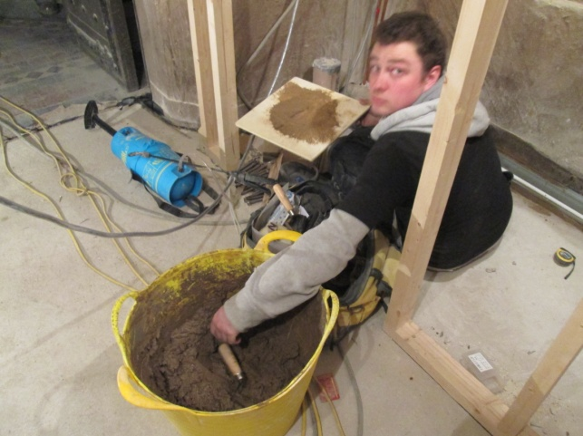

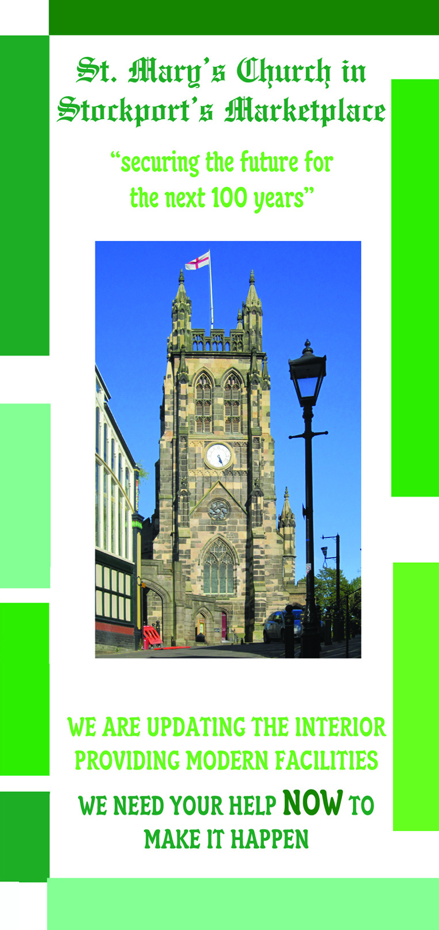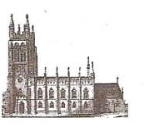 St Mary’s in the Marketplace.



Issue No 19 (25th November 2012)

**“Securing the future for the next 100 years”**

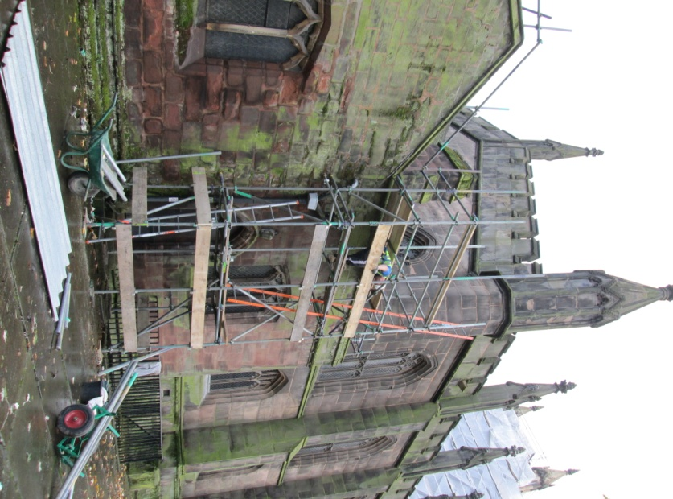More scaffolding can be seen  
climbing up St Mary’s – this  
time preparing the site for  
temporary roof repairs.

The vestry areas below will be  
allowed to dry-out before any  
further work takes place and   
further funding will be needed  
before permanent repairs can   
be undertaken to fully restore   
this area of the building. We   
hope to have funding in place  
as soon as possible in 2013/14.

There is however still plenty of activity on Phase 5 and Roger has been up on the tower roof once again to look at developments as well as to take photographs for those of us required to remain at ground level.

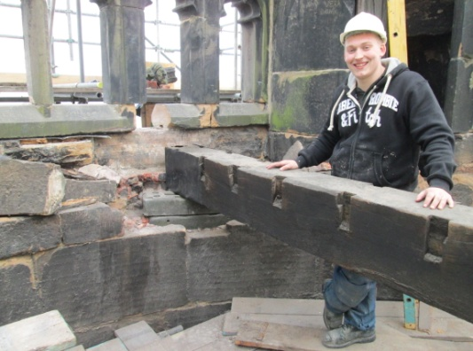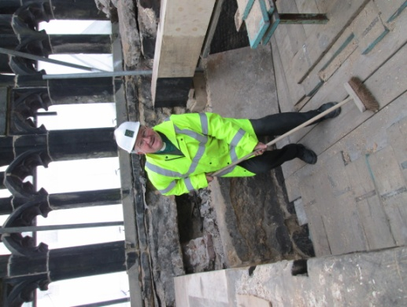

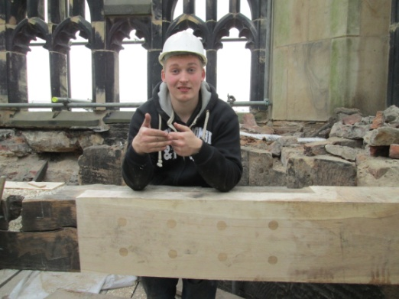

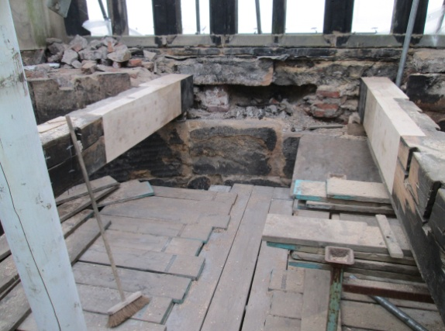

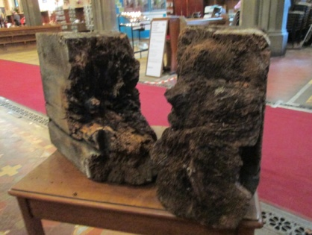

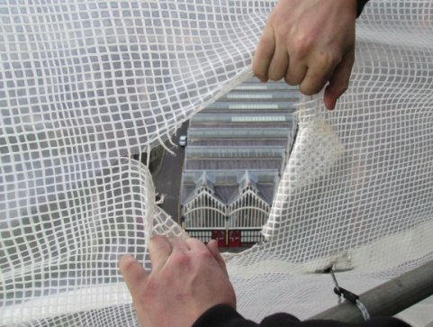Repairs on the roof timbers  
continue with samples of  
the rotten ends presently  
available to view.

Someone appears to be   
 taking a peek at the out-  
 side world. A reminder  
 as to the height they are  
 working!

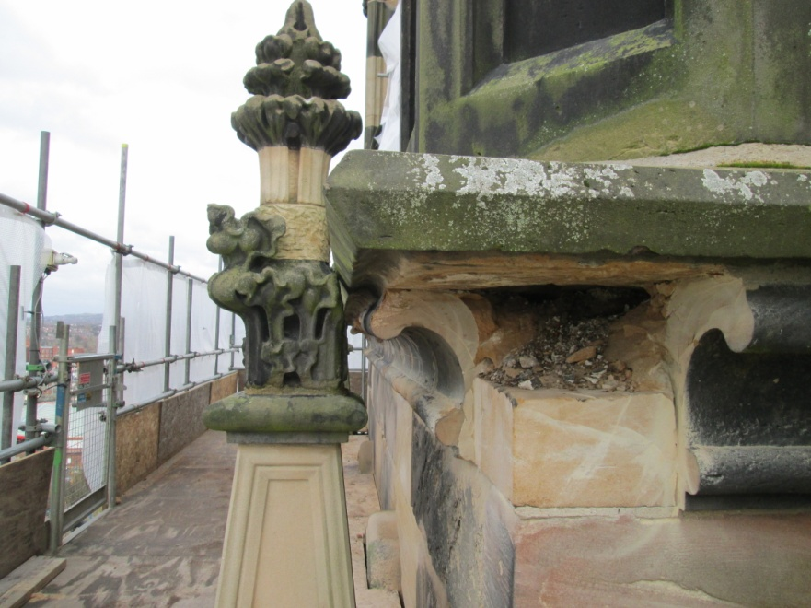

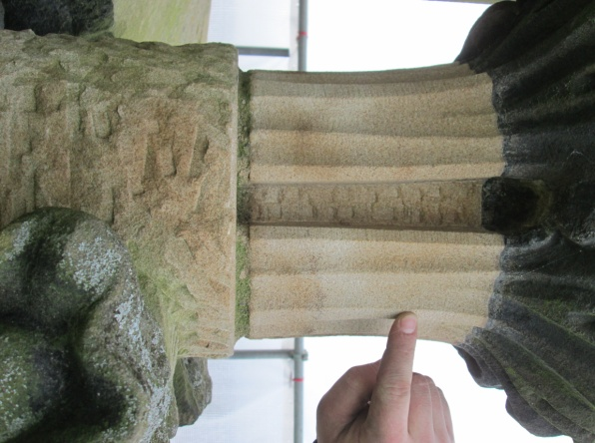

You can’t help than be impressed with  
the skill of our stonemasons, restoring  
and replacing stonework with such detail as shown here.

