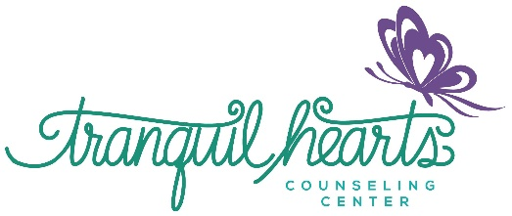
Assumption of Risk and Waiver of Liability
Relating to Coronavirus/COVID-19

The novel coronavirus, COVID-19, has been declared a worldwide pandemic by the World Health Organization. COVID-19 is extremely contagious and is believed to spread mainly from person-to-person contact. As a result, federal, state, and local governments and federal and state health agencies recommend social distancing and in many locations have prohibited the congregation of groups of people.

Tranquil Hearts Counseling Center therapists have put in place preventative measures to reduce the spread of COVID-19; however, Tranquil Hearts Counseling Center therapists cannot guarantee that you or your child(ren) will not become infected with COVID-19. Further, attending in-person appointments with a Tranquil Hearts Counseling Center therapist could increase your risk and your child(ren)’s risk of contracting COVID-19.

By signing this agreement, I acknowledge the contagious nature of COVID-19 and voluntarily assume the risk that myself and/or my child(ren) may be exposed to or infected by COVID-19 by attending in-person appointments Tranquil Hearts Counseling Center therapists and that such exposure or infection may result in personal injury, illness, permanent disability, and death. I understand that the risk of becoming exposed to or infected by COVID-19 at Tranquil Hearts Counseling Center may result from the actions, omissions, or negligence of myself and others, including, but not limited Tranquil Hearts Counseling Center therapists, their employees, volunteers, and other participants and their families. I voluntarily agree to assume all of the foregoing risks and accept sole responsibility for any injury to myself and/or my child(ren), including, but not limited to, personal injury, disability, and death, illness, damage, loss, claim, liability, or expense, of any kind, that I or my child(ren) may experience or incur in connection with my attendance or my child(ren)’s attendance at in-person appointments with Tranquil Hearts Counseling Center therapists. On my behalf and/or on behalf of my child(ren), I hereby release, covenant not to sue, discharge, and hold harmless Tranquil Hearts Counseling Center therapists, its employees, agents, and representatives of and from the claims, including all liabilities, claims, actions, damages, costs or expenses of any kind arising out of or relating thereto. I understand and agree that this release includes any claims based on the actions, omissions, or negligence of the Tranquil Hearts Counseling Center therapists, its employees, agents, and representatives, whether a COVID-19 infection occurs before, during, or after participation in any in-person appointments with Tranquil Hearts Counseling Center therapists.

_________________________________________________ _______________________________________
Name of Client/ Signature of client/parent Date

