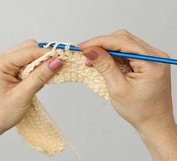 "V"** Stitch Crocheted Shawl ( lap afghan)
Size: approx 22" x 64" (32" x 48") *
Material: approx 20oz for both
"V" st-- (dc, ch, dc) all in same st
Shawl( (afghan):
CH 70st (88)
Row 1--(dc,ch1, dc) in 5th ch from hook (Vst is made), * sk next 2 ch, V-st in next ch; rep from * across to last 2 ch, sk next ch, dc in last ch-- 22 V-sts at end of this row (afghan will have 28 V-sts)
Row 2-- ch3. turn, V-st in each ch-1 sp across, dc in top of turning ch.
Repeat row 2 to desired length. Fasten off.
(directions are the same for an afghan)
Fringe
* size will depend on type of yarn used
** This pattern is adapted from Lion Brand pattern, (# 90347) found on inside of label from "Baby's First" yarn. www.LionBrand.com
(Rev 2-13-15)

