YES This Happened TODAY OMG!!!!!!!

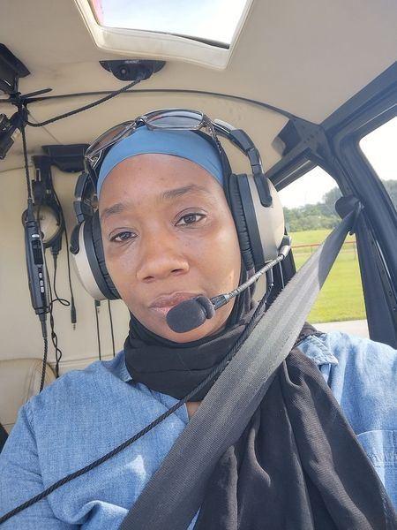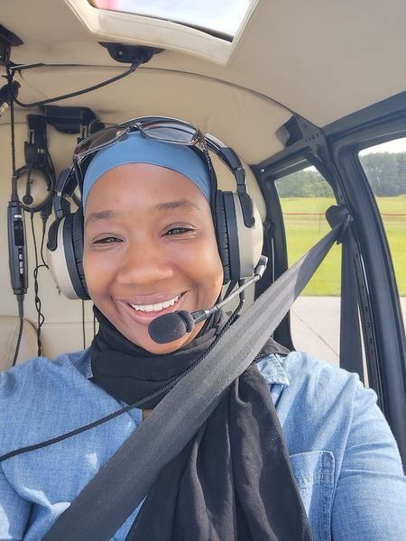
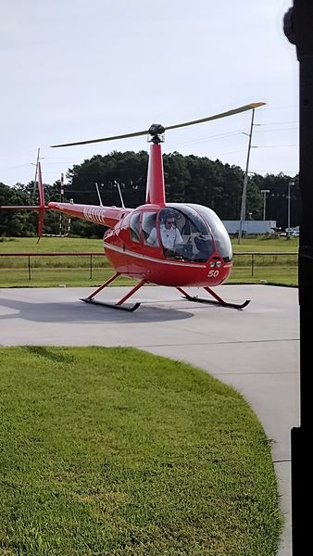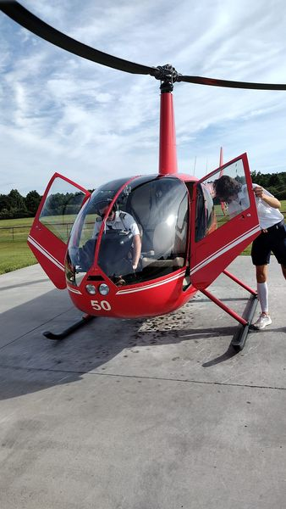

Pushing Past Your FEAR!!!!!

OMG! My first ever helicopter ride😱. My spirit has been pushing me to jump more and more out of my comfort zone, to rid myself of all my fears....so here goes!!! The ride was bumpy since the winds are high due to the hurricane. I tried to hold the phone steady, but it was hard with the way the helicopter was moving. I made it through though😁. I ain't gonna lie, I was so scared...LOL
Y'all whatever you are going through today, push past it! Freedom is on the other side, I promise. In the end God's process will make sense❤️. He is always working things for our good.
Please watch my video!!!!

