It has basically been business as normal at St Mary’s this week with Christmas well and truly behind us. Discussions continue with Lloyd, Evans, Prichard regarding all matters “architectural” and with Lambert Walker to plan the time-table for the remaining interior works within the Church – any disruption or closure arrangements to be announced when known. The carpets will be coming up shortly and repairs to the tiles made before the whole of the floors are sanded and sealed. Work is also being scheduled for the “glazing in” of the chapel – this to be undertaken as soon as the necessary materials are available
We have a big task ahead of us – to sell and remove the pews remaining in the Nave at St Mary’s (as quickly as possible to allow works to proceed) and to vacate St Marks, Edgeley, before transfer of the site to new ownership. Some are already sold (and will be labelled accordingly), others remain available for sale (we are looking for a minimum offer of £100 for the general 10ft+ pews – other prices negotiable depending on size and fittings etc.). Those purchasing pews will be required to pay at least a deposit “up-front” to secure “the deal”; to agree to move them quickly (when full payment will be required) and to arrange and pay for transportation costs. A certificate of authenticity will be issued on request. Expressions of interest from members of the congregation and/or other interested parties must be given NOW please!
Final costs are being obtained for the chairs and quotations received for the cushions for the chancel pews. It is indeed “ALL GO”! All this, our financial year end, and preparation for the Annual Parochial Church Meeting as well as preparing for “new ways of working”…
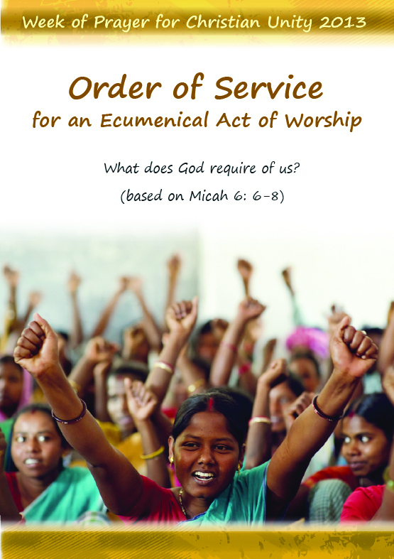
DIARY NOTE:
Please join us if you can for a special service to mark the “Week of Prayer for Christian Unity 2013” to be held at St Mary’s in the Marketplace on Tuesday 22nd January 2013 at 12.15pm
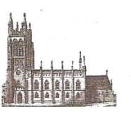
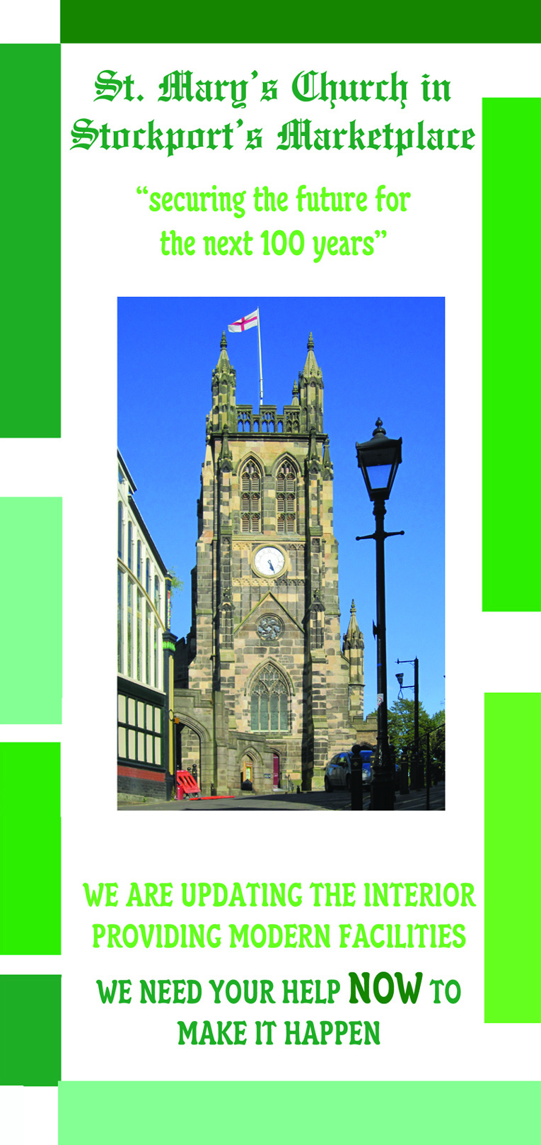
St Mary’s in the Marketplace.
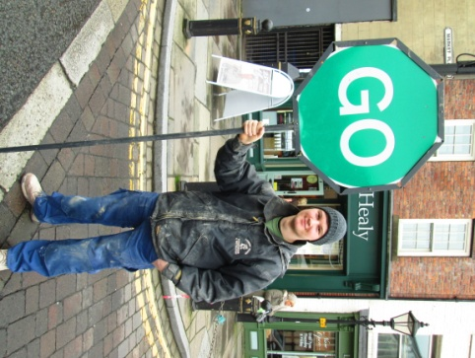

Issue No 26 (13th January 2013)
“Securing the future for the next 100 years”
It’s all go at St Mary’s with our contractors back on site this week and completion of the interior (Phase 1) and tower (Phase 5) due in only a few weeks time.
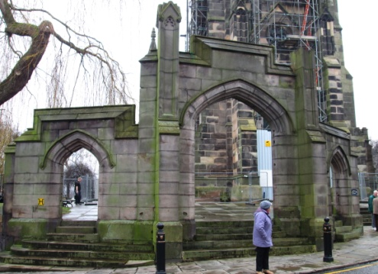
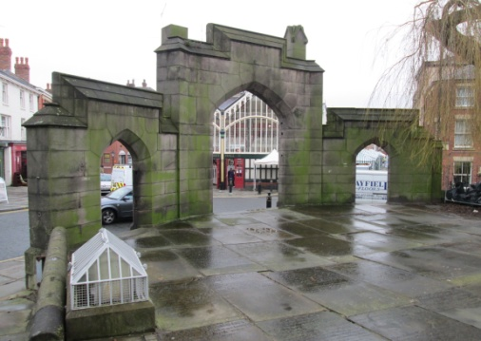
To make life more exciting work starts on Monday to prepare for the restoration of the gateway arch. It is the responsibility of Stockport Council to upkeep the churchyard and we are delighted that the funding has been found to enable them to undertake the repairs at this time. Works are being undertaken by our existing contractors and are due to be completed by the end of March.

Lots of photos this week to show you round the site – thank you Roger for walking round with your camera in hand.
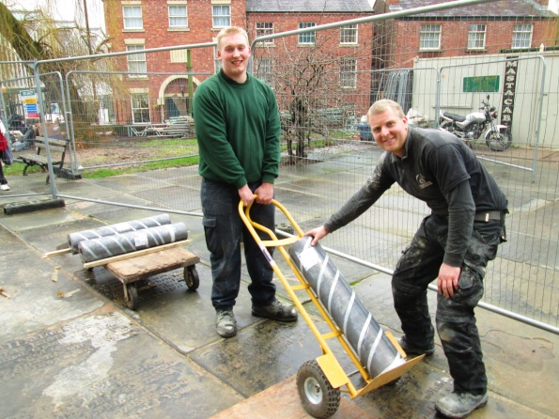
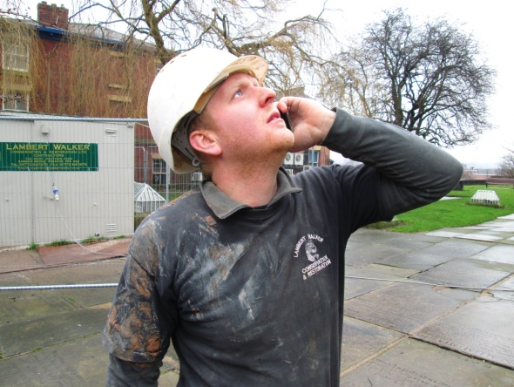
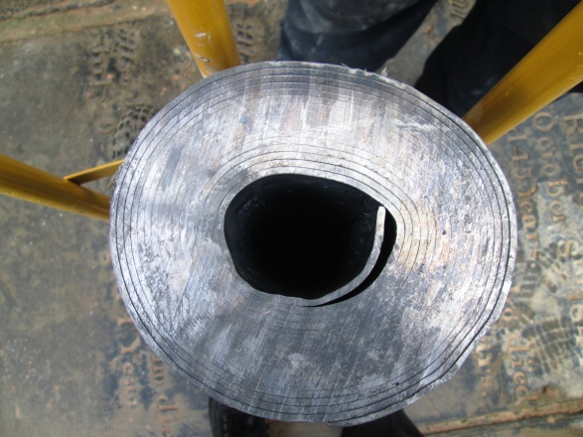
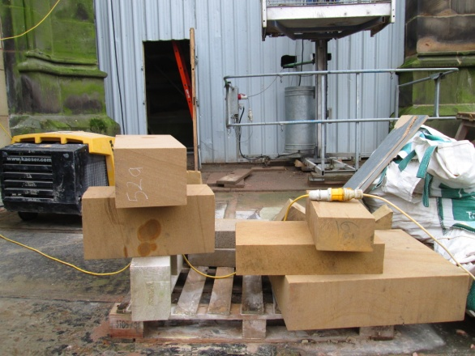
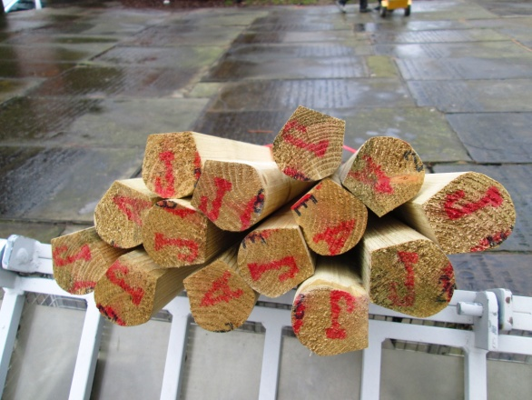
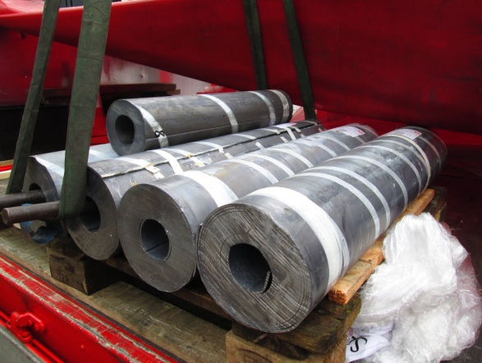
The roofing materials have been
delivered on site this week ready for completion of the tower roof – it all has to go up to the top of the tower of course - and quite a task ahead to get it all down and water-tight.

And there remains an awful lot of stone to be transported and put in place – but they will succeed and we look forward to flying the flag and ringing the bells - and of course using the new facilities inside the church!
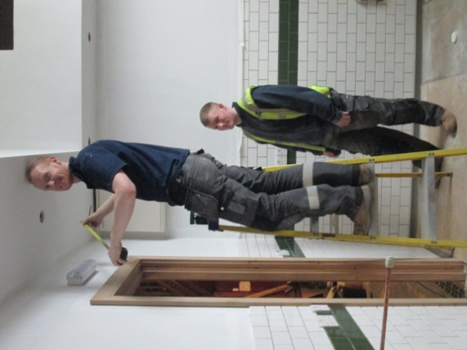
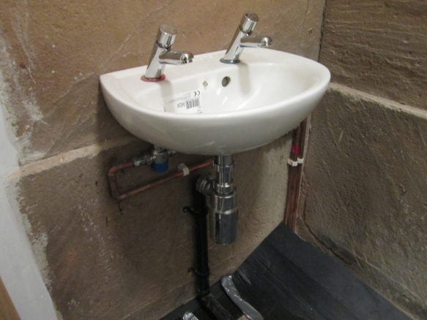
Inside and work continues to prepare the kitchen - with electricians and decorators finishing off before the fittings arrive. The toilet area is now looking the part with the first of the loos and basins being fitted and plumbed in.

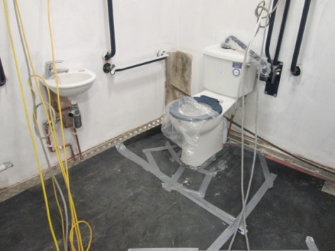

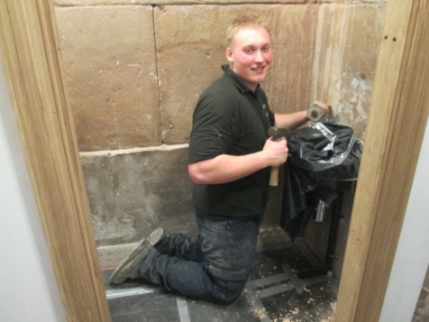
Work continues on the chair store and east end of the north aisle (towards the vestry areas).
