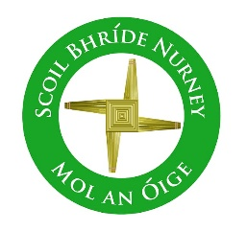
Scoil Bhríde Nurney
Home Learning
May
December Home Learning
Class / Book Name | A Way with Words | Busy at Maths | Small World
Junior Infants | Unit 13 and 14 | Pages 99 – 118 | Pages 49 – 53
Senior Infants | Unit 13 and 14 | Pages 100 – 118 | Pages 49 – 53
1st Class | Unit 13 and 14 | Pages 150 – 157 | Pages 82 – 90
2nd Class | Unit 13 and 14 | Pages 148 – 156 | Pages 78 – 85
3rd Class | Unit 13 and 14 | Units 21 and 22 | Unit 16 and 17  (History, Geography and Science)
4th Class | Unit 13 and 14 | Units 21 and 22 | Unit 16 and 17  (History, Geography and Science)
5th Class | Unit 13 and 14 | Units 21 and 22 | Unit 16 and 17  (History, Geography and Science)
6th Class | Unit 13 and 14 | Units 21 and 22 | Unit 16 and 17  (History, Geography and Science)
- All the above listed books are available free online at https://www.cjfallon.ie/
- Children can do all of the above work and write all their answers in the one same copy. Please write on the front of this copy your name and the title of “Home-Learning”
- Please write the date on all your work and a subject heading
- Any queries on this work can be sent to your child’s class teacher at sbnurney@gmail.com
- When your child returns to school please give this copy to your class teacher for review
- This work is in line with the work being carried out in class

