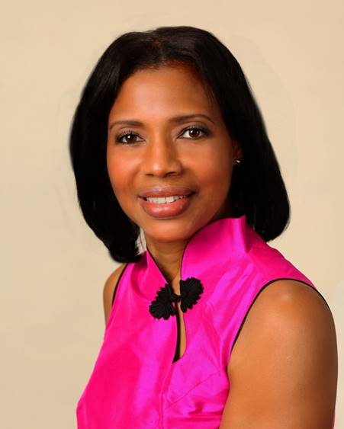
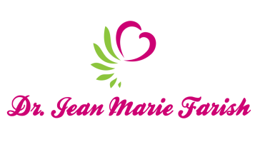

LOVE LIGHT NewsLetter
Living in the Spirit of Love
I am excited to host my VoiceAmerica Empowerment Show-LOVE LIGHT with amazing Guests to cultivate a lifestyle of love and wholehearted connections through worthiness. My show is aligned with my mission to live an altruistic and heart centered life.

MEET OUR LOVE LIGHT GUESTS for January 2020 Shows

Viki Winterton “Authentic Self-Expression and Expert Insights”
Founder of Expert Insights Family of Opportunity and Home of Bestselling Award-Wining Books and Magazines
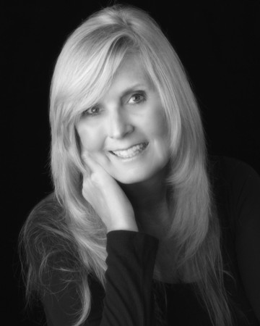
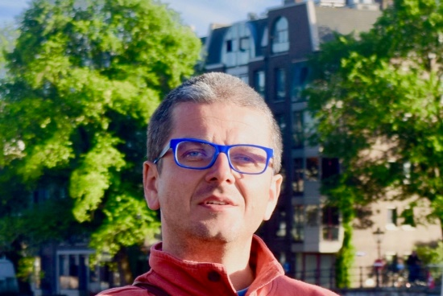
Dr. Igor Iwanek “Fill Your Cup with Self-Love and Self-Care”
Certified International Yoga Instructor of SoundFounder of Sound- -Mind and ThinkArtMusic

Debbie Johnson “The Angelic Love Connection
Renown Psychic/Medium with a special connection to the Angelic Realm

