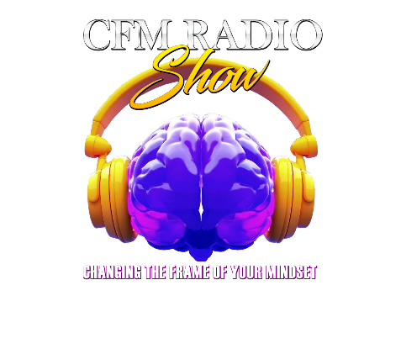
Name: ______________________________________ DOB: __________ Age: ______________
Address: _____________________________________City: ______________Zip: ____________
Phone: _______________________________________Email: ___________________________
Agency: _____________________________________Ph: ________________Email: _________
- For our Adult League 18+ older we can up 8 teams 24 players total for our 3 on 3 Adult games and up to 22 players for our 5 on 5 full court adult game. If you have more than one person or a group, please complete a registration form for everyone.
Child Name: ______________________________________ DOB: __________ Age: __________
Address: _____________________________________City: ______________Zip: ____________
Phone: _______________________________________Email: ___________________________
Agency: _____________________________________Ph: ________________Email: _________
- For our Junior League we can have up to 8 teams 24 players total for our 3 on 3 Junior games. If you have more than one child playing, please complete a registration form for each child. Please select appropriate age bracket for your child below:
7-10__________ 11-14___________ 15-17___________
- Please note Registration fees are $25 per player and non-refundable. Each player Registration includes the admission fee of $20. All family and friends must purchase a ticket to enter the Gym. All players must complete the waiver and liability forms upon submission of registration. Please download the forms and email them to cfmradioshow@gmail.com. Also, registration fee is due at the time of registration
- All registration and tickets fees may be paid via Cashapp $nbslf2020
Signature: ___________________________________________________ Date: ____________
(For Minors)
Parental Signature: ____________________________________________ Date: ____________

