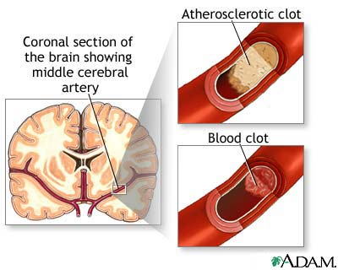

Stroke

A stroke is the rapidly developing loss of brain functions due to a disturbance in the blood vessels supplying blood to the brain. This can be due to ischemi (lack of blood supply) caused by thrombosis or embolism or due to a hemorrhage. As a result, the affected area of the brain is unable to function, leading to inability to move one or more limbs on one side of the body, inability to understand or formulate speech or inability to see one side of he vision field. In the past, stroke was referred to as cerebrovascular accident or CVA, but the term "stroke" is now preferred.
- A stroke is a medical emergency and can cause permanent neurological damage, complications and death.
- It is the leading cause of adult disability in the United States and Europe.
- It is the number two cause of death world-wide and may soon become the leading cause of death worldwide.

Causes:
- Diabetes, High blood cholesterol, High blood pressure, atrial fibrillation, being overweight, excessive alcohol consumption, physical inactivity, smoking, stress, birth control pills, HRT
- high homocysteine, deficiency of B Vitamins, lack of essential fatty acids

The usual medical response is to put an individual on blood thinners such as:
- Coumadin
- Heparin
- Warfarin
- Aspirin
All of the above medications have serious side effects.

Drug-free approach: Many people are looking for a drug-free approach, since the drugs do not address the cause.
- Vitamin E … is a highly effective anti-thrombin in the bloodstream, inhibiting coagulation of blood and preventing clots from forming. It causes dilation of blood vessels, thereby permitting a fuller flow of blood to the heart. (Use only Vitamin E with the mixed tocopherols … 8 family members as found in nature – Shaklee Vita-E is suggested).
- Garlic … thins the blood by inhibiting platelet aggregation. It MUST be a cool processed garlic where the allicin is still VERY active … Shaklee Garlic is suggested. Garlic also dilates the blood vessel walls.
- Lecithin … emulsifies atherosclerotic plaque
- Omega 3 Fatty Acids … reduce the risk of blood clot formation by preventing the platelets from sticking together. They also increase the dilation of arteries resulting in improved blood flow and also reduce atherosclerosis (the build-up of plaque in the blood vessels.)
- Ginkgo Biloba: inhibits blood clotting, and has the ability to squeeze through even the narrowest of blood vessels to increase the supply of oxygen to every living part
- CoenzymeQ10 … its actions resemble those of Vitamin E
- Vitamin C … reduces the cell’s ability to clot

