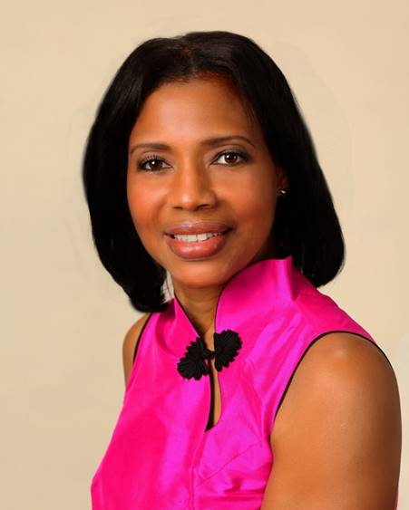
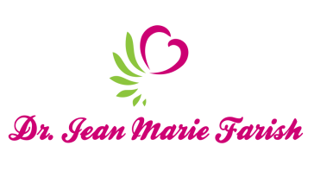

LOVE LIGHT NewsLetter

I am excited to host my VoiceAmerica Empowerment Show-LOVE LIGHT with amazing Guests to cultivate a lifestyle of love and wholehearted connections through worthiness. My show is aligned with my mission to live an altruistic and heart centered life.

MEET GUEST AUTHOR KEN SLAY

Daily Ponderances and Expressions of Love
February 7, 2020

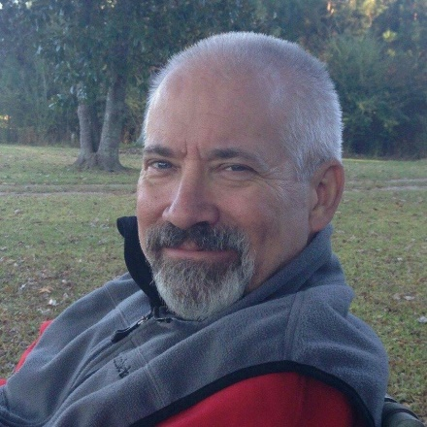

ABOUT KEN SLAY

Ken Slay is a native Mississippian who graduated from Forest Hill High School in 1976 and earned a Bachelor of Science degree from Mississippi State University in 1980. After majoring in Business Statistics and Computer Science at MSU, Ken spent the better part of four decades in a variety of roles within the computer software industry. A lifelong writer, Ken has recently published, “Daily Ponderances –Words of Wisdom, Humility, and Sage Advice in 140 Characters or Less, a collection of 365 original quotes designed to keep God at the center of all you and provide daily inspiration based on the following observation.

“Never underestimate the power of words. Weaving their way into our subconscious words can wrap themselves around our thoughts and manipulate our emotions. More than any other external stimuli, words affect our decision-making and frequently dictate our actions. When we consider the undeniable impact of mere words, both positive and negative, why would we not make every effort to feed our ravenous inner spirit with words of praise, affirmation, and beneficial advice?”

As Author of Daily Ponderances, I’m often asked which of the 365 quotes is my favorite…While the answer may vary from time to time, a list of my favorites always include those quotes that espouse personal accountability and a commitment to living a compassionate life based on truth and love for all of God’s children.

It was an honor for me to be a Guest on VoiceAmerica Empowerment Show –LOVE LIGHT hosted by Dr. Jean Marie Farish. My goal was to unpack the true meaning of a few of the Daily Ponderances while sharing personal experiences of how the book has enhanced the lives of those who have read it. I hope and pray I was successful on both accounts.

To get a copy of the book, visit Amazon or my website at www.kenslaybooks.com

Happy Pondering!

“An empowered self is a loving self, and keep your love light shining”

