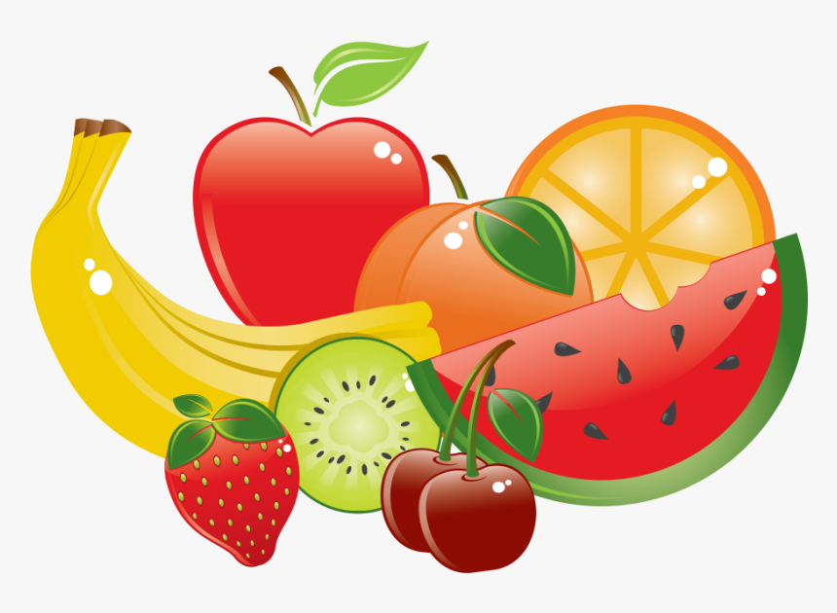

A PLACE TO GROW WEEKLY MENU
Week #1 | Monday | Tuesday | Wednesday | Thursday | Friday
Morning Snack | Whole Wheat Bagels with WOW Butter  Fruit | Plain Oatmeal  Fruit (Strawberries or Blueberries) | Celery  Raisins  WOW Butter | Cheerios  2% Milk  Bananas | Frozen Yogurt Tubes  Fruit
Lunch | Chicken Noodle Soup with Whole Wheat Noodles and Vegetables  Whole Wheat Bread and Butter | BBQ Meatballs  Brown Rice  Vegetables | Scrambled Eggs  Hash browns  Sausage  Orange Slices | Whole Wheat Pasta  Tomato Sauce with Ground Beef  Salad with Italian Dressing | Hamburgers  Whole Wheat Buns  Cheese  Salad with Ranch Dressing
Afternoon Snack | Apple Sauce  Arrowroot Cookies | Assorted Vegetables  Cheese Cubes  Ranch Dip | Bran Muffins  Fruit | Hummus  Whole Wheat Naan Bread  Carrots and Cucumbers | Canned Fruit  Rice Crackers

ALL SNACKS SERVED WITH WATER. ALL LUNCHES SERVED WITH WATER OR 2% MILK.

A PLACE TO GROW WEEKLY MENU
Week #2 | Monday | Tuesday | Wednesday | Thursday | Friday
Morning Snack | Berry Pancakes | Egg Salad  Whole Wheat English Muffins | Rice Cakes  with WOW Butter  Fruit | Smoothies | Whole Wheat Waffles  Fruit
Lunch | Cream of Broccoli Soup  Whole Wheat Grilled Cheese Sandwiches | Stir-Fry  with Whole Grain Rice and Chicken | Vegetarian Chili  Whole Wheat Garlic Bread with Cheese | Homemade Mac and Cheese with Broccoli  Coleslaw | Vegetable and Bean Quesadillas  Mexican Brown Rice
Afternoon Snack | Assorted Vegetables  Pita Chips  Hummus | Tomato Bruschetta on Whole Wheat Bread  Feta Cheese | Jello  Graham Crackers  Fruit | Banana Bread  Fruit | Guacamole or Salsa  Baked Tortilla Chips

ALL SNACKS SERVED WITH WATER. ALL LUNCHES SERVED WITH WATER OR 2% MILK.
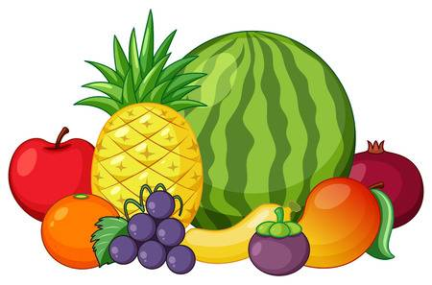

A PLACE TO GROW WEEKLY MENU
Week #3 | Monday | Tuesday | Wednesday | Thursday | Friday
Morning Snack | Blueberry Muffins  and Blueberries | Yogurt  Fruit | Hard Boiled Eggs  Whole Wheat English Muffins | Cheerios  2% Milk  Bananas | Dried Fruit (Raisins, Cranberries, Apricots)  Ritz Crackers
Lunch | Tuna Melts on Whole Wheat Naan Bread with Cheese and  Low Fat Mayonnaise | Tacos with Ground Beef and Beans  Whole Wheat Tortillas  Lettuce, Tomatoes, Sour Cream  Salad with Italian Dressing | Salisbury Steak  Mashed Potatoes  Green Beans  Gravy | Wraps on Whole Wheat Tortillas  Turkey, Chicken, or Ham  Raw Vegetables  Cheese  Melon | Vegetable Spring Rolls  Roasted Potatoes  Salad with Ranch Dressing
Afternoon Snack | Rice Pudding  Fruit | Oatmeal Cookies  Oranges | Cubed Pineapple or Watermelon  Graham Crackers | Air Popped Popcorn  Apples | Assorted Vegetables  Cheese Cubes  Ranch Dip

ALL SNACKS SERVED WITH WATER. ALL LUNCHES SERVED WITH WATER OR 2% MILK.
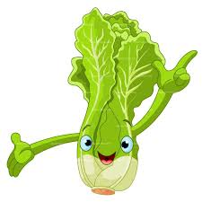
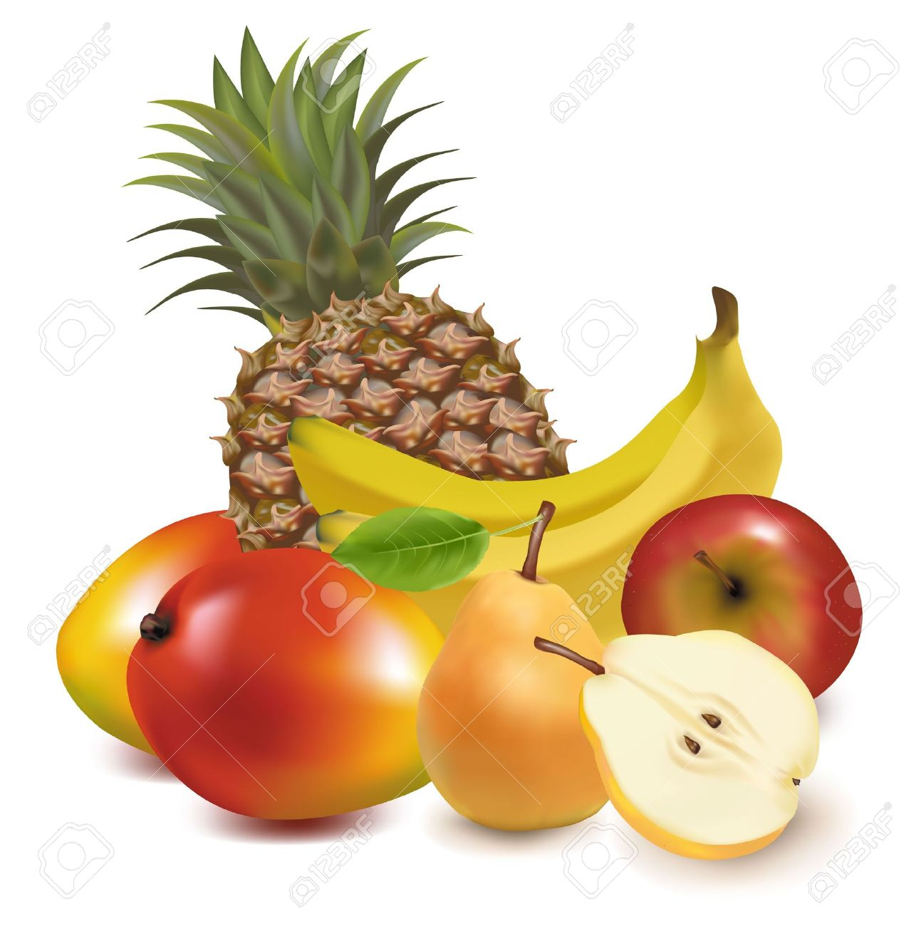

A PLACE TO GROW WEEKLY MENU
Week #4 | Monday | Tuesday | Wednesday | Thursday | Friday
Morning Snack | Sliced Pears with Ricotta Cheese | Homemade Granola Bars  Fruit | Goldfish  Fruit | Mini Quiche with Spinach and Cheese | Whole Wheat French Toast Sticks  Fruit
Lunch | Tuna Noodle Casserole  Salad with Italian Dressing | Fettuccine Alfredo with Whole Wheat Noodles and Chicken  Corn | Cheddar Cheese and Potato Perogies  Ham  Salad with Italian Dressing | Roast Beef  Carrots and Celery  Mashed Potatoes  Gravy | Tomato Soup with Vegetables  Whole Wheat Garlic Bread
Afternoon Snack | Whole Wheat Cinnamon Toast  Fruit | Black Bean Brownies  Apples | Assorted Vegetables  Hummus  Pita Chips | Fig Bars  Fruit | Pickles  Cheese  Crackers

ALL SNACKS SERVED WITH WATER. ALL LUNCHES SERVED WITH WATER OR 2% MILK.

