Introduction about Thuan An center for students with disabilities (Thuan An center)
The predecessor of Thuan An center is Lai Thieu Deaf School which was founded in 1886 by Father Azemar, a French priest of the Missionaries of Paris. This school is known as the first school for teaching and caring people with hearing lost in Vietnam.
From October 1999, Thuan An center became a part of Ho Chi Minh City University of Education.
Currently, more than 300 deaf students in many provinces are studying at Thuan An center in early intervention programme; primary and secondary programme and vocational programme.
Thuan An center is also a intership workplace of the Special Education department, Ho Chi Minh City University of Education.
Thuan An center locate in Binh Duong province where is famous for tropical orchird farm and some traditional craft villages such as Lai Thieu pottery village, Tuong Binh Hiep lacquer village and Tan Uyen bamboo and rattan villages.

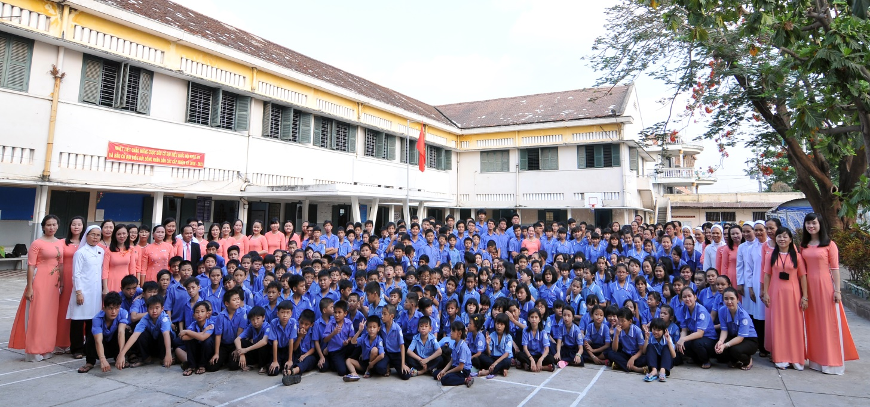

CENTER FOR SPONSORING - VOCATIONAL TRAINING AND JOB CREATION FOR PEOPLE WITH DISABILITIES
OF HO CHI MINH CITY

1/ Contact information: The center is under the Ho Chi Minh City Department of Labour, War Invalids and Social Affairs.
The Center's headquarter is located at 215 Vo Thi Sau, Ward 7, District 3, Ho Chi Minh City.
2/ Formation process:
- On August 7, 1998, the Ho Chi Minh City Center for Sponsoring - Vocational Training and Employment Introduction for disabled people was established under the decision No. 4060/QD-UB-VX of the Ho Chi Minh City People's Committee which belonged to the Ho Chi Minh City Department of Labour, War Invalids and Social Affairs
- On August 23, 2019, the Center for Sponsoring - Vocational Training and Employment Introduction of Ho Chi Minh City was established under the Ho Chi Minh City Department of Labour, War Invalids, and Social Affairs. The establishment was based on the reorganization of the City Restaurant Professional School and the Center for Sponsoring - Vocational Training and Employment Introduction for disabled people.
3/ Functions and duties:
The center organizes vocational training and career counseling for students with disabilities and street children in the city.
Organize production labor associated with vocational training to create jobs for people with disabilities. Coordinate with departments, districts, businesses, production facilities, and employment service centers in the city to introduce and create jobs for people with disabilities.
Support groups and production facilities for people with disabilities in applying for the establishment, creating financial sources, making sources of processed goods, and finding places to sell products according to Vietnamese regulations.
Provide accommodation and food support for disabled people with difficult family circumstances (certified and recommended by local authorities) during their apprenticeship at the Center.
Organize the literacy program, primary school supplement program, secondary school supplement program, and high school supplement program for people with disabilities in the city. These programs are based on the program promulgated by the Ministry of Education and Training and the professional guidance of the Department of Education and Training.
4/ Some jobs are taught:
- Consumer electronics
- Civil electricity – Industrial electricity,
- Tailors
- Cosmetic makeup
- Cut - perm female hair
- Facial skin care
- Manicure technique
