May 2023 | Pope XC 2023  Latest news and updates |  |  |  |  |  |  |  |  |  |  |  | Issue #14
Right now you need to do the following for Pope XC:  - Get a new physical and upload it to Your Student -vue account. form  - Register for the 2023 XC team  - Check www.popetfxc.com for updates. |  |  |  |  | 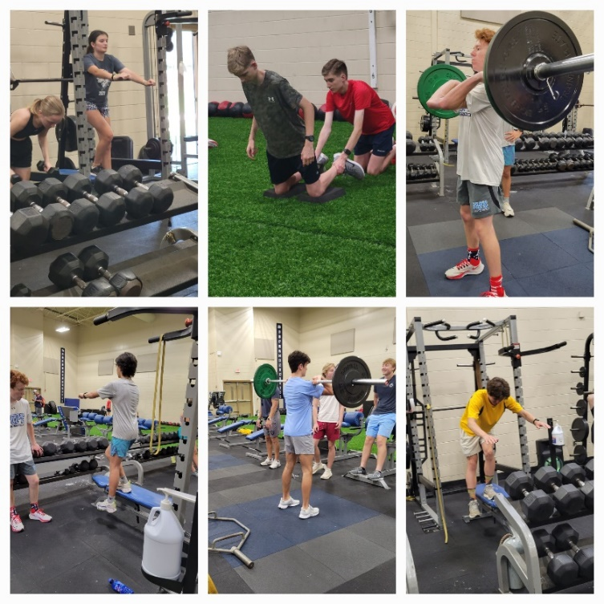  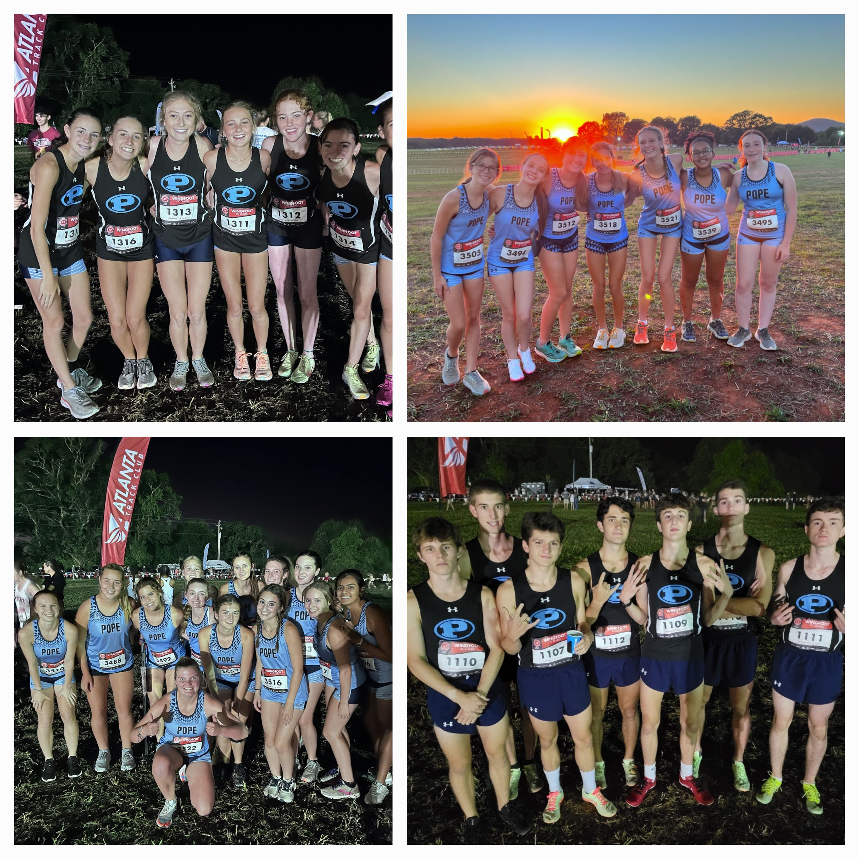
 |  |  |  |  | Athletes may be STRONGER than they appear!!!!!!
 |  |  |  |  | What do I need to know for the summer training?
 |  |  |  |  | Once you have been cleared by the athletic department you will be eligible to attend summer weight room sessions and run with the team. We will update www.popetfxc.com with the most recent list of athletes who are cleared. ONLY those athletes are eligible to attend workout sessions.  Weight room training- Pope HS is fortunate to have our Strength and Conditioning Coach, Jerad Johnson, to conduct overall fitness training in the summer. These sessions are held in the weightroom on Monday/Wednesday/Thursday’s 11-12 and start 6/5. All athletes should come dressed in workout clothes and bring a water bottle.  Summer training runs- Athletes should progress over the summer so that they can jog for at least 20-30 minutes by the time school begins. We will have several team runs during the summer that will prepare athletes for the XC racing season. Once registered you will receive a training calendar for the summer. First team run for returners is 6/12 and for new runners is 6/26. |  |  |  | 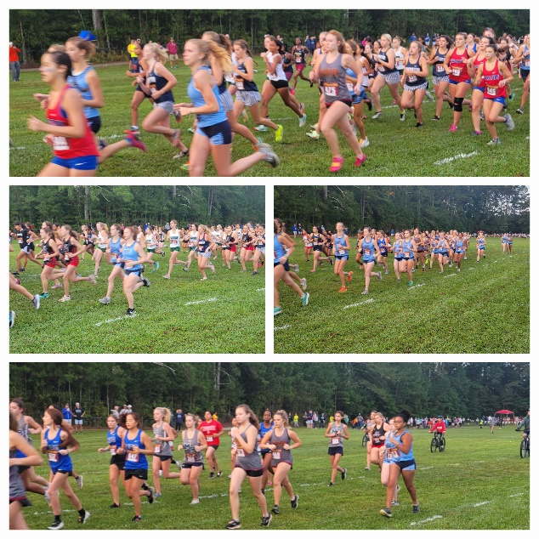  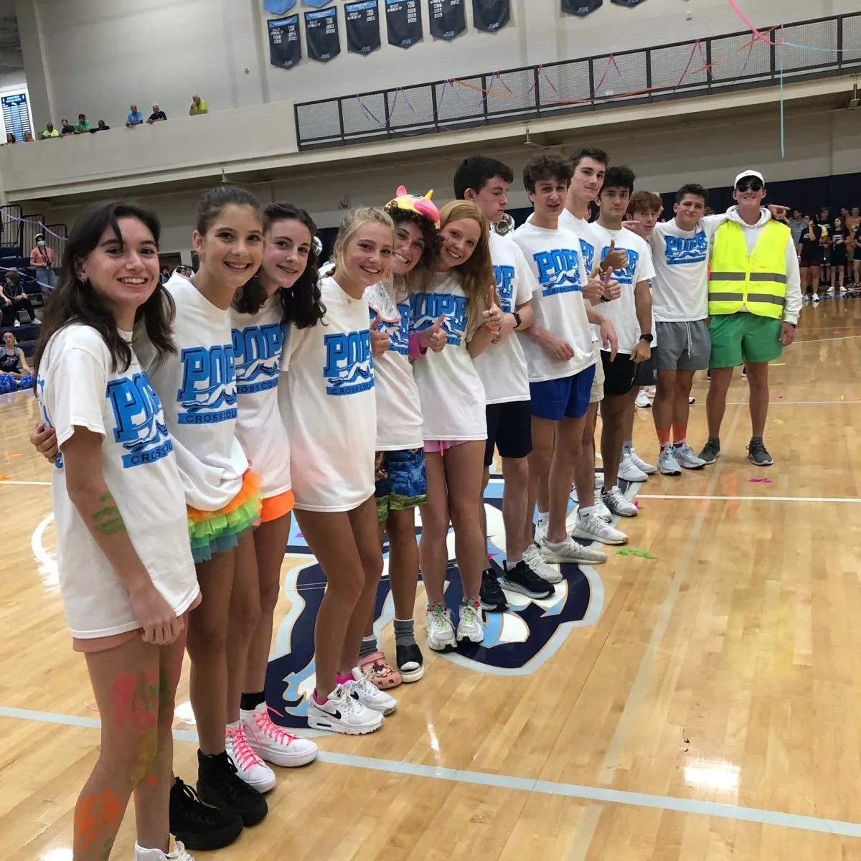
Returning athletes should plan on attending at least 10 sessions (weight room and/or training runs) over the summer OR load 15 workouts on Strava to avoid having a time qualifier at the time trial.  New runners do NOT have time qualifier to make the team but are encouraged to get in shape over the summer. |  |  |  | 2 mile run time trial standards to make the Pope XC team:  Boys Girls  Seniors 12:55 16:40  Juniors 13:30 17:00  Sophomores 14:10 17:20  New athletes of any grade will not have a time qualifier if they add to the overall PXC program. ALL athletes will run the time trial to be placed in a training group. |  |  |  |  |  |  | Join us on social media:  Instagram: Pope_ xc  Strava running app: download the app, set up an account and then search Pope high school XC in the club section.
 |  | Proposed schedule will be updated in mid July. |  |  |  |  |  |  |  |  |  | 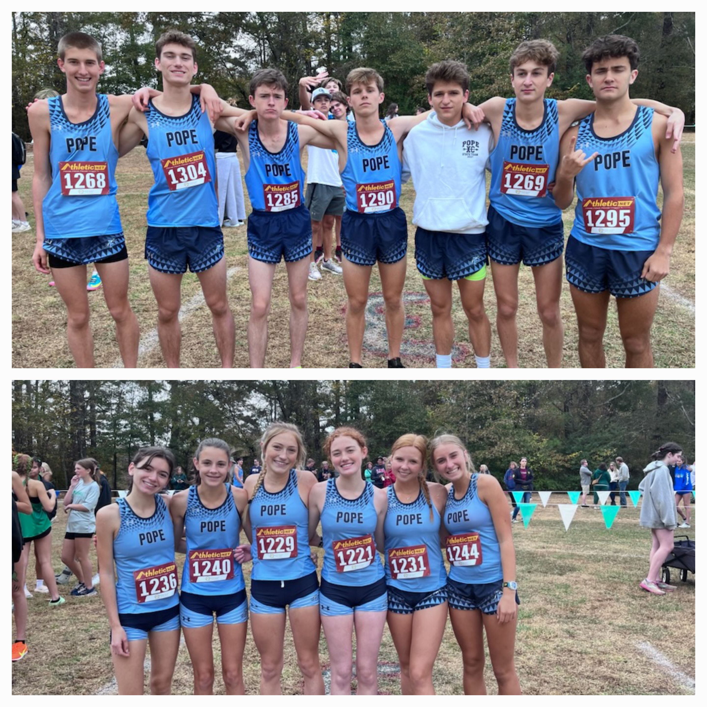
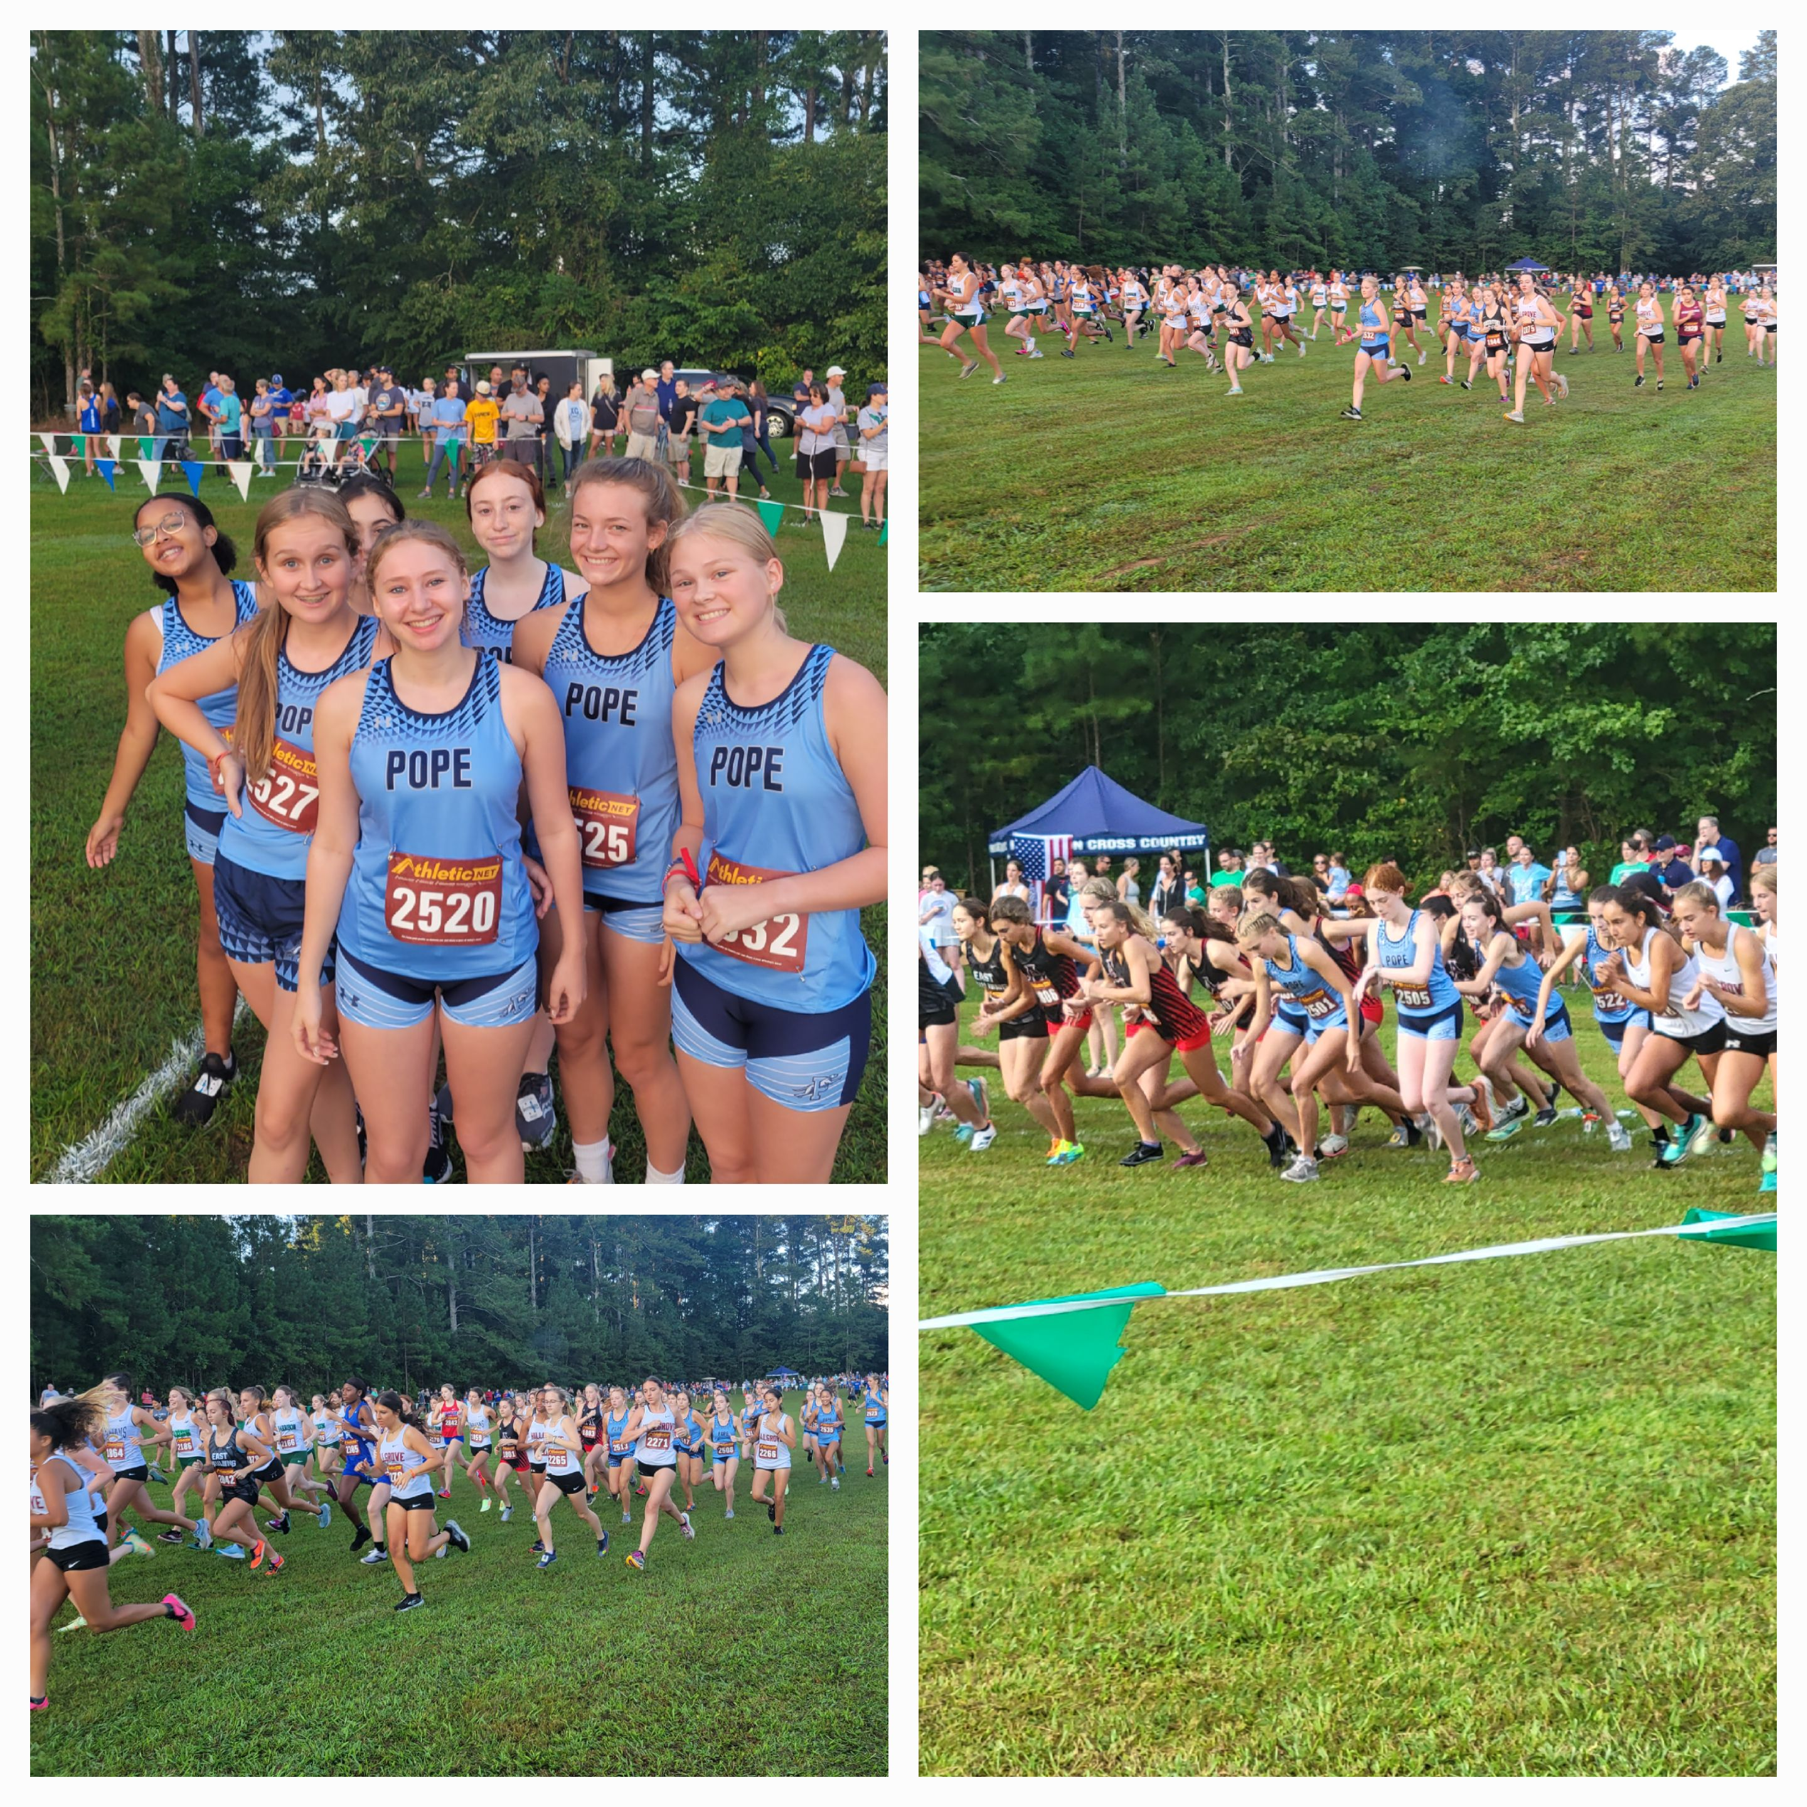
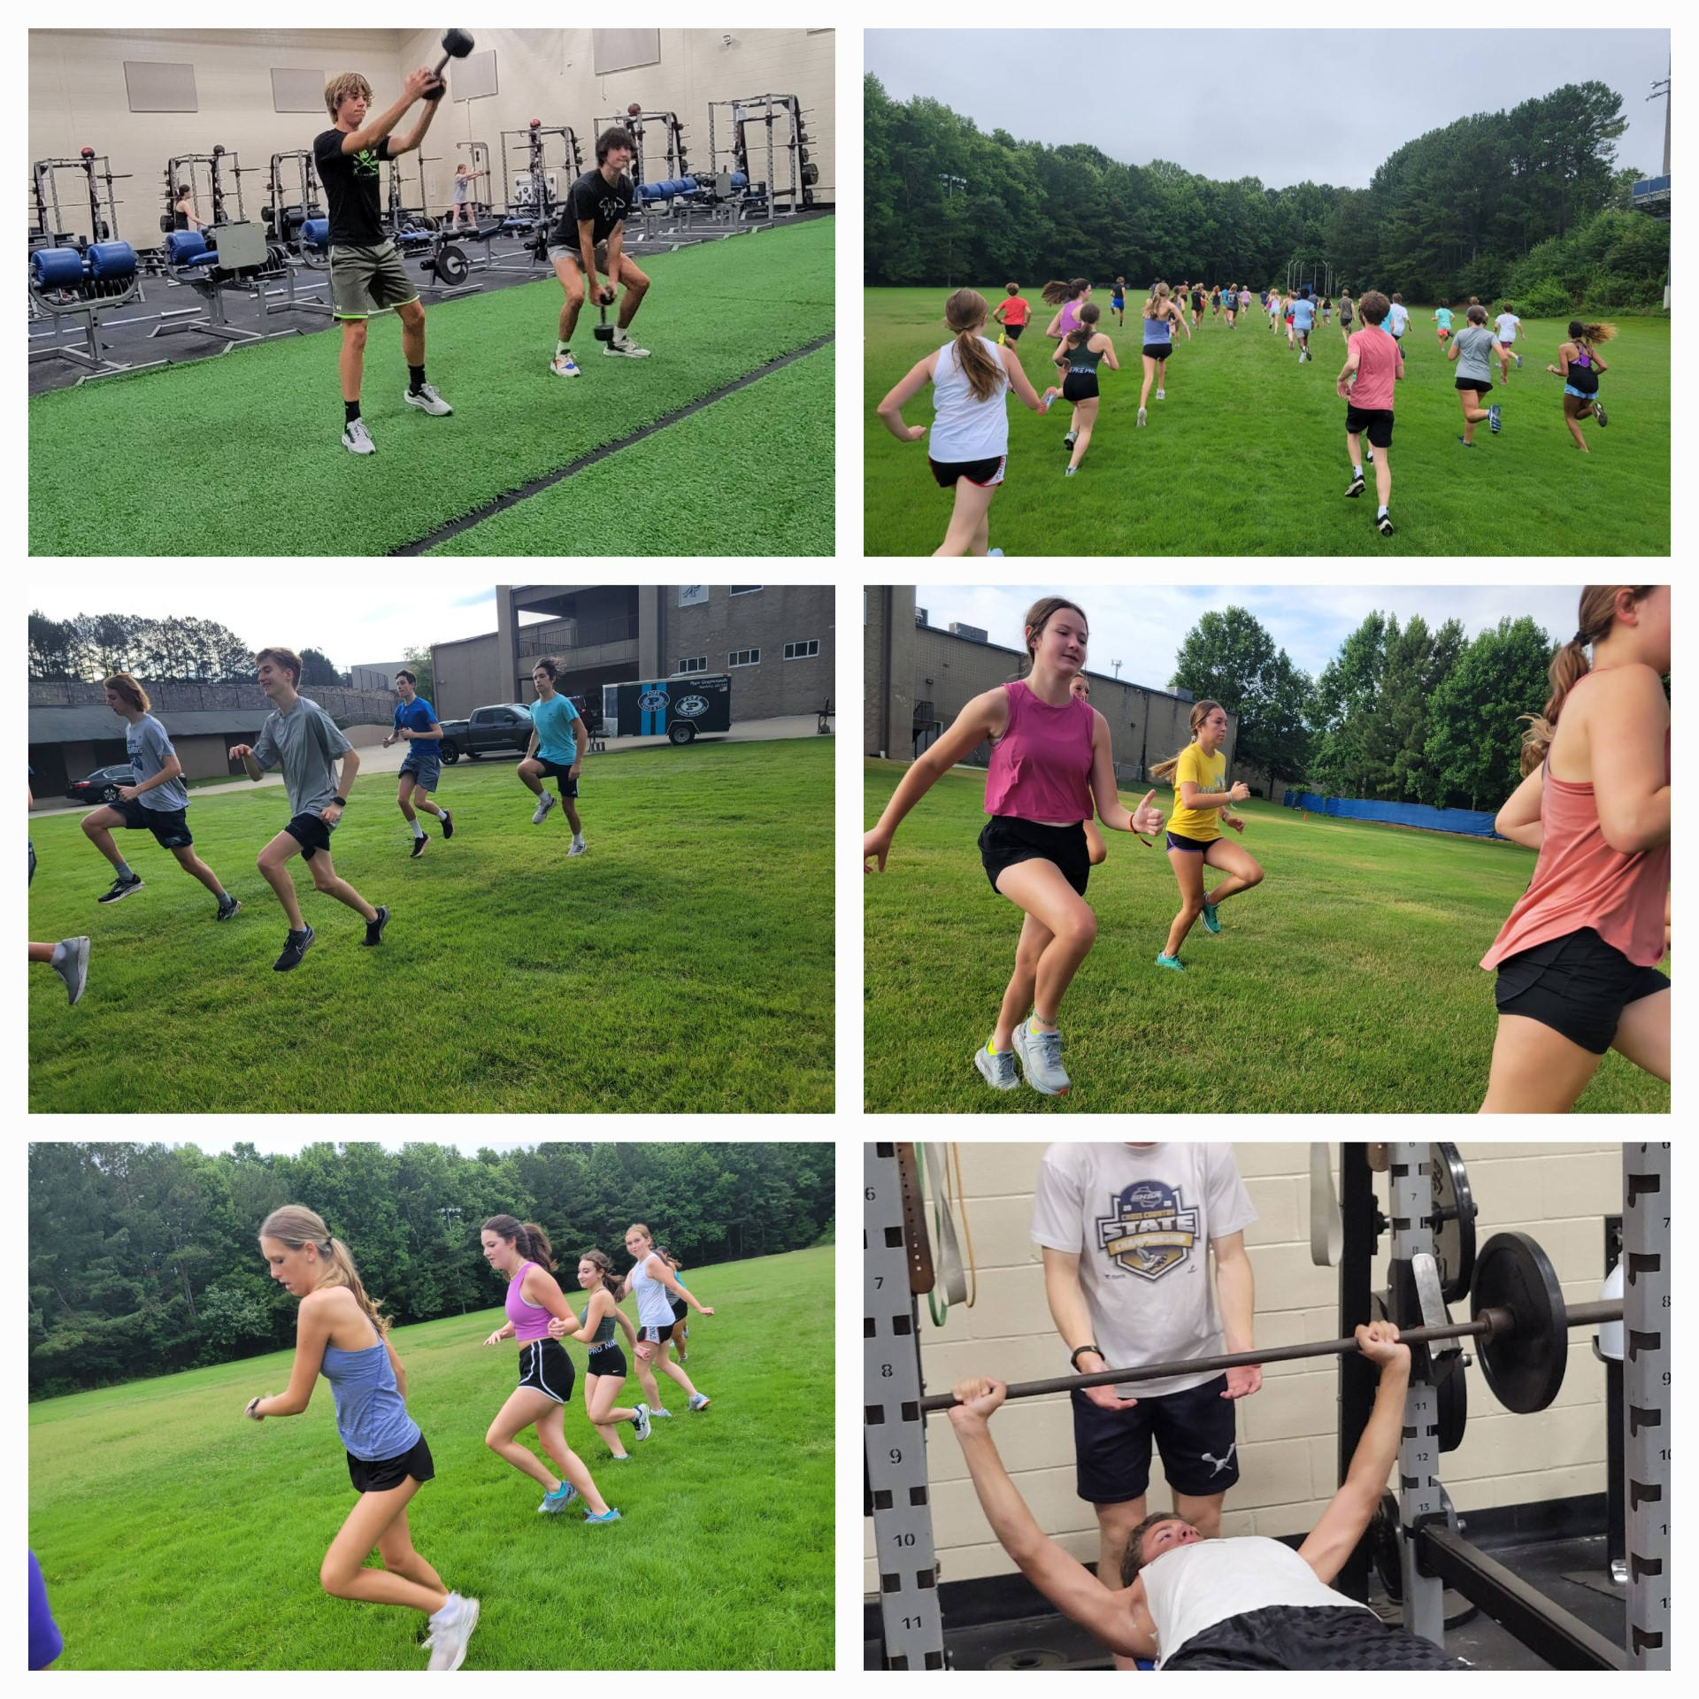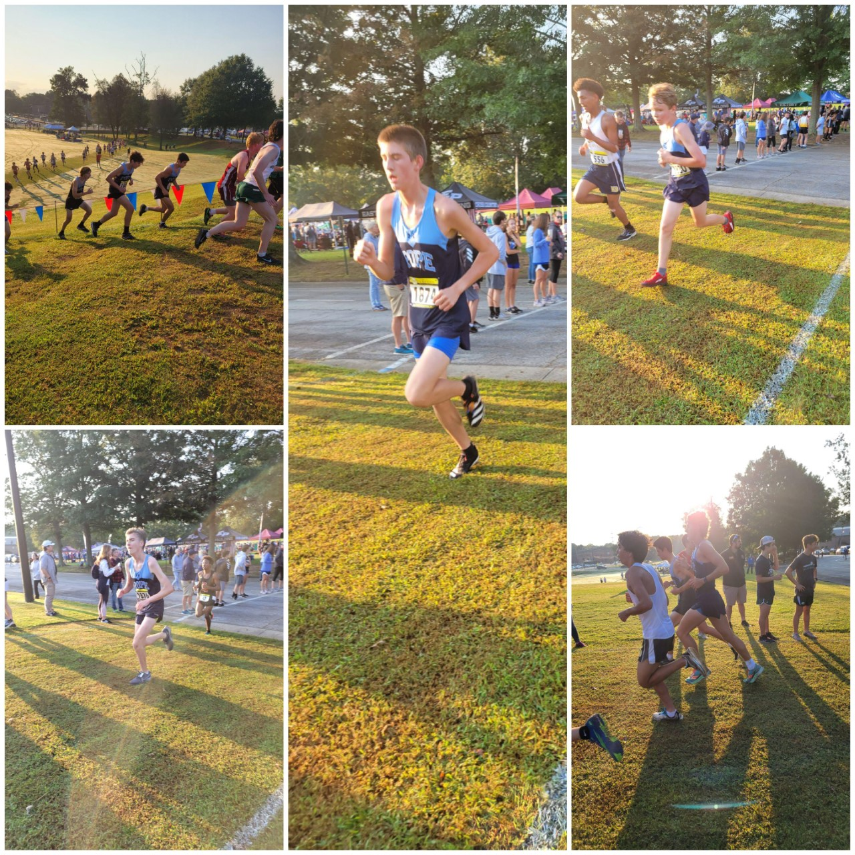
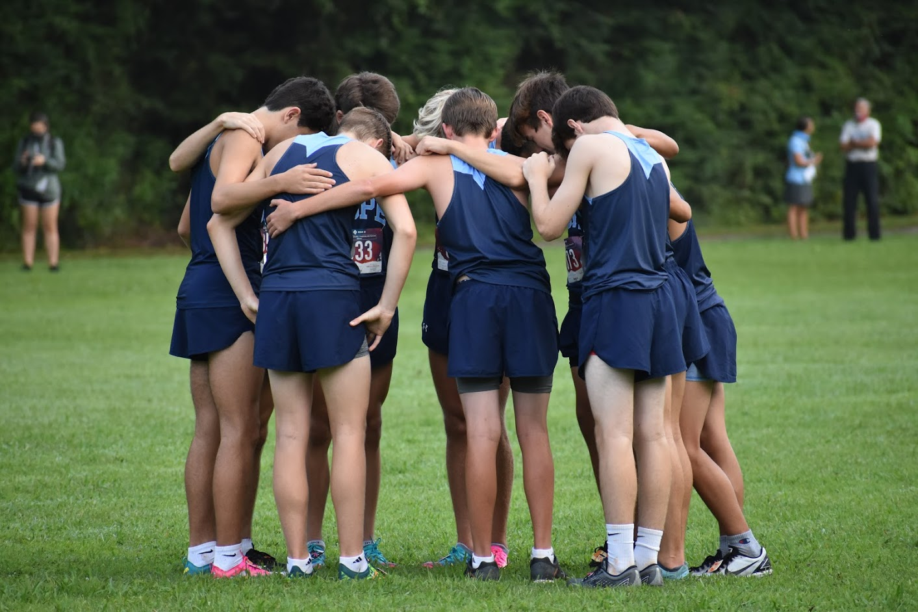
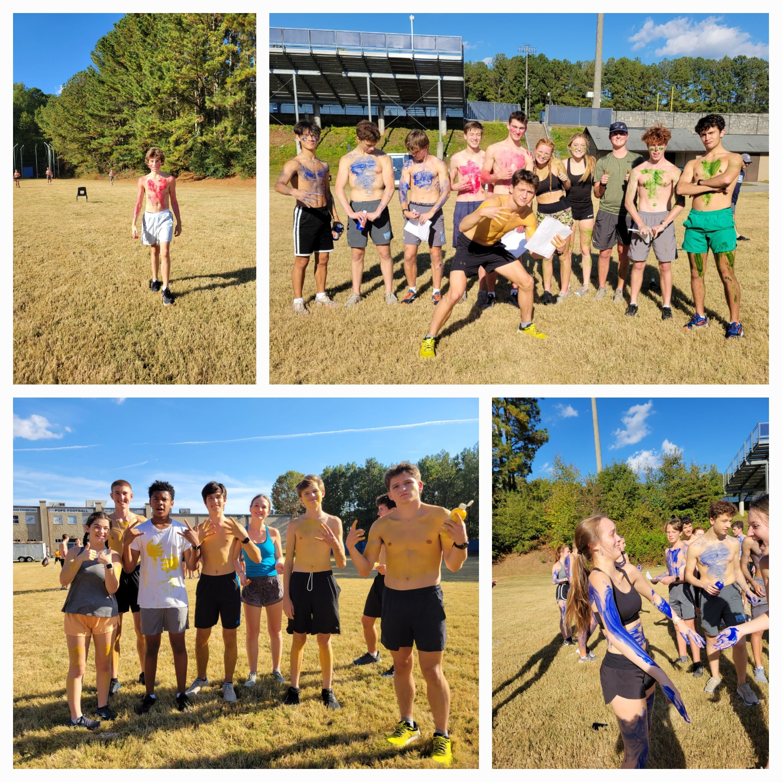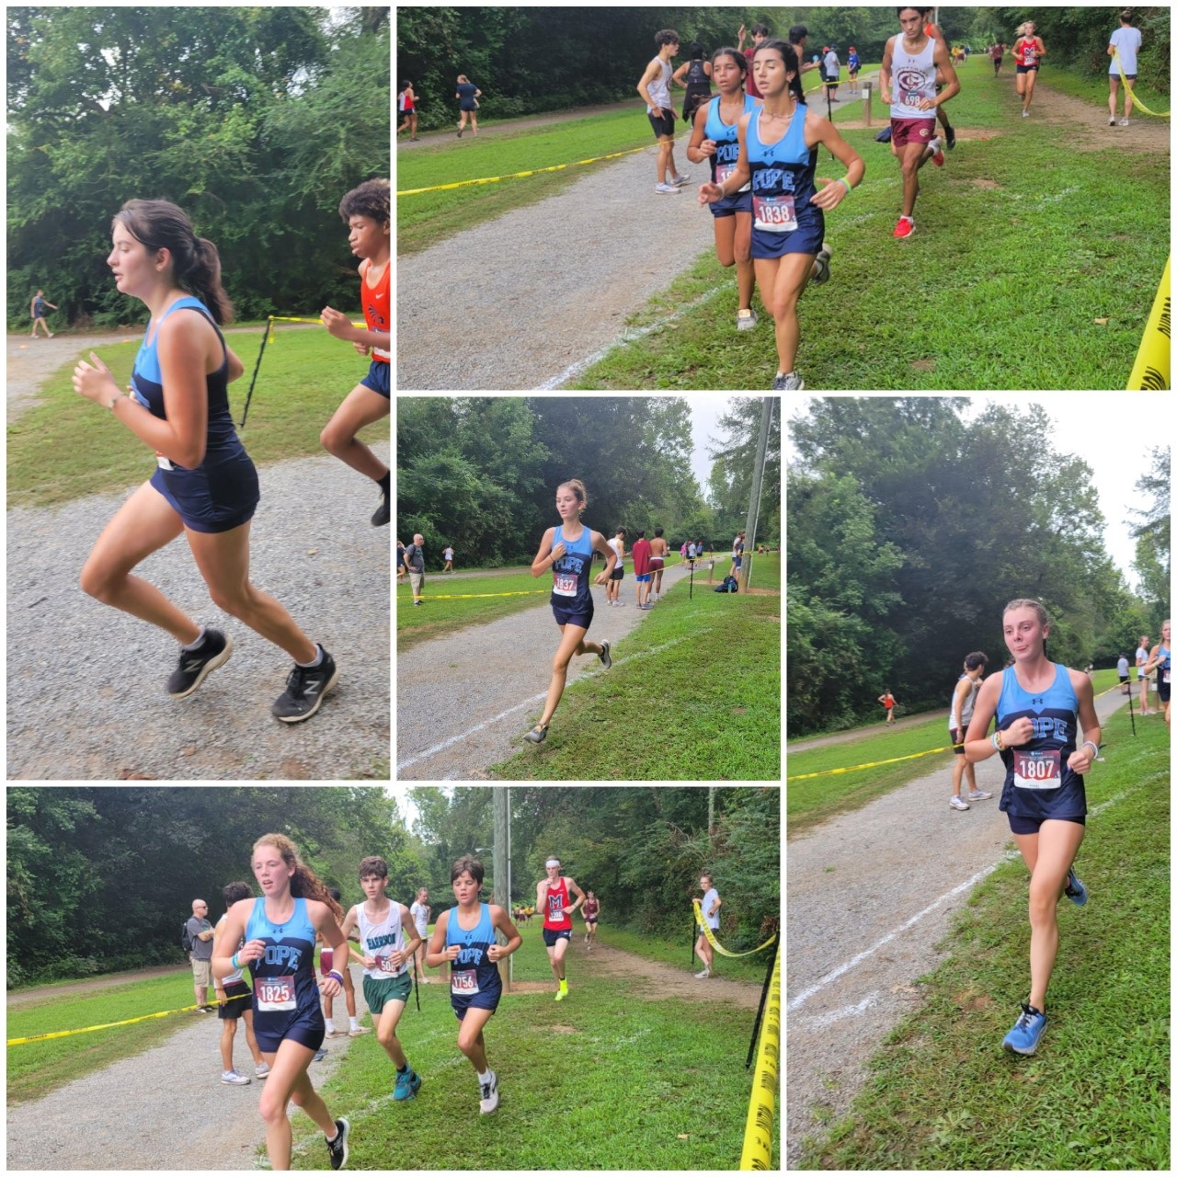
Date | Meet | location | Time | Athletes
Sat. 8/12 | Hoya 2 mile Invitational | Allatoona Creek Park | 8-12 | ALL
Sat. 8/19 | Kosh Classic | Westminster HS | 8-12 | ALL
Sat. 8/26 | Kowboy XC Invitational or Bob Blastow | Kissimmee/FL  or  Douglas County GA | 8-12 | ALL
9/2 | OFF (Labor Day)
Sat. 9/9 | Carrollton Orthopedic XC | Carrollton, GA | 6-12 | Top 14
Sat. 9/16 | Cobb County Championships | Allatoona Creek Park | 8-12 | ALL
Fri. 9/22 | Wingfoot Classic | Sam Smith Park, Cartersville, GA | 7-12 | ALL
Tues. 10/3 | Cass Cartersville Invitational | Dellinger Park Cartersville, GA | 2-7 | ALL
Sat. 10/14 | East River Invitational or Coach Wood Invitational | Orlando FLA  Or Douglas County GA | 7-1 | ALL
Tues or Wed tba  10/25 ? | Region meet | TBA | 9-1 | ALL
Saturday 11/4 | State | Carrolton Elementary School, Carrollton GA | 2:00 and 2:30 | TOP 10

Contact cathi.monk@cobbk12.org with questions
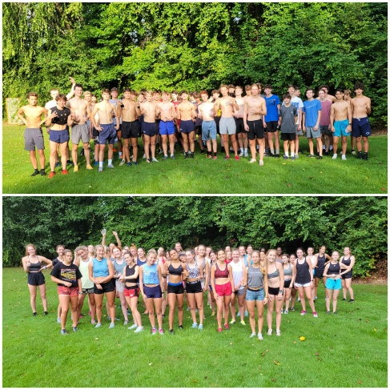 |  |  |  |  |  | 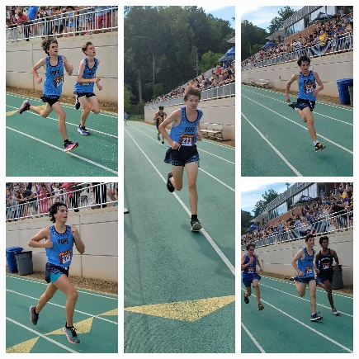 |  |  |  | Mandatory practice for all athletes begins 7/24-7/28 from 7:30-8:30am. @PHS  Practices once school begins @PHS starting 8/1  M/T/Th 3:45-5:45  W/F 6:20-7:30 am  *Practice times may be adjusted due to heat or weather.  *Dual sport athletes will need to contact the coaching staff ASAP should they have a training conflict.

