



Trinity Times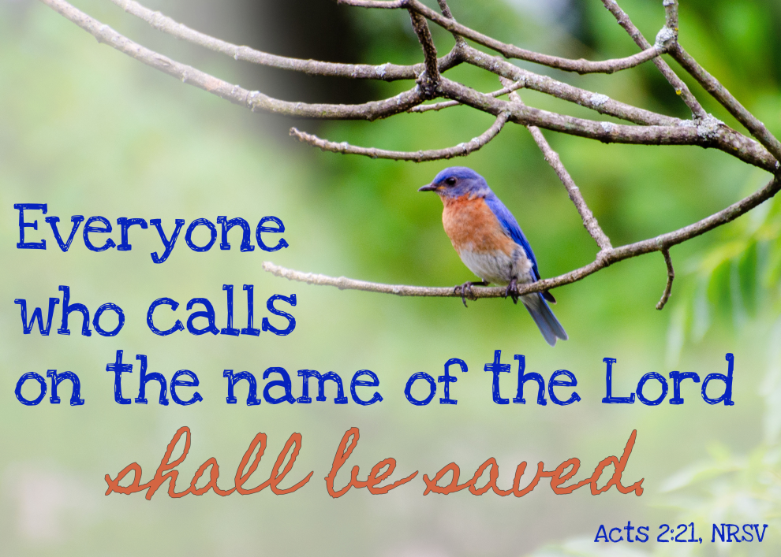es



**Volume 9, Issue 5-6**

**May & June 2021**



**With Feet Firmly Planted**

***Psalm 69:1-3: 1Save me, O God, for the waters have come up to my neck. 2I sink in deep mire, where there is no foothold; I have come into deep waters, and the flood sweeps over me. 3I am weary with my crying; my throat is parched. My eyes grow dim with waiting for my God.***

The psalmist in his plea acknowledges living in a world that seems overwhelming, chaotic, and threatening. As I prepare to leave Trinity and New Chapel and accept the challenge of a new church appointment, I think back on the days leading up to my first pastoral appointment. I must admit to feelings somewhat akin to the emotions expressed in the passage above. I was not certain that I was up to the task of being a pastor. I was afraid of the unknown ground that lay ahead of me. I remember wondering whether I had stepped into deep waters, too deep, for me to safely navigate. I was just not sure if I knew enough. I was not certain whether I was well-enough prepared for the challenges that lay ahead of me. In my uncertainty and doubt, the future that I faced in those days, just nine years ago, seemed overwhelming, chaotic, and threatening. I was afraid that I might “sink in the deep mire where there is no foothold” and that the flood might sweep over me.

But I learned something while facing those challenges. I learned that God was with me. I learned that God, who called me into this ministry, would lead me safely through the treacherous waters. I patiently waited and God did just that. And I learned that the people I served in that first appointment kindly and patiently allowed me to begin to learn how to be a pastor. By the time I came to the wonderful congregations of Trinity and New Chapel, my uncertainty was less pronounced. My confidence had grown. I did not fear the flood quite as much as I once did. But my foothold still was in danger of slipping. Then came the pandemic and the way that church was conducted literally changed within a week. What I had learned about being a pastor did not altogether apply to the reality around me any longer. The “deep mire” once again threatened my foothold.

A person wearing a suit and tie

Description generated with very high confidence

But I learned something facing those challenges also. I learned that God was STILL with me. I learned that God, who called me into this ministry, would STILL lead me safely through the treacherous waters. I patiently waited and God was STILL there to do just that. As I prepare to go and face new challenges and new uncertainties, I am strengthened by something else. The wonderful people of Trinity and New Chapel kindly and patiently allowed me to learn how to be a pastor in times of the turmoil and the chaos of a world-wide pandemic. We learned together and you allowed me to regain my foothold. And I will always be grateful. I will forever carry the memories of you and what we have done together with me.

The friendships I have made here will remain precious to me. Shin and I will NEVER forget you. I will begin this new chapter in my life with the comfort of knowing that, thanks to you and to God, my feet are firmly planted.

Blessings,

Charles



Trinity United Methodist Church

1160 Trinity Church Road

Newberry, SC 29108

803-276-1245 Office

803-206-4623 Pastor Cell

[clwilbanks@bellsouth.net](mailto:clwilbanks@bellsouth.net)

[trinityumcnewberry@gmail.com](mailto:trinityumcnewberry@gmail.com)

[www.trinityumcnewberry.net](http://www.trinityumcnewberry.net)

PLEASE VISIT OUR WEBSITE

AS OFTEN AS YOU CAN!

Peggy Bogart, Church Secretary

Head Usher: Harry Longshore

Choir Director: Jane Pollard

Organist: Eddie Welborn

Alternate Organist: Phyllis Sanders

Video Board: Josh Pitts, Bryan Waldrop

Caroline Senn, Foster Senn

Acolytes/Cross Bearers Coordinator: Eli Martin

Newsletter Editor: Harriet Stevenson

There are items in the kitchen

with the following names on them. Please pick up at your leisure:

Betsy Black

Crystal Waldrop

Gloria Brehmer

Peggy Marlowe

June Pitts

Marie Somers

Dixie Waldrop

** July 3rd at Trinity**

**Boston Butts - $30.00 each**

**Turkey Hash - $8.00 Quart**

**Pickup: 12:00 – 4:00 p.m.**

**Tickets available after church on May 23.**

Page 2



We are a caring church and want to share your concerns. Let us know if you or someone you know would like to share a prayer request with us. We will be happy to pray for you. To add or remove names, contact Peggy Bogart, Church Secretary, Harriet Stevenson, Communications Chairperson, or Pastor Charles Wilbanks.

***Trinity Church Members****: Jane and Robert Pollard, James and Jeanette Poag, Cheryl Longshore, Shirley*

*Berry, Gloria Brehmer, Rebecca Bundrick, Alice and John Longshore, Frieda Kesler, Joan Morris Johnny Marlowe*

***Family and friends of Trinity:*** *Blake Hendrix, Jennie O’Shields. Phillip Sanders, Richard Douglas, Wilson Bowles, Charlotte Berry, Sal*

*Welborn (White Oak), Harriet Connelly, Merle Simpleton Reynolds, Megan Wainwright, Jessica Griffin*



* Mother's Day — May 9
* Epworth Offering – May 9
* Administrative Council – May 10 – 6:30
* Day of Pentecost – May 23
* MYF – May 23 – 5:30 at church
* Memorial Day — May 31
* UMW Meets – June 1- 6:30
* Men’s Club Meets – June 3
* Administrative Council – June 8 – 6:30
* MYF – June 13 – Bowling in Greenwood
* Father's Day — June 20
* Summer Begins – June 21
* MYF -June 27 – 5:30 at church



|  |  |  |  |  |  |  |  |  |
| --- | --- | --- | --- | --- | --- | --- | --- | --- |
| *May 1 – Anna Grace Waldrop*  *May 5 – Sheryl Burgess*  *May 9 – Beverly Brehmer*  *May 15 -Charles Senn*  *May 16 – Josh Pitts*  *May 16 -Erin Pitts*  *May 19 – Shirley Berry*  *May 22 – McCallum Senn*  *May 28 – Frances Pitts*  *May 28 -Carol Johnson*  *May 30 – Ashley Wilson*  *May 30 – Tyler Poag*   |  | | --- | | bdays_17231c*June 3 – Heather Armstrong* | | *June 6 - Eddie Welborn* | | *June 6 - Peggy Marlowe* | | *June 6 - Lavone Coats* | | *June 17 - Dale Bundrick* | | *June 22- Ronnie Davenport* | | *June 25 – Lynn Mohler*  Page 3 | | |
|  | |
|  | |
| welcome_26c  Effective July 1, 2021 our new pastor will be Rev. Doug Benton from Leesville, SC. Rev. Benton became a widow in 2016 and as you can imagine, he went through a hard time. But God is good and blessed him by bringing another wonderful woman into his life and they plan on getting married on August 7, 2021. Her name is Carrie and she is a pastor’s daughter. Between them they have 6 adult children, 16 grandchildren and 3 great grands. Carrie currently serves part time in Newberry County as an occupational therapist as well as a volunteer Guardian ad Litem. Rev. Benton and Carrie hope to continue to serve the Lord together and to travel and spend time with family as much as possible. Rev. Benton’s most recent appointment was at Pinopolis UMC in the Charleston District. He retired last July and admitted to us that he still had a strong call to serve God in ministry and service. When Dr. Love asked him to come out of retirement to come and serve Trinity and New Chapel, he happily and readily agreed. We are excited to have Rev. Benton and Carrie join our church family and look forward to his first sermon on **July 4th**. It should be a blast! | |
| Douglas  **Rev. Doug Benton** | |
| |  | | --- | |  | |  | | flowers_17128c | |  | | EPWORTH’S MOTHER’S DAY OFFERING  **EPWORTH IS OUR MINISTRY!** Did you know that in the last year Epworth Children’s Home gave over 200 children a safe and loving place to call home? Each of these children had this opportunity because of United Methodist churches in South Carolina who embrace and provide for this ministry in support of the children and families in our state. We will  participate in the annual Mother’s Day Offering on Sunday, May 9th, 2021, to benefit the children who call Epworth home. Please be in prayerful consideration of what God is calling you to give to this valuable and life changing ministry.    ANNUAL CONFERENCE 2021  Annual Conference will be virtual again this year on June 6-7. The Conference will be at the Florence Civic Center with the Florence District and Cumberland UMC as hosts. Only those persons who must be onsite to facilitate conducting business will be attending in person. Good News TV will host the virtual gathering and coordinate participation via ZOOM.  **Page 4**  **Asbury Hills Summer Employment**  **Asbury Hills is looking to hire college aged staff for Summer 2021 at Asbury Hills.** If you know of anyone looking for a summer job that will be a life changing experience, contact Asbury Hills. They are looking specifically for counselors and kitchen staff but all who are interested should apply. [www.asburyhills.org](http://www.asburyhills.org)   |  | | --- | | meeting_18207c | | **ADMINISTRATIVE COUNCIL WILL MEET MONDAY, MAY 10th and MONDAY,**  **JUNE 14th AT 6:30 P.M. IN THE CHURCH SANCTUARY. PLEASE CONFORM TO CDC COVID GUIDELINES.** | | | | | |  | | | email_167c | | |  | | | If you have an email address, please call and give it to Peggy Bogart or leave it on her desk. We would like to send out the Trinity Times Newsletter through email each month to those who have email addresses. This will cut down on postage and you will get your newsletter much faster. Thank you for providing this information. It will not be given out to anyone. | | | confirm_6530 | | |  | | |  | | |  | | | |

(L to R, Noah Mohler, Olivia Martin, C J Griffin, Isabel Martin, Kruz Bouknight, and Kella Bouknight) Absent from photo: Dalton Morris.

United Methodists use the term "confirmation" to mark the first time a baptized Christian publicly "confirms" their intention to live the vows of the baptismal and membership covenant and so becomes a professing member of the local congregation and The United Methodist Church.

We are proud of the following youth who were confirmed on Easter Sunday.

**Noah Mohler**, son of Lynn and Burt Mohler

**Isabel and Olivia Martin**, daughters of John and Eli Martin

**C.J.Griffin**, grandson of Eugene Thomas

**Kruz Bouknight**, son of Bridget and Michael Bouknight

**Kella Battiste**, daughter of Heather and Mickey Armtsrong

**Dalton Morris**, son of Kelly and Michael Morris

Page 5

**Meet our Latest Trinity UMC Member**

**Baptism of James Marion Pitts**

**Son of Zach and Brandy Pitts**

Mrs. Shirley Berry will be celebrating her **98 th birthday** on May 19. She loves receiving cards, so let’s bombard her with birthday cards from her Trinity friends. Her address is: 1247 Rose Lane, Newberry, SC. or you may drop them in the box for her at Trinity by May 16th.

.

The MYF met on April 3rd in the Fellowship Hall for Pizza, games, and fellowship.  
  
The MYF volunteered at the Pomaria Food Bank on April 10th. We took our non-perishable items donated through Souper Bowl of Caring as well as our monetary donations totaling $50.

On May 23rd, MYF will meet in the Fellowship Hall for MOVIE NIGHT at 5:30! Wear your comfy clothes, bring a blanket, and get ready to eat some popcorn while we splurge on movie night!  
  
**June`s meetings**:  
**June 13th**: Bowling (If Covid allows) - We will be leaving after Church service and heading to Greenwood for an afternoon of bowling! The cost of bowling will be covered - Youth just need to bring enough money to cover the cost of their lunch. We expect to return by 4PM.  
**June 27th**: Meeting in the Fellowship Hall at 5:30 PM. Join us for good food and great fellowship!  
  
If anyone is interested in joining MYF or has any questions, feel free to reach out to Erin Pitts at (803) 968-0136. We would love to have you at MYF!  
  
Thanks!

Josh and Erin Pitts, MYF Leaders

**VACATION BIBLE SCHOOL AT TRINITY -** There will be no 5-day VBS at Trinity this year but we are working on a new and exciting 1-2 day camp for the youth of our community. Stay tuned for more info as well as dates and times in the near future!!!

Easter Eggstravaganza at Trinity

Page 6





Sunday, June 27th, will be Pastor Wilbanks last Sunday here at Trinity. He and Shin will be residing in Little River, SC and he will be pastoring at Herbert United Methodist Church in Georgetown. Pastor Wilbanks, you are indeed a reflection of God’s love and we want you to know how very much we appreciate all that you have done while at Trinity. Thank you for serving us with all your heart. Thank you for blessing us with all that God has blessed you with. Thank you for helping us to learn and grow, even during a pandemic year. Love and Blessings for your future.

Your Trinity Family

Page 7

**Trinity UMC**

**1160 Trinity Church Road**

**Silverstreet, SC 29145**