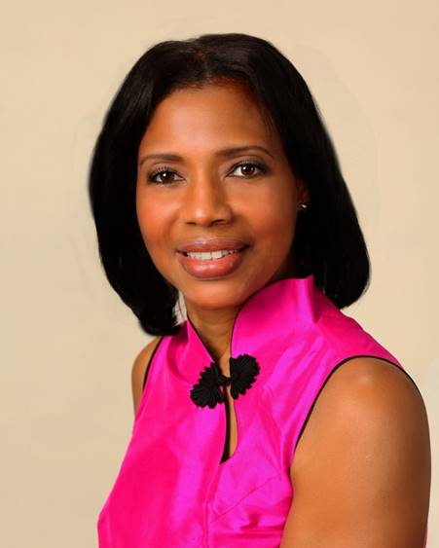
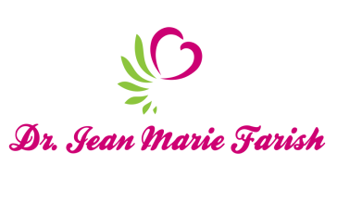

LOVE LIGHT NewsLetter

I am excited to host my VoiceAmerica Empowerment Show-LOVE LIGHT with amazing Guests to cultivate a lifestyle of love and wholehearted connections through worthiness. My show is aligned with my mission to live an altruistic and heart centered life.

MEET LOVE LIGHT GUEST
Julie Coraccio
Certified Life Coach
Author

Supporting You to Live Fully

April 17, 2020
OPENING TO LOVE

ABOUT Julie Coraccio

Julie Coraccio is an award-winning professional life and end of life organizer, and certified life coach. She is passionate about supporting people in clearing clutter in all areas of their lives, getting organized, and becoming more mindful and aware. She hosts the popular self-help podcase, Clear Your Clutter Inside & Out and is the author of ten books including the Got Clutter? 365 Journal Prompts Series.

Happily married to Tony, she is also at the beck and call of rescued cats Joey, Antonio, Athena, Annina and Augusta. Based in Raleigh, NC, Julie works with people all over the world.

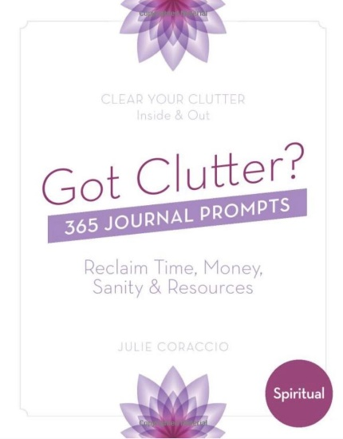
www.reawkenbrillian.com
https://www.youtube.com/userSibertRadio?feature=watch
https://amzn.to/zZOkHDw

“An empowered self is a loving self and keep your love light shining”

