How to Design a
Supplement Program

Health
Target

Target Roadmap
to Health

© Copyright 2010

Martha Willmore
Wellness Coach



Martha Willmore is an internationally recognized educator and author in the field of complementary health care. During her Health career of almost 30 years, she has earned respect in the field of functional wellness, complementary health care, and hormonal health

Martha is a certified Dietary Consultant and Nutritional Symptomatologist. She is the Administrator of “The Institute of Optimal Lifestyle Wellness”. Besides her personal consultation business and distribution centre of Shaklee vitamins, minerals, herbs, and natural beauty care, she also works part-time as a Wellness Coach at a chiropractic clinic in Niagara Falls, Ontario.

The information in this book is for educational purposes only. It is not intended to be prescriptive or substitutionary for health care by a medical doctor. Persons wishing to follow any advice should do so strictly of their own accord. The contents herein do not prescribe the use of any techniques as a form of treatment, nor does it dispense medical advice as a form of treatment for medical problems without the advice of a physician, either directly or indirectly.

For additional copies of this booklet: contact Second Chance … 905-871-4281 … hoop@inter-pc.com

Wellness Balance Wheel

TOTAL WELLNESS is dependent on many factors
and each one plays an important role in health.

Don’t look for the “magic bullet” to make you well. Get SERIOUS about “TOTAL WELLNESS”
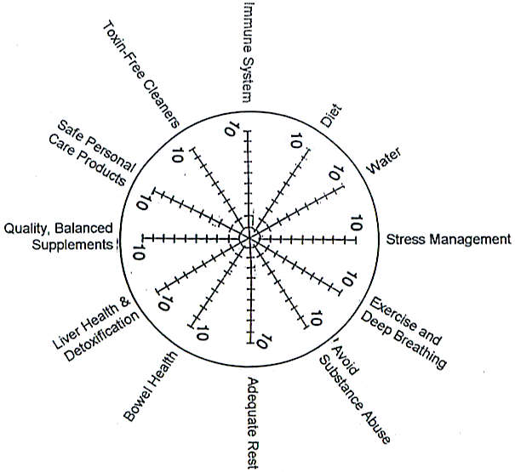

Rate yourself on a scale of 1 to 10. Where do you need to improve?

- Diet: 51% raw; variety; close to nature; adequate protein; avoid allergic foods
- Water: purified water – ½ ounce per pound of body weight
- Stress management and positive attitude
- Exercise and deep breathing
- Avoid substance abuse: smoke, alcohol, drugs, etc.
- Adequate rest
- Bowel health: frequency – bulk-in should equal bulk-out; adequate microflora
- Liver health and detoxification
- Quality, balanced supplements
- Toxin-free cleaners
- Safe personal care products
- Immune system: extra antioxidants? parasites?

Health Target – Roadmap to Health
… divided into FOUR simple steps
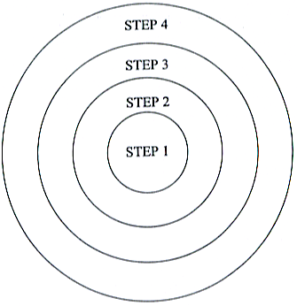

Always start with STEP 1 – The Bull’s Eye
… the Bull’s Eye is divided into SIX HEALTH BASICS

Step 1A, 1B, 1C, 1D, 1E, 1F



Step 1A: Diet

How does your daily diet
compare to what your body needs?

According to the Food Guide, the amount of food you need every
day from the four food groups depends on
- Age
- Body size
- Activity level
- Whether you are male or female
- If you are pregnant or breast-feeding

 | Sedentary Women,  Older Adults | Children,  Teenage Girls,  Active Women, Sedentary Men | Teenage Boys, Active Men, Very Active Women
Whole Grain Products  5-12 servings/day | 5 | 9 | 12
Vegetables & Fruit  5-10 servings/day | 5 | 8 | 10
Milk Products | 2-4 | 2-4 | 2-4
Meat, Fish, Nuts,  Beans, Eggs | 2 | 3 | 3

What’s a Serving?

Bread, cereal, pasta, rice, starchy vegetables Milk, Yogurt, Cheese
¾ cup whole grain cereal 1 cup milk
1 slice whole grain bread ¾ cup yogurt
½ bagel, pita, or bun 50 gm cheese (3x1x1)
1 cup pasta, rice, corn, potato

Fruit Meat, Fish, Nuts, Beans
1 whole fruit 50-100 gm meat, fish, or poultry
½ cup chopped fruit 1-2 eggs
1/3 cup tofu
Vegetables 125-250 ml beans
1 cup raw, leafy vegetables 2 tbsp. peanut butter
½ cup chopped vegetable

How many people really eat according to the Food Guide …
7 days a week … 365 days a year???
A Healthy Body Diet

Choose foods from this list
- Fowl – with skin removed
- Wild ocean fish
- Low-fat dairy products
- All the veggies you want
- Lots of fruit
- Legumes –beans, lentils, peas, etc.
- Whole grain products – pasta, cereal, etc.
- RAW nuts and seeds
- Cold-processed vegetable oils ONLY
- Always choose foods made with whole, natural, ingredients, whenever possible
- Use honey, molasses, pure maple syrup, or fructose when a sweetener is needed
- Drink a minimum of 8 glasses of water per day (purified water only)

Reduce or Eliminate

- Red meat … limit to once a week
- Processed meat of any kind
- Organ meats … liver, kidney, brains, etc.
- Skin of fowl
- Fried foods
- High fat diary products
- ROASTED nuts and seeds
- All heat-pressed vegetable oils
- Alcohol, coffee and black tea
- White sugar
- White flour
- Heavily processed foods
- Pre-salted prepared foods
- Non-prescription, street drugs or self medications
- Soft drinks/phosphate seltzers/mineral waters
- Limit salt intake

Notes:
- 51% of your diet should be RAW for health maintenance … aim for 80% if you are ill
- Provide variety in your food choices
- Eat food as close to nature as possible (unprocessed and unrefined)
- Consume ADEQUATE protein on a daily basis – 30% of the diet should be protein
- Avoid foods you are allergic to
- When you eat, divide your plate into quarters:
  - half of your plate should be vegetables
  - one quarter of your plate should be protein
  - one quarter of your plate can be starch or grain foods (eg. sweet potatoes, brown rice, baked potato, whole grain bread, etc.)
- The appropriate amount of calories for your weight …
  - Up to 150 lbs – 1,200 calories
  - 151 to 200 lbs – 1,500 calories
  - 201 to 250 lbs – 1,800 calories
  - 251+ lbs – 2,100 calories

Changing Your Diet to Whole Foods
Avoid | Replace with:
white bread and other foods made from white flour (pasta, pastries) | 100% whole grain breads, whole grain pastas, etc.
Sugar, Aspartame | Fructose, stevia, unpasteurized honey or maple syrup
Tea, coffee, & soft drinks | Water, herbal tea, fruit juice
White rice | Brown rice, wild rice, etc.
Salted & roasted nuts | Raw nuts & seeds
Sugar coated cereals | Whole grain cereals or fruit juice-sweetened cereals
Mashed, fried & peeled potatoes | Potatoes with skins, preferably baked
Artificial colours/flavours | Natural colours and flavours
Table salt | Herbamare, sea salt, etc.
Canned foods | Fresh or frozen foods
Margarine, lard | Unsalted butter or fresh pressed oils
Processed cheese | Natural white cheese, cottage cheese
White vinegar | Lemon juice or apple cider vinegar
Sulphured dried fruits | Sun-dried fruits (no sulphur)
Heated oils | Raw oils

Tip:
- Upon rising in the morning, drink two 8 oz. glasses of water.
- Do ten minutes of a mini-trampoline to jumpstart your metabolism
- Then eat a high protein breakfast (eg: Shaklee Cinch shake & fruit; a soy protein smoothie; 2 soft boiled eggs with whole grain toast, etc.)

Step 1B: Water

Water
... is more important to survival than any other nutrient!

THE BODY IS LIKE A FISH BOWL!
If you don’t change the water in the fish bowl, it becomes stagnate and the FISH DIE

If you don’t drink adequate pure water to change the water in your body, your interior environment is not a healthy one for cells to live in!

Question: How much WATER should you drink daily?

Answer: ½ ounce for every pound of body weight

- Water flushes the cells AND escorts nutrients into the cells.
- It does not take long to suffer from mild dehydration. Mild dehydration causes hair loss, fatigue, headaches, tight muscles, lack of proper elimination.
- ADD FRESH SQUEEZED LEMON JUICE TO YOUR WATER DAILY. This will help alkalize your body, and clean out your liver.

Tip: If you drink and are still thirsty, this is a strong indicator that your electrolytes (minerals) are out of balance. Add Shaklee Sport Drink to your water to increase the sodium, potassium, chloride, magnesium, calcium, and phosphorus.
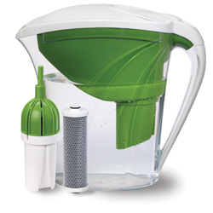

Dehydration is a serious health problem.

Ask about the Shaklee Water Filtration options
GET CLEAN WATER –
Certified to reduce lead (Brita® and Pur® pitchers are not!)
ONLY 0.061 cents per litre (when you purchase the filters in the refill 3-pak)

Step 1C: Bowels

The bowels are the sewage system of the body,
but by neglect and abuse, they become a cesspool.

Death begins in the colon …
therefore; keep it healthy and functioning well.

Three Specific Issues Regarding Bowel Health:
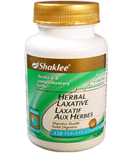

- Frequency: Bulk-in should equal Bulk-out
  - Diet must contain adequate fiber (Shaklee Fiber Plan Tablets)
  - Flax Seed – mill it yourself in a coffee grinder, 3-6T fresh daily
  - Drink adequate water

- Bowel conditioners: nourish & condition the soft mucosal
lining in the bowel to strengthen it and keep it clean. Choose Shaklee’s
Premium Bowel Conditioner – Herb-Lax.

- Maintain HIGH Levels of Bowel Microflora: The fragile balance of good health is determined by whether the numbers of good bacteria out-number the bad. The average adult requires approximately 100 trillion good microflora (3-5 pounds). Supplementation maintains optimal levels.

Shaklee OPTIFLORA is a unique two-part product guaranteed to deliver 500 million LIVE microflora per capsule
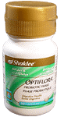
- Step 1 – provide Microflora (Optiflora Part 1)
  - 250 million Acidophilus
  - 250 million Bifidus
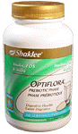

- Step 2 – Feed the Microflora (Optiflora Part 2)
  - Contains FOS (fructooligosaccharides) Inulin,
Jerusalem artichoke flour and gamma tocopherol
  - This fuel MULTIPLES the microflora
Step 1
  - The numbers DOUBLE every 10 minutes (within an
hour you will have created 8-10 billion!)

Step 2

Health Target

Bull’s Eye

Address Steps 1A, 1B, 1C, FIRST
- Step 1A = Diet
- Step 1B = Water
- Step 1C = Bowel
- Frequency
- Microflora
- Bowel Conditioner

Step 1D:
Multi-Vitamin/Mineral

Scientifically Advanced VITA-LEA
High potency multivitamin & multi-mineral dietary supplement

Shaklee Corporation brings you the BEST Multi-Vitamin/Mineral in the World equivalent to 30 foods …
To ensure that “ALL” the known and unknown Vitamins and Minerals are available in balance as they are in nature
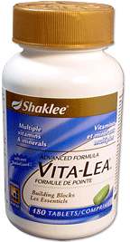
Three formulation options:

- Vita-Lea with iron - for teens, women, of children bearing age

- Vita-Lea without iron - for menopausal women and for men

- Vita-Lea Ocean Wonders Chewable – for children
(or adults who have difficulty swallowing)
Vita Lea with iron

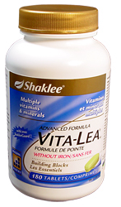
Clinical tests showed that using
Vita-Lea consistently for one year
reduces sick days by 65%

- Scientifically proven for potency and bioavailability
Vita Lea without iron
- Over 350 quality tests performed
- Easy on the stomach

- Spirulina coating (a powerful antioxidant)
- Gentle formulation of zinc and protein-bound trace minerals for
easy digestion
- Contains 450 mg calcium and 200 mg magnesium
- No artificial colours, flavours, sweeteners or preservatives
Vita Lea Chewable

Step 1E: Multiple Essential Amino Acids

Start your day with SOY PROTEIN


The ultimate super food for Optimal Health …
a sustained BURST OF ENERGY!

Imagine a FOOD that can:
- Provide the protein quality of a steak, without the fat
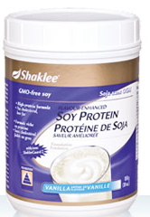
- Increase your energy

- Aids in weight loss
- Help prevent top cancer killers in men and women
(breast, lungs, colon, prostate)
- Reduces the risk of osteoporosis
- Reduce the risk of heart disease
- Balance hormone levels
- Reduce menopausal symptoms
- Help hypoglycemia
- Support healthy breast tissue
- Help prevent gallstone formation

1 serving = 3 level tablespoons (1 oz) 1 serving is equivalent to the protein in:
14 gm protein 2 ½ eggs, OR
500 mg calcium ¼ cup tuna fish, OR
30+ mg isoflavones ¼ lb. chicken, OR
0 mg cholesterol ¼ lb. beef, OR
Less than 1 gm fat (0.9) ½ cup cottage cheese
110 calories

HOW TO USE: it mixes in a jiffy with juice, water or milk. It’s great sprinkled over hot or cold cereal, or stir into yogurt or apple sauce.

What’s So Special About Soy?
- Soy contains plant chemicals call “phytonutrients”, or “isoflavones”, particularly ones known as genistein and daidzein. These isoflavones are responsible for many of the benefits listed above.

- Our bodies require a continuous supply of protein. Protein is the building block of EVERY CELL! It is essential to build muscles, skin, bones, hormones and the immune system.

- Shaklee Soy is a RAW, non-GMO, 100% cholesterol-free, vegetable protein, gluten-free, yeast-free and lactose-free. It has NO artificial flavours, sweeteners, colours, or preservatives.

Step 1F:
ESSENTAIL Fatty Acids

You have heard it time and time again … “cut down on fat”. It is wrong to assume you must stop eating ALL fat. Contrary to popular myth, the body NEEDS FAT … but it must be the right kind. There are GOOD-FOR-YOU fats, and BAD-FOR-YOU fats. “Good-for-you” fats are found in RAW nuts and seeds.

A deficiency of Essential Fatty Acids can lead to an impaired ability to learn, and poor memory recall!

RAW oils from plants, nuts and seeds or fish are the food sources from which we get ESSENTIAL Fatty Acids. They are:
- Essential to reduce blood clotting

- Essential raw materials for hormones
- Essential for proper brain/nerve function
- Essential for a healthy immune system
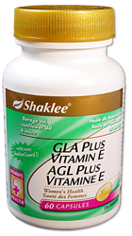
- Essential for healthy hair
- Essential to burn calories (weight loss)
- Essential to regulate cholesterol and triglycerides
- Essential to prevent drying and flaking skin
- Essential to recover fatigued muscles

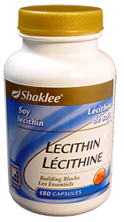
Recommendations:
- Eat RAW nuts & seeds as healthy snacks
- Make RAW nut/seed milk
- Eat 3 to 5 tablespoons of milled Flaxseed daily
- Supplement with Shaklee GLA, Lecithin, OmegaGuard

GLA (more potent than Evening Primrose Oil)
GLA contains borage seed oil, Vitamin E, and sunflower seed oil. It contains Omega-6 fatty acids which our bodies use to form prostaglandins – potent hormone-like substances that help the body to regulate hormones, inflammation and many other body processes.

Borage Seed Oil is 2 ½ times more potent and 3 times more bioavailable than evening primrose oil.

Summary of Step 1:
Six Basic Areas of Health
Essential Starting points for Optimal Health

Address Steps 1A, 1B, & 1C first

- Step 1A – Diet: follow the Healthy Body Diet

- Step 1B – Water: Drink adequate purified water daily

- Step 1C – Bowels:
- Frequency – Bulk-in = Bulk-out
- Bowel Conditioner – be proactive
- Microflora – for optimal body function

Address Steps 1D, 1E, & 1F next:

- Step 1D – To ensure that “ALL” the known and unknown Vitamins and Minerals are available in balance as they are in nature … take Shaklee Vita-Lea

- Step 1E – To ensure that “ALL” the ESSENTAIL Amino Acids are available in the proper balance … take Shaklee Soy Protein

- Step 1F – To ensure that the “ESSENTIAL Fatty Acids” are available every day in the RAW form … eat RAW nuts and seeds as healthy snacks, eat fresh-ground flaxseed, or supplement with Lecithin, GLA, or OmegaGuard.

Step 2:
Detoxification
Digestion

If you want to be well, you must GET SERIOUS about
helping your body function well so that you can digest
your food better and actually use the nutrients in your
food and supplements efficiently.

Detoxification: Commit to annual/biannual cleanses – Rejuvenating Cleanse

Liver Health
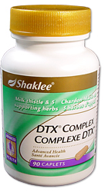
Your liver is endangered! Liver Detoxification is ESSENTIAL in a polluted
environment. Be proactive … Choose a complete liver protection package …
SHAKLEE LIVER DTX COMPLEX:
- Helps regenerate liver cells
- Helps maintain bile flow
- Contains three powerful antioxidants … milk thistle, schirandra, and
reishi mushroom
- Contains three bile flow enhancers … dandelion, artichoke, turmeric

Digestion
Malabsorption is a very serious problem. The “Three B Syndrome” (Burp, Belch, and Bloat Syndrome) is an indicator that the digestive system is not working properly.
- Increasing intestinal microflora with Optiflora (Step 1C) helps to correct some problems
- Shaklee provides other products of benefit:
  - Alfalfa Complex – for minor problems (3-6 with each meal)
  - EZ-Gest – (a comprehensive digestive enzyme product)
  - Chewable Bifidus – relief for heartburn & acid reflux (available in Canada only)
  - Stomach Soothing Complex – contains four herbs: peppermint, ginger, fennel & anise (U.S. only)

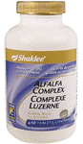
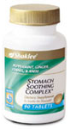


Step 3:

Protectors
(Antioxidants)

EVERY cell in the body needs protection from free radical damage, and
in a polluted world where we are exposed to so many toxins, it is very
wise to be proactive and provide higher levels of the antioxidant
nutrients over and above what are provided in a high potency multiple
vitamin/mineral supplement. Protector nutrients reduce our risk or slow down the development of degenerative disease.
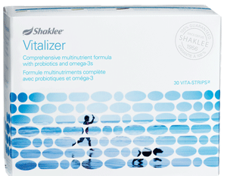

What happens to people who take Antioxidants
- Cancer deaths down 13%
- Cancer survival up 50%
- Heart attacks & strokes down 50%
- Skin cancer down 70%
Shaklee Vitalizer … Guaranteed Delivery
There are 12 patents and 2 patents pending on the S.M.A.R.T. delivery system, which means the right nutrients to the right place at the right time. Available with or without iron

Available with or without iron
- Immunity up 50%
- Infections down 50%
- Cataracts down 27 to 36%

This is compelling reason to make Shaklee antioxidants a regular part of the diet as Nutritional Insurance.

The above statistics were gathered from the Cancer institute, National Institute of Aging, West Virginia University, Harvard Medical School, U.S. Department of Health, Laval University (Quebec), John Hopkins University, New Jersey Medical School, Memorial University (Newfoundland)

Protector Nutrients include:
- Vitamin C (each Shaklee tablet is equivalent to the Vitamin C found in 7 ½ oranges
- Vitamin E (Shaklee Vitamin E is three products is one … each contains 400 I.U. of Vitamin E, 65 micrograms of Selenium, and 38 mg of Grapeseed Extract
- CarotoMax (Optimum blend of Nature’s Phytonutrients: Beta carotene, Lycopene, Lutein, Zeaxanthin, Alpha carotene, Astaxanthin)
- B Complex (lowers homocysteine levels which reduces cardiovascular disease … reduces the risk of colon cancer … reduces dementia & Alzheimer’s –like symptoms)

Shaklee Vitalizer = 80 bio-optimized nutrients

Fifty years in the making, based on 12 Shaklee clinical studies:
- 26 antioxidants, including powerful Vitamin C, carotenoids and flavonoids, (lutein, lycopene, quercetin, zeanthantin, etc.) … high potency for supercharged vitality
- All eight highly potent B vitamins including biotin
- 500 million probiotics (acidophilus and bifidus)
- full-spectrum Vitamin E (all 8 natural forms)
- 7 Omega-3s including high potency EPA and DHA

Shaklee Vitalizer Strip
SIX capsules in a convenient, easy-to-take
Daily Strip (30 per box)


Step 4:

Addressing Problem Areas or
slowdown “Accelerated” Aging

Step 4 is providing supplements that are specific to address problem areas or slowdown-accelerated aging. Interestingly enough, if someone follows Steps 1-3 consistently, those proactive steps often prevent problem areas, but sad to say, a high percentage of people do not get serious about their health until problems have already developed. Some of the products Shaklee provides that are problem specific are:

Vivix – Anti-oxidant Tonic Zinc
Calcium / Magnesium + other minerals Garlic
CoenzymeQ10 Lecithin
Menopause Complex Mighty Smarts
Ginseng Formula – CorEnergy Energy Chews
St. John’s Wort Formula – Moodlift (U.S. Only) Pain Relief Complex
Ginkgo Biloba (Mental Acuity Formula) Saw Palmetto Complex
Stress Relief Complex Iron
Gentle Sleep Complex (U.S. only) Vitamin D3
Weight Management Program (Cinch) VitalMag (magnesium & potassium)
Sports Products
NutriFeron
Joint Health Complex (glucosamine hydrochloride)
Glucose Support Complex (blood sugar management)
Shaklee DR (Defend & Resist … Premium Echinacea Formula)
Cholesterol Reduction Complex
Fiber Advantage Bars

So as you can see from the vast array of products mentioned, there are many items that can help to address specific health needs, and it is simple to just add them to Steps1-3 in an effort to prevent or bring relief to developed problems areas, or slowdown accelerated aging.


Shaklee’s Guarantee
- 100% REFUND if you don’t experience the desired results. This allows you to try the products RISK FREE!
- 100% GUARANTEE that the ingredients listed on the label are in the product

- 100% GUARANTEE that each product consistently delivers what’s on the label

- 100% GUARANTEE of quality controlled product formulations that insure product safety, purity, reliability and
performance

- 100% GUARANTEE that we use the finest-quality ingredients possible, and have set standards for ingredient purity and consistency

QUALITY
Is built into every step of production instead of waiting to check the quality of finished products

- To protect enzymes, temperature controls are monitored on ALL Nutritional Products! (not more than 55°C/131°F)

- To ensure consistent product freshness, indoor temperatures of 24°C/75°F with 50% relative humidity are maintained at ALL times during the manufacturing process

- Over 350 separate tests for PURITY, FRESHNESS, POTENCY & SAFETY are performed on the raw materials for a single product

- Some products undergo as many as 262 separate QUALITY ASSURANCE TESTS throughout the manufacturing process.

QUALITY DETERMINES RESULTS!

Summary of Shaklee Products

- Vitamins, Minerals and Premium Herbal Formulas
- Soy Protein
- VIVIX – Anti-Aging Tonic
- Meal replacement and weight management products
- Environmentally safe cleaners
- Anti-Aging Skin Care Products … Clinical Test results on Deluxe System after ONLY one month:
  - 665% increase in skin firmness
  - 421% reduction in lines and wrinkles
  - 268% increase in skin smoothness
- Hair Care Products …Clinical Test results after 90 days:
- 65% reduction of hair loss during combing
- 73% decrease in the number of broken hairs
- 61% of subjects noted an increase in thickness of hair
- 55% of users noted a significant increase in volume
      - Personal Care Products
      - Sports Nutrition Products
      - Water Purification Products
Shaklee supplements are considered the safest and highest quality products.

Shaklee stands behind ALL of their products with rigorous scientific testing, clinical studies, third-party research, integrity, and a money-back guarantee.

