CARIBBEAN SOUNDS 5K/10K
This Map Is a 5K Route
10K Runners will run Route Twice
Washington, D.C.

Start and Finish | 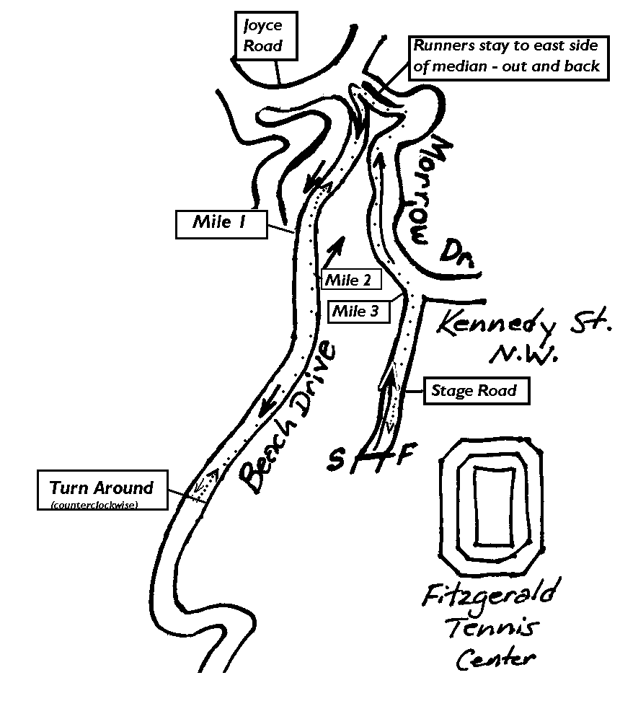  On Stage Rd. near the northwest corner of the Fitzgerald Tennis Center. 9 feet north (down course) of the north edge of the white pedestrian crosswalk.
Mile 1 | 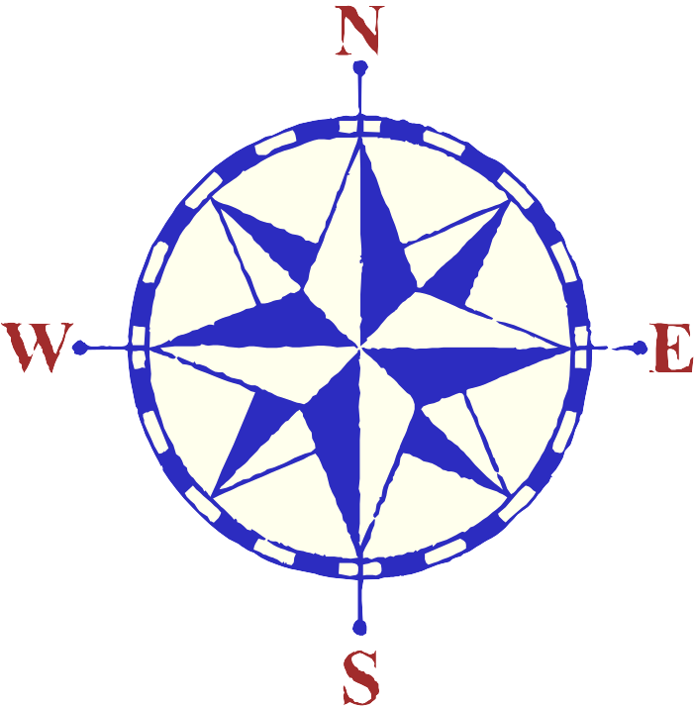  On Beach Drive going south. After a sharp left turn, 84 feet south (downstream) of the center of a metal manhole cover over the storm drain on the left (east) side.
Turn-  around | 15 ‘ south of “Picnic Area #4” sign. 30’ south of center of manhole cover on the east side of Beach.
Mile 2 | 9’ north of manhole cover on west side of Beach. 2’ past north end of low stone wall.
Mile 3 | Exactly at the corner of Morrow Dr. and Stage Road.
USATF Certification DC0900 JS
Expires 12-31-2019
Measured 6-14-2009 by Lyman Jordan

