On 27 June 1877, a 'Bright Lady' showed herself to 13-year-old Justyna Szafrynska and a day later also to her friend Barbara Samulowska. The lady appeared over the maple tree in front of the church, seated on a throne with the infant Jesus on her lap, surrounded by angels.
She told the girls she was the Blessed Virgin Mary of the Immaculate Conception, and she wished them to say the rosary every day. The Virgin blessed a spring, said the sick would be healed and asked that they too pray the rosary.
Asked what happens to people who swear falsely, the Holy Mother said that "Such person is not deserving to go to Heaven (and) is induced to do it by Satan".
The Prussian authorities saw the apparitions as an expression of Polish nationalism and sought to suppress the event, even imprisoning the local parish priest.

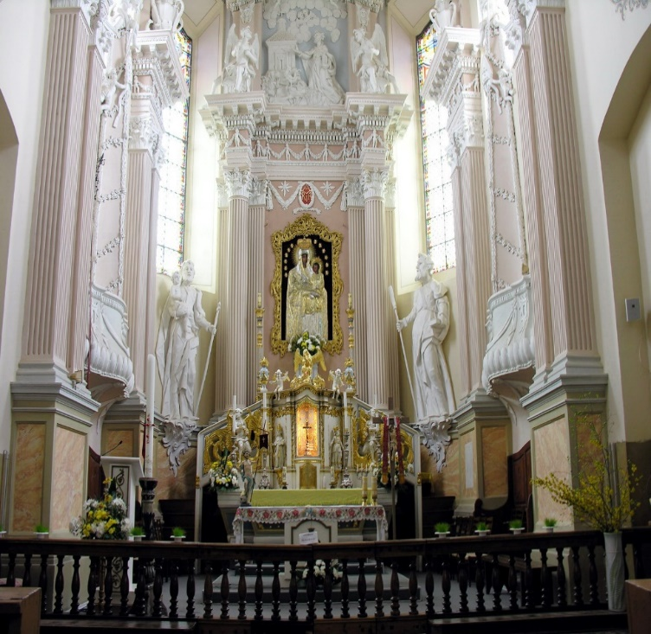
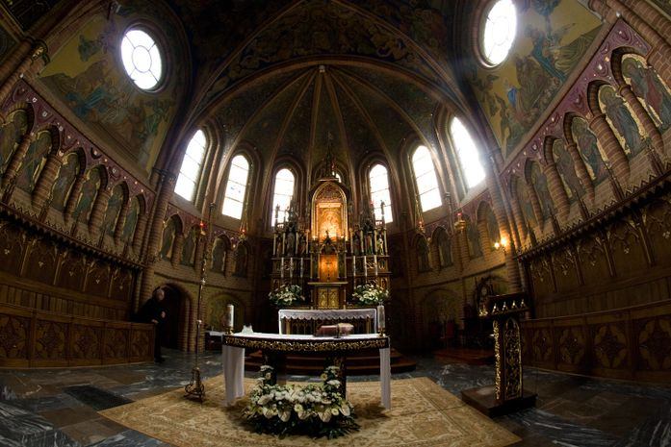

The inside of the basilica at Gietrzwald, the 'Polish Fatima'.
Image: Mazaki, CC BY-SA 4.0

