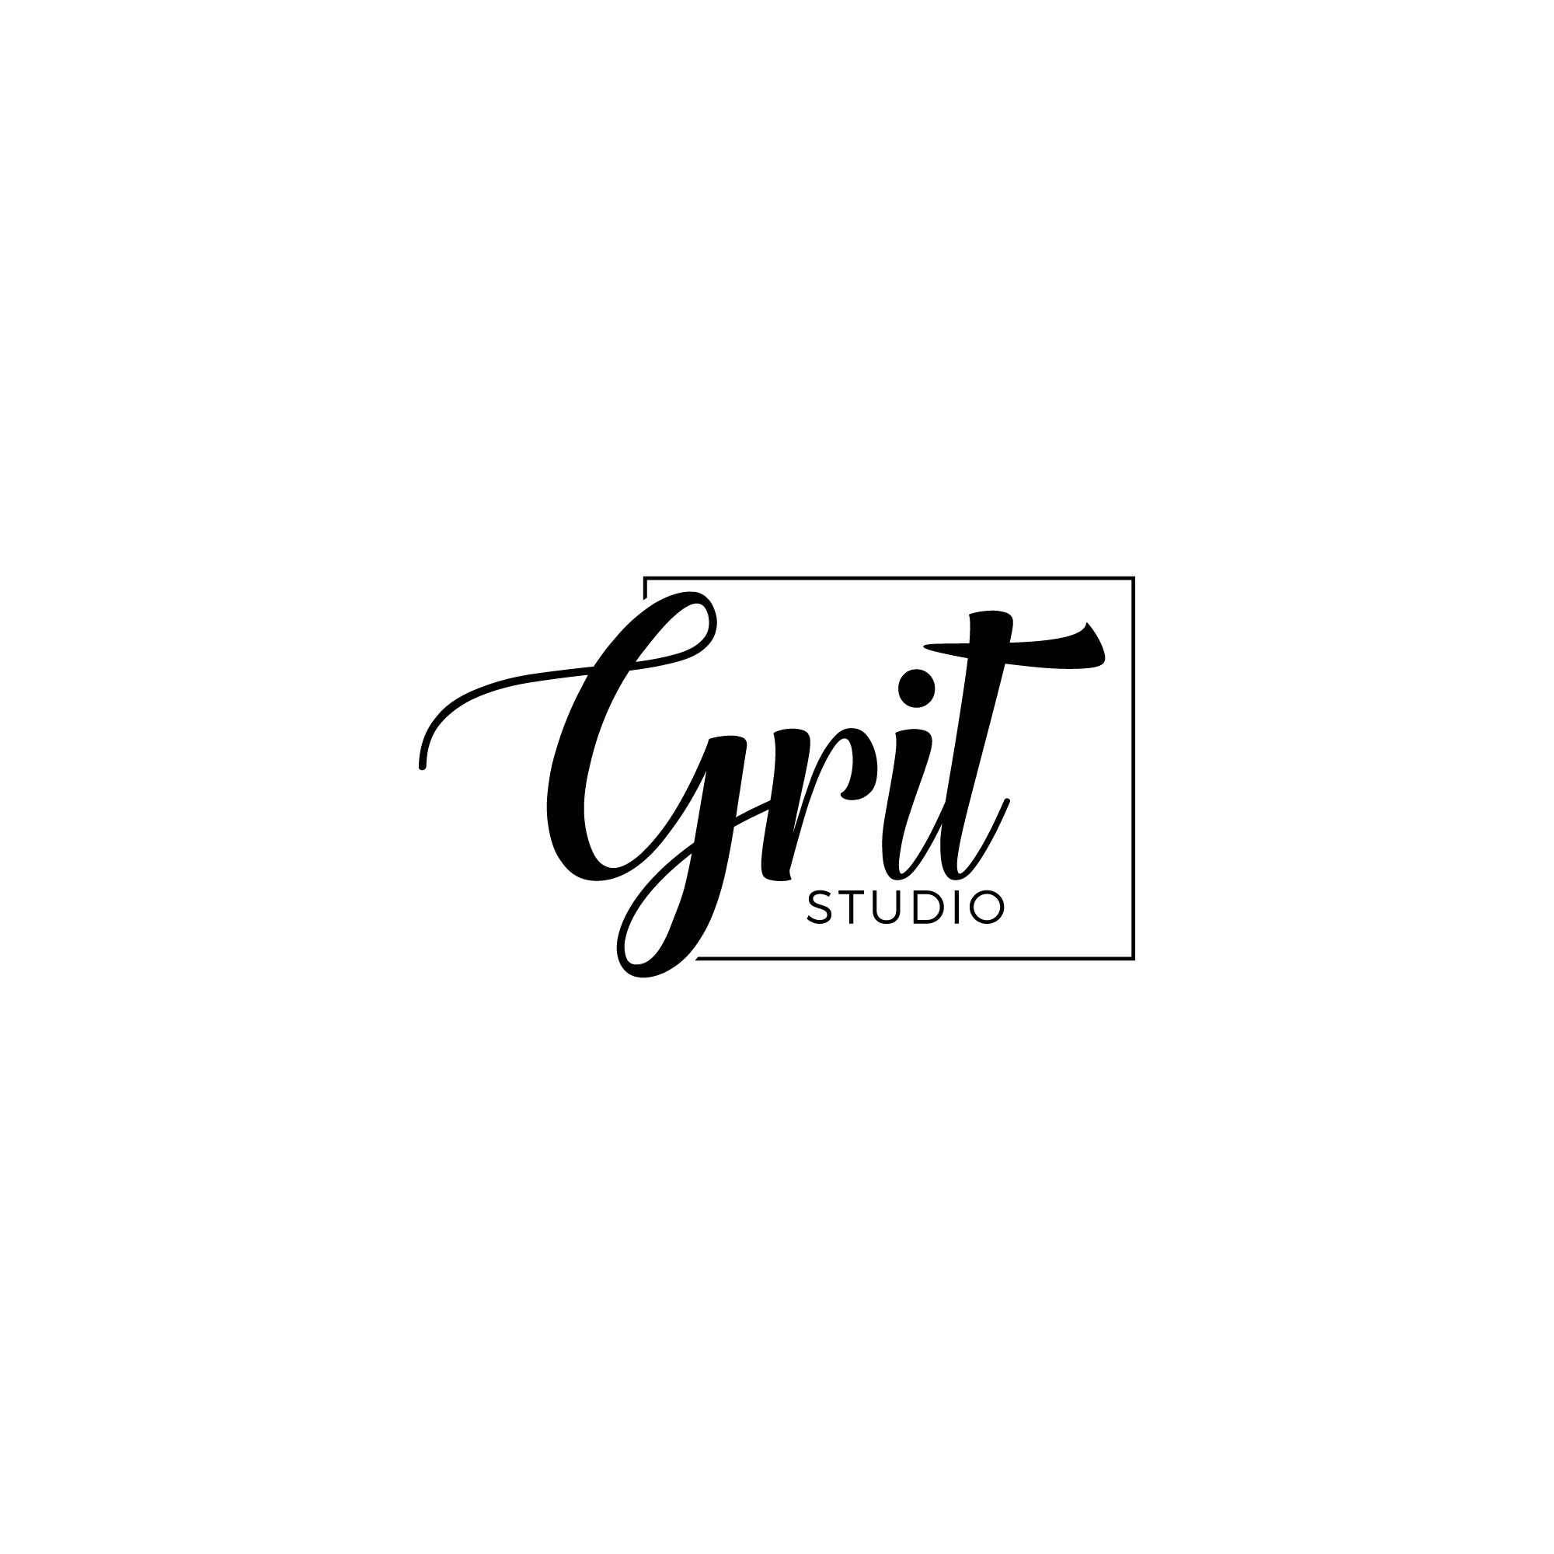

Kris Clark: Owner, Creative Director, Hair Stylist & Make-Up Artist
Email: krisclarkartistry@gmail.com
Website: www.krisclarkartistry.com
Phone: 603.858.4957

HAIR & MAKE-UP BRIDAL CONTRACT
Client: _______________________________________________
Phone Number: _______________________________________
Alternate Phone Number: ________________________________
Email Address: ________________________________________
Pre-Wedding Consultation/Run Through? Y / N
If Yes, Please Give a Desired Date & Time: _________________
(Please note that run through is an additional $345)
Photographer’s Name: _________________________________
Photographer’s Phone Number: __________________________
Wedding Planner’s Name: ______________________________
Wedding Planner’s Phone Number: _______________________
Start time of Wedding: __________________________________
Date of Wedding: ______________________________________
“Finished-by” Time: ______________________________
Location Where Services Are Being Rendered For Wedding:
___________________________________________________
Room Number: _______________________________________
Additional Relevant Information:__________________________
How did you hear about me?____________________________

MENU OF SERVICES
On-Location Services – I will come to your location where you will be getting ready before the wedding

BRIDE
Engagement/ Bridal Photo Shoot Makeup & Hair $460 = $_______
Wedding Day Makeup & Hair $575 = $_________
Bridal Makeup ONLY $345 = $_________
Bridal Hair ONLY $345 = $___________
Extra Hair/Hairpiece (starts at $173) = $____________
100% Human Hair Extensions/Clip Ins (start at $414) $_____________

BRIDAL PARTY
Mother/Bridesmaids Makeup & Hair $345 X_______ people=$_________
Mother/Bridesmaids Makeup ONLY $230 X_______ people = $_________
Mother/Bridesmaids Hair ONLY $230 X_______ people = $_________
Flower Girl Makeup and Hair (under 10) $115 X_______ people = $_________

“BLOW-DRY”
Short Hair (above the shoulders) $115 X_______ people = $_________
Long Hair (below the shoulders) $173 X_______ people = $_________
Assistant Fee: $35 per person, for each
additional person over 4 people = $__________

TOTAL DUE: $_____________________

All makeup applications include optional false eyelashes upon request. Thank you for inquiring about my bridal hair and makeup services.

Please read over my policies as stated below. I receive many inquiries and dates fill up quickly.

I. BOOKING MINIMUM:
There is a minimum charge of $700 for on-location services, which does NOT include the consultation or “trial run”.

II. TRAVEL: Client agrees to cover ALL valet/parking/flight and hotel expenses for on location services, for myself and for my assistant(s), if necessary. HOLIDAY FEE: $86 will be added to weddings booked on a holiday or holiday weekend.

III. HAIR EXTENSIONS: When booking hair extension services in advance, I will need to do one of the following A) see your hair during a consultation, or B) alternatively, you can send a clipping of your hair to my studio with your deposit, in order for me to match the color exactly. I will then purchase your hair extensions in advance of the wedding. Please note that ALL hair extensions are a non-returnable, non-refundable personal item.

IV. LIABILITY: All brushes and makeup products are kept sanitary and are sanitized between every makeup application. Makeup products used are hypoallergenic. Client(s) agree to release LOOKS, hair/make-up artist from liability for any skin complications
due to allergic reactions. If power outage, the client cannot hold LOOKS, hair/makeup artist responsible for discontinued use of the airbrush equipment if requested and, or hot tools in the need for electric. Services will resume with traditional application.

V. PHOTOGRAPHS: The client understands that any photographs taken during their trial or on the event day, may be used for promotional purposes, unless otherwise discussed with the artist.

PHOTO RELEASE FORM
Client’s name: ___________________and_______________________
We, the undersigned, hereby grant GRIT Studio, LLC
and her legal representatives and assigns, the right and permission to publish, without charge, select photographs taken at our wedding.
These photographs may be used on www.krisclarkartistry.com, as examples of weddings that she has worked on, or in promotional literature. We hereby warrant that we are over eighteen (18) years of age, and are competent to sign this contract in our own names.

Client Signature(s)

X______________________________________________
Sign Name
__________________________________________________
Print Name

VI. CONTRACTED SERVICES PER PERSON: You may add additional people before the wedding date. Please give ample notice of a minimum of 7 days if you will be making changes to your bridal party, as your artist may need to hire an assistant to
accommodate the extra services.

VII. BOOKING DEPOSIT: 50% deposit and contract is required to reserve your date. Deposit and contract can be mailed, OR deposit may be paid through Credit Card and contract faxed or emailed. Deposit is due upon signing of this contract.
I understand that this deposit is NON-REFUNDABLE if I decide not to use the service (“GRIT Studio, LLC ”) less than 6
months prior to my wedding date. By signing
below, I acknowledge that my credit card account will be charged for 50% of the amount due above, plus processing fee.

VIII. CONTRACTED DATE: I understand that if I cancel less than 6
months prior to the date of service, I will lose my deposit. If I cancel within 48 hrs prior of the service date; I will be subject to 100% of the fees due. Cancellation must be done in writing. Payment
of the balance in full is expected on the contracted “date of service” by cash ONLY. Prior arrangements to pay in full for the services using a credit card are also accepted, but must be arranged in advance. By signing below, I agree to & understand all the terms and conditions of this contract.

IV. MISCELLANY: If I cannot perform the agreed upon services due to unforeseen circumstances beyond her control, on the event day, 100% of all payments shall be returned to the client with the understanding that there will be no further liability with
respect to the agreement. This Agreement shall be binding upon the parties, their heirs, successors, assigns, and personal representatives. This Agreement constitutes the entire understanding of the parties. Its terms can be modified only by an instrument in writing signed by both parties, except that the Client may authorize expenses or
revisions orally. No terms attached to any check for payment under this Agreement can modify the Agreement except under an independent instrument in writing signed by both
parties.

X__________________________________________________
Sign Name
____________________________________________________
Print Name
____________________________________________________
Date

GRIT Studio, LLC
Thank You For Making Me Part Of Your Special Day!!!!

