June 2, 2009

Representative Spencer Black, Chair
Committee on Natural Resources
417 North (GAR Hall)
State Capitol
Madison, WI 53708

RE: Support for AB 278

Dear Chairman Black and Committee on Natural Resources Members:

Waukesha County Environmental Action League (WEAL) is an all volunteer organization established in 1978 to protect Waukesha County’s natural resources through dedicated grass-roots participation and action.

WEAL supports AB 278 because the Bill increases recycling, limits disposal, and promotes extended producer responsibly.

Since Waukesha County has two massive landfills; Emerald Park (Veolia) in Muskego, and Orchard Ridge (Waste Management) in Menomonee Falls, the passage of AB 278 will positively impact Waukesha County resident's environment and health.

Banning electronic waste from landfills and incinerators coupled with adding responsibilities for manufacturers and retailers, demonstrates AB 278 is well-planned and incorporates principal components for success.

WEAL urges the Committee on Environment to support AB 278.

Sincerely,
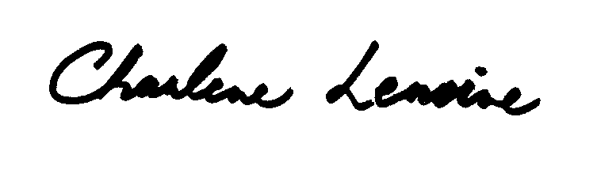
Charlene Lemoine
Waste Issues Representative
Waukesha County Environmental Action League (WEAL)

cc: Representative Penny Bernard Schaber (via e-mail)

