|  |  |  |  |  |  |
| --- | --- | --- | --- | --- | --- |
| John H. Finley Campus School  PS/MS. 129  425 West 130th Street  New York, NY. 10027 | | | | | |
|  |  |  | Parent Handbook  School Year 2020-2021 |  |  |

**Odelphia H Pierre, Principal**

**Andrea Story, Assistant Principal**

**Table of Contents**

WELCOME ......................................................................................................................................................3

SCHOOL CALENDAR……………………………………………………………………………………-4-7

VISION AND MISSION................................................................................................................................. 8

CREATE A SCHOOL ACCOUNT……………………………………………………………………….….9

INSTRUCTION..........................................................................................................................................10-11

LEARNING BRIDGES...................................................................................................................................11

EXPECTATIONS………………………………………………………………………………………….12

COVID-19 PROTOCOL…………………………………………………………………………………13-14

IMMUNIZATION REQUIREMENTS ................................................................................................... 15-17

NYCDOE ATTENDANCE POLICY........................................................................................................... 18

ELEMENTARY SCHOOL PROGRAM ...........................................................................................................21

MIDDLE SCHOOL PROGRAM................................................... ....................................................................21

**WELCOME**

September 2020

Welcome new and returning families,

John H. Finley Campus School is a place where every student's education is met with hands-on support and an individualized education plan for future successes; we truly take to heart our motto "Every Student, Every Day."

Finley is currently preparing for Remote and Blended Learning models. Blended Learning means that students learn part of the time in-person at the school building, and part of the time remotely from home. A family can also choose all-remote learning this fall, for any reason. For example, if you begin in blended learning, you can decide later to transition to all remote. However, to best support our school in planning for reopening, we ask that those who prefer 100% remote notify the school as soon as possible.

Through an individualized and adaptive plan for educational success, John H. Finley Campus School stands strong on a foundation of motivation and achievement. We are excited to work with and engage families and students who believe in the benefits of online schooling and strive for comprehensive, collaborative mastery of their own goals and educational dreams. We welcome you to the John H. Finley Campus School family!

Sincerely,

Odelphia H Pierre,

Principal

**NYCDOE Calendar School Year 2020-2021**

| **DATES** | **WEEKDAYS** | **NOTES** |
| --- | --- | --- |
| **September 16–18** | Wednesday–Friday | Fully remote orientation day for students. |
| **September 21** | Monday | First full day of school; blended learning commences. |
| **September 28** | Monday | Yom Kippur, schools closed |
| **October 12** | Monday | Columbus Day, schools closed |
| **November 3** | Tuesday | Election Day, fully remote instructional day for all students |
| **November 4** | Wednesday | Evening parent teacher conferences for elementary schools and K–8 schools. |
| **November 5** | Thursday | Afternoon parent teacher conferences for elementary schools and K–8 schools; students in these schools dismissed three hours early. |
| **November 11** | Wednesday | Veterans Day, schools closed |
| **November 12** | Thursday | Evening parent teacher conferences for high schools, K–12, and 6–12 schools. |
| **November 13** | Friday | Afternoon parent teacher conferences for high schools, K–12, and 6–12 schools; students in these schools dismissed three hours early. |
| **November 18** | Wednesday | Evening parent teacher conferences for middle schools and District 75 school programs. |
| **November 19** | Thursday | Afternoon Conferences for middle schools and District 75 school programs; students in these schools dismissed three hours early. |
| **November 26–27** | Thursday–Friday | Thanksgiving Recess, schools closed |
| **December 24–January 1** | Thursday–following Friday | Winter Recess, schools closed |
| **January 18** | Monday | Rev. Dr. Martin Luther King Jr. Day, schools closed |
| **February 1** | Monday | Professional Development Day for 9–12 and 6–12 schools in Districts 1–32 only; students in these schools do not attend.  Students in K­–5, K–6, 6–8, and K–12 and D75 schools and programs are in attendance. |
| **February 12** | Friday | Lunar New Year, schools closed |
| **February 15–19** | Monday–Friday | Midwinter Recess (includes Presidents’ Day and Lincoln’s Birthday), schools closed |
| **March 3** | Wednesday | Evening parent teacher conferences for elementary schools and K–8 Schools. |
| **March 4** | Thursday | Afternoon parent teacher conferences for elementary schools and K–8 schools; students in these schools dismissed three hours early. |
| **March 10** | Wednesday | Evening parent teacher conferences for middle schools and district 75 schools and programs. |
| **March 11** | Thursday | Afternoon parent teacher conferences for middle schools and district 75 schools and programs; students in these schools dismissed three hours early. |
| **March 18** | Thursday | Evening parent teacher conferences for high schools, K–12, and 6–12 schools. |
| **March 19** | Friday | Afternoon parent teacher conferences for high schools, K–12, and 6–12 schools; students in these schools dismissed three hours early. |
| **March 29–April 2** | Monday–Friday | Spring Recess, schools closed |
| **May 13** | Thursday | Eid Al-Fitr, schools closed |
| **May 31** | Monday | Memorial Day, schools closed |
| **June 3** | Thursday | Anniversary Day. Chancellor’s Conference Day for staff development. Students not in attendance. |
| **June 8** | Tuesday | Clerical Day for K­–5, K–6, 6–8, and K–12 and D75 schools and programs only; students in these schools do not attend.  Students in 9–12 and 6–12 schools in Districts 1–32 are in attendance. |
| **June 25** | Friday | Last day of school for all students. |

**School Vision**

To establish a school culture that puts children first to ensure academic excellence through continuous –aggressive progress monitoring that promote academic achievement and mastery for all students.

**Mission Statement**

At the John H. Finley Campus School, we believe that all children are entitled to a high quality education. We are committed to developing a child-centered environment and instructional program, which will result in a community of critical thinkers and lifelong learners. With the collaborative efforts of parents, faculty, students, and community, we 2020-2021 our students to become responsible, productive and enlightened individual. We will collectively hold ourselves accountable to ensure the following:

* The Common Core State Standards will be utilized to provide a consistent, clear understanding of what students are expected to learn, so teachers and parents know what they need to do in order to ensure academic success.
* Instructional programs will be developed to fully prepare our students for college, careers and beyond, to compete successfully in the global economy.
* Use of current and relevant student data will inform and drive standard based instructional practice.
* All students are expected to reach high standards of proficiency- our goal is to have 90% of our students at achievement levels 3 and above in reading and mathematics standardized tests.
* Instructional programs will provide an environment whereby literacy will be infused in all subject areas (social studies, science, mathematics, technology and the arts).
* Emphasis will be paced on alignment of curriculum and assessment, in order to increase the level of student thinking and engagement to ensure that students attain grade level performance.
* Administration, staff, parents, and community stake holders are involved in a collaborative decision making process.

**Create a New York City Department of Education School Account**

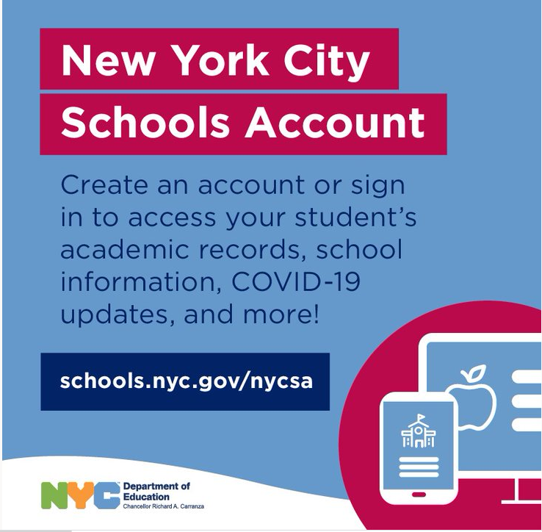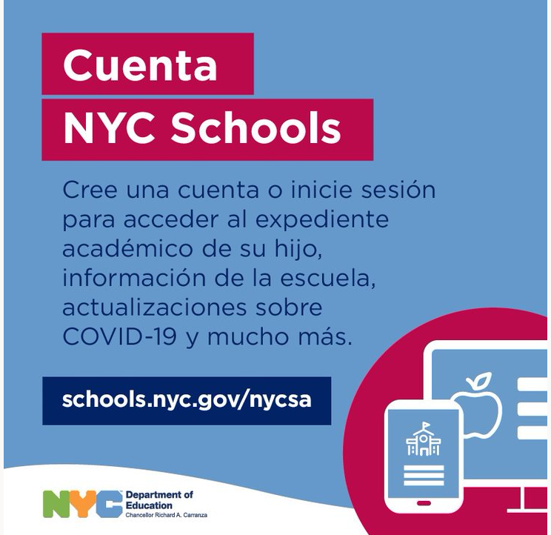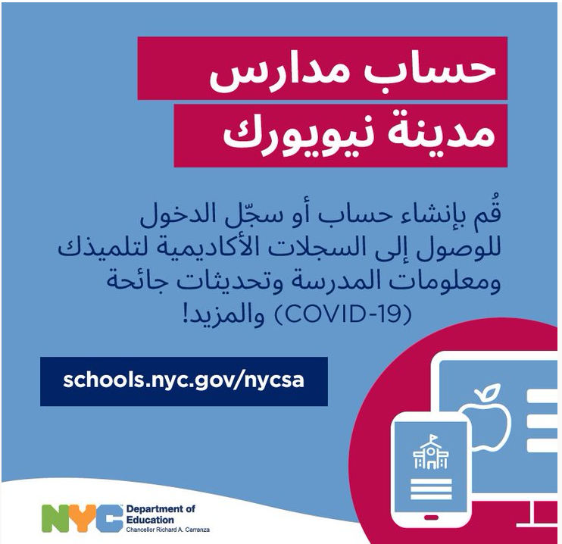

Instruction

Students, whose parent have not opted for full remote John H. Finley will engaging in blended learning. Blended learning adds technology, resources, and flexibility to personalize instruction. Students will maximize learning time as more digital content and innovative data resources become available.

​ The DOE will provide supports to schools on:

Blended learning models that support instruction to ensure students continue learning whether in school buildings or at home;

* Using data and tools to understand the individual academic needs of each student, and support students who may have lost learning or skills during remote instruction;
* Identifying shared, inclusive, and standards-based curricula that schools may use to support learning happening in-person and remotely; and
* Emphasizing culturally responsive, inclusive and sustaining educational content and practices based on students' racial and cultural identities.

Schools will have the option to use iLearnNYC and/or Google Classroom to provide a cohesive and consistent student experience. These tools will be available in phases, based on funding availability and other factors.

**Learning**

Whether your child is participating in blended learning or learning 100 percent remotely, they will receive instruction by 1) interacting live with their teachers and 2) by independently completing assignments and projects throughout the school day and week.

**Teachers**

Students engaged in remote learning will, for the most part, be taught by teachers from their school community. While there may be limited exceptions on a school-by-school basis, parents can expect their children to be assigned teachers from their school community when they receive their children’s full schedules before the school year begins.

**Live Interaction**

Teachers will provide daily live instruction for our fully remote learners, as well as for those students participating in the blended learning model. Teachers will deliver live instruction in short intervals (15– 20 consecutive minutes) throughout the school day for our youngest learners and may increase in length based on the student’s developmental stage and grade level. We will share additional information on live instruction in the coming weeks.

**Posting Schedules**

Schools will post class schedules and schedules for live instruction for all students—those fully remote as well as those participating in blended learning—online. You will have access to these schedules in advance so you can plan your work and family commitments. Schools will also ensure students have sufficient time for high-quality interactions with their teachers and classmates.

**Direct Support**

Teachers will have dedicated time every school day to engage with students and families via video conference or telephone. We encourage you to take advantage of this time to get guidance and updates related to your child’s progress and learning.

We will send more information in the coming days and weeks. As always, we encourage you to check schools.nyc.gov/returntoschool2020 for the latest information on what the next year will bring. Thank you for being part of the DOE/John H. Finley Campus Academy family.

**Social-Emotional Support**

We know that current circumstances in the pandemic have been very difficult for you and your children. Students have been isolated from their teachers, classmates, and school communities. For this reason, we will allow time for teachers, school-based staff, and students to readjust to being in school buildings and to adapt to changes. In addition, we will integrate social-emotional activities and trauma-informed care into academic subjects to the greatest extent possible throughout the day. We will also prioritize mental health supports throughout the school year.

These brief grounding conversations matter. Checking in students to process instructions they received from their teachers, and it helps them organize themselves and set priorities – older students too. Not all students thrive in distance learning; some struggle with too much independence or lack of structure. These check-in routines can help avoid later challenges and disappointments. They help students develop self-management and executive functioning that are essential skills for life. Parents are good life coaches.

**Grading**

All students must meet the same academic requirements, whether they are engaged in fully remote or blended learning. The teacher overseeing your child’s classwork is responsible for designing or selecting assessments

**LEARNING BRIDGES PROGRAM**

The Learning Bridges Program Will:

Be operated by community-based organizations and other partners Provide opportunities for children to engage in learning activities Include time for art, recreation, and other age-appropriate activities Follow the same rigorous health and safety precautions as schools

Instruction School Year 2020-21

**Expectations**

1. Establish routines and expectations

It is important to develop good habits from the start. Create a flexible routine and talk about how it’s working overtime. Chunk your days into predictable segments. Help students get up, get dressed and ready to learn at a reasonable time. Everybody make your bed! Keep normal bedtime routines, including normal rules for digital devices. Adjust schedules to meet everyone’s needs but don’t default to staying up late and sleeping in (However, a ‘duvet day’ now and then can be a treat).

2. Choose a good place to learn

Your family’s regular learning space for occasional homework might not work for extended periods. Set up a physical location that’s dedicated to school-focused activities. Make sure it is quiet, free from distractions and has a good internet connection. Make sure an adult monitors online learning. Keep doors open, and practice good digital safety. Our teachers, counsellors and safeguarding teams will do the same.

3. Stay in touch

Teachers will mainly be communicating regularly through our online platforms and virtual learning environments. Make sure everyone knows how to find the help they need to be successful. Stay in contact with classroom and support teachers, school leaders and counsellors but understand it may take a day or two for us to respond. If you have concerns, let someone know.

4. Help students ‘own’ their learning

No one expects parents to be full-time teachers or to be educational and content matter experts. Provide support and encouragement, and expect your children to do their part. Struggling is allowed and encouraged! Don’t help too much. Becoming independent takes lots of practice. At ACS, your child usually engages with others students and any number of adults hundreds of times each day. Many of these social interactions will continues from a distance, but they will be different. You cannot replace them all, and that’s OK.

5. Begin and end the day by checking-in

In the morning, you might ask:

• What classes/subject do you have today?

• Do you have any assessments?

• How will you spend your time?

• What resources do you need?

• What can I do to help?

At the end of the day you might ask:

• How far did you get in your learning tasks today?

• What did you discover? What was hard?

• What could we do to make tomorrow better?

**COVID-19 Information and Protocols**

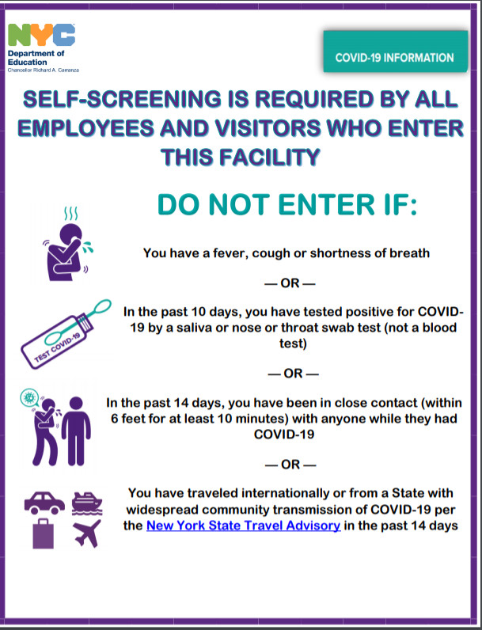

**COVID -19 Testing**

The city has said it will prioritize free rapid COVID-19 testing for school staff and students and will encourage them to get tested on a monthly basis and also provide free face coverings to them and disinfect schools throughout the day.

But one positive COVID-19 test in a classroom would be enough to quarantine an entire classroom for two weeks, and two cases confirmed within a school would shut the entire school for two weeks.

**PPE and Face Coverings**

The mandatory use of face coverings while on NYCDOE property must be enforced for all individuals, including staff, students, and essential visitors, with the exceptions below. NYCDOE will communicate, educate, and reinforce the required wearing face coverings with families engaged as full partners in this process. Exceptions to face covering usage are as follows:

Medically verified students who cannot tolerate a face covering, including where students for whom the use of such coverings would impair their physical or mental health;

Where the use of face covering is inappropriate considering the development level or age of the student (e.g. under two years old);

Guidance and policies will account for any modifications to social distancing or PPE that may be necessary for certain student or staff populations, including individuals who have hearing impairment or loss, students receiving language services, and young students in early education programs, ensuring that any modifications minimize COVID-19 exposure risk for students, faculty, and staff, to the greatest extent possible.

**Visitors**

To minimize opportunities for spread is a necessary component for maintaining health and safety in NYCDOE schools. In an effort to limit the number of visitors in a school at any given time, as recommended by the CDC, Finley are encouraged, where possible, to address all visitor and parent concerns by phone or virtually. Principals and designated staff should conduct meetings remotely, where possible. When

**Lunch in the Classroom**

In-person student lunch will be instructional time in most instances, modeled on our Breakfast in the Classroom program. In elementary schools, for example, during lunch, students will take part in learning activities that are fun, engaging, and enriching, such as interactive read-alouds, social-emotional learning, and content through music. In middle during lunch, students will engage with a specific content area. Schools will maintain all health and safety guidelines for in-person learning and for consuming food and drink during this time.

**Community Building**

All students will have routines that build community, center the day,  and set them up for success. These procedures will provide students with relationship building experiences that are an integral part of a typical school community.  For example, this may consist of a daily morning meeting where the teacher engages students in activities related to social-emotional wellness and community-building, or a daily closing activity where the teacher recaps the learning for the day, and gets students prepared for the following day. Schools and teachers will share more about this as we approach the first day of school.

# 2020-21 School Year

**New York State Immunization Requirements for School Entrance/Attendance**

## NOTES:

Children in a prekindergarten setting should be age-appropriately immunized. The number of doses depends on the schedule recommended by the Advisory Committee on Immunization Practices (ACIP). For grades pre-k through 11, intervals between doses of vaccine should be in accordance with the ACIP-recommended immunization schedule for persons 0 through 18 years of age. Doses received before the minimum age or intervals are not valid and do not count toward the number of doses listed below. Intervals between doses of vaccine DO NOT need to be reviewed for grade 12 except for interval between measles vaccine doses. See footnotes for specific information for **each** vaccine. Children who are enrolling in grade-less classes should meet the immunization requirements of the grades for which they are age equivalent.

**Consult your physician for requirements that MUST adhered to for admission for this school year.**

|  |  |  |  |  |  |
| --- | --- | --- | --- | --- | --- |
| Vaccines | Prekindergarten (Day Care, Head Start,  Nursery or Pre-k) | Kindergarten and Grades 1, 2, 3, 4 and 5 | Grades 6, 7, 8, 9, 10  and 11 | Grade 12 | |
| **Diphtheria and Tetanus toxoid-containing vaccine and Pertussis vaccine (DTaP/DTP/Tdap/Td)2** | **4 doses** | **5 doses**  **or 4 doses**  if the 4th dose was received at 4 years or older or  **3 doses**  if 7 years or older and the series was started at 1 year or older | **3 doses** | | | |
| **Tetanus and Diphtheria toxoid-containing vaccine and Pertussis vaccine booster (Tdap)3** | **Not applicable** | | **1 dose** | | | |
| **Polio vaccine (IPV/OPV)4** | **3 doses** | **4 doses**  **or 3 doses**  if the 3rd dose was received at 4 years or older | **4 doses or 3 doses** if the 3rd dose was received at 4 years or  older | | **3 doses** | |
| **Measles, Mumps and Rubella vaccine (MMR)5** | **1 dose** | **2 doses** | | | | |
| **Hepatitis B vaccine6** | **3 doses** | **3 doses** | **3 doses or 2 doses**  of **adult hepatitis B vaccine** (Recombivax) for children who received the doses at least 4 months apart between the ages of 11 through 15 years | | | |
| **Varicella (Chickenpox) vaccine7** | **1 dose** | **2 doses** | | | **1 dose** | |
| **Meningococcal conjugate vaccine (MenACWY)8** | **Not applicable** | | **Grades**  **7, 8, 9 and 10:**  **1 dose** | | **2 doses**  **or 1 dose**  if the dose was received at 16 years or older | |
| **Haemophilus influenzae type b conjugate vaccine (Hib)9** | **1 to 4 doses** | **Not applicable** | | | | |
| **Pneumococcal Conjugate vaccine (PCV)10** | **1 to 4 doses** | **Not applicable** | | | | |

**NYC Department of Education Attendance Policy**

In SY 2020–21, the DOE will track and follow up upon the attendance for every student every day (Monday through Friday), regardless as to whether those students are engaged in remote or in-person learning, and schools will use the daily attendance values of P=Present and A=Absent for in-class attendance and O=Present and M=Absent for remote attendance. (Schools that schedule periods of instruction must also record period attendance, though it is not required to be stored in ATS.) The definition of “present” will be defined as:

* In Person: Student is physically present in the classroom / school learning environment for instruction during the scheduled school day.
* Remote: Student is virtually present in a virtual learning environment for synchronous instruction during the scheduled school day.

Please note that early childhood programs are required to limit screen time to 20 minutes per day and much of the remote learning day should be spent on asynchronous activities, which means that the definition of present for remote learning should be modified for students in 3-K and pre-K classes. For 3-K and pre-K, participation in asynchronous activities can count as daily attendance. Please refer to additional guidance forthcoming from the Division of Early Childhood Education.