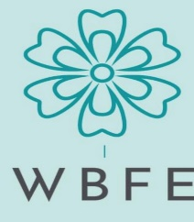
MAR 2023
WARM BLANKETS FOR EVERYONE
Latest News & Updates

OPENING ADDRESS

Hello Warm Blankets volunteers,
Off to a great start at Warm Blankets for 2023.
We are now making 'PRIORITY BLANKETS', i.e. making blankets for the greatest needs first.
These are prepared weekly, and pinned by the teams ready for the sewers. At the beginning of the year, the pinners were also sewing these blankets in order to build up stock. Some sewers still collect kits at the workshop to sew at home, and at the workshop we now have a production line in full swing. This is helping keep supply up to needs.
We are now into a routine, with the pinning teams currently working on the dark blankets for those people 'sleeping rough'. This year we will include dark beanies and fingerless gloves in our outreach.
Blankets for WHO's are also up and running, with the first 100 WBFE blankets of their order for 200, recently being delivered. All other organizations needs are all being addressed on a priority needs basis. It is working well.
There have been many new volunteers so far this year, most coming from our speaking engagements at various organizations. We have done three so far with two more booked. As always, the groups are 'absolutely stunned' at what we do. By speaking at local community groups, we are becoming quite well known. We regularly hear, 'Warm Blankets For Everyone', 'yes, we have heard of you.'

I was very sad to learn that one of our volunteers, Gillian Fehlberg, passed away recently. Gillian learned about WBFE when she came to Laverty for blood tests a couple of years ago. She initially popped in to find out what we were all about and then joined the Tuesday group. Last winter she knitted some very lovely shawls for our fundraising markets. Gillian made beautiful Christmas Candles, which we are planning to use at the Christmas in July, High Tea. We will enjoy these candles and remember Gillian.

Thank you to everyone for completing the Volunteer Form. This is important for our records as well as for insurance purposes. We now know we have 86 active Volunteers which is fantastic.
Many thanks to all of you, everyone in the Warm Blankets team is making a difference.
Keep up the good work. We are meeting a great need within our community and further afield.
Well done,
Sue Bardsley
Chairman / Co-founder WBFE

TEAM LEADER REPORTS

Monday Preppers (Sue Bardsley)
This group started with about 7-8 showing interest, however, it sits at about four regulars now, i.e. on a good day! We meet once a month on the first Monday, 9.30 a.m. to 12.30 a.m. for whatever time volunteers have spare to help.
At this group we sort the larger pieces of fabric for the toppers, add if necessary and pin for the sewing girls. It is working well, and I especially thank Glennis for her support.

Tuesday (Rebecca Wett)

We all started back on Tuesday 31st January. It was nice to have a break over the Christmas & New Year period to catch up with family & friends but it was also nice to come back to WBFE to start another year doing something that is worth while for our community that need our help.

We have been busy pinning blankets for the sewing team. Lately we have been pinning children blankets. We average about 12 to 13 adult blankets or about 20 children blankets a week. I have been away for the last couple of weeks spending some quality time with my mother. Carolyn, Kay & Sandra have been pinning blankets to keep up with the demand. It’s wonderful to have such a supporting & helpful team. We all enjoy coming on a Tuesday morning & catching up with each other.

It is with great sadness that I advise that our good friend Gillian passed away. Gillian will be truly missed from the Tuesday group. Our thoughts & prayers go out to the family.

Wednesday AM (Julie Farquhar)

Our Wednesday mornings continue to be a time of work laced with laughter and interesting discussions on the world around us. Over the past few weeks we have been listening to Haptic and Hue podcasts where Jo Andrews explores the world of material and its history. This is worthwhile listening and free to air if you have Audible or just as easily downloaded. Also The Sewing Bee, a British sewing competition on Britbox has become a talking point too.
The team works with the changes that take place and continues to diversify, all showing skills in pinning, sewing and material organisation. We remain a varied and lively group of women, now friends, who are threaded together through sewing and the charity. Excellent cooking skills too!
We care about doing the best we can for the people who need it most.

Wednesday PM (Christine Gill)

Wednesday afternoon workshop is running smoothly. Our team of seven has just welcomed a new member, Elizabeth. Sounds like a lot of members in our team but there is always one or two on well deserved holidays, appointments to attend, grandchildren to mind, and unfortunately occasional illness means our full team isn’t always in attendance.
We started off the year sewing toppers onto backing but now as the stock of blankets have built up, attending to all the little jobs which keep the 'priority blankets' flowing. Chez and Ruth are expert pinners (and Pat has been lending a hand here as well), Joan, Pam, Susan, Chris and Elizabeth are madly sewing with Chez and Ruth sewing when not pinning. Pat is a rare gem who loves ironing!! (We are all grateful for that!)
One task we all ‘loved’ was sewing scraps of fleece together to create ‘interesting’ toppers! Thank you Sue for these projects...it was a pleasure??? putting those together!!! All jokes aside it was good to make something useful out of scraps and this is one of the aims of Warm Blankets...cutting down on waste while keeping people warm. Sue has said we are getting a break.......what a shame!
Looking forward to keeping on working together for Warm Blankets for Everyone!

Thursday (Ruth Dewar)

Thursday afternoon sewing group continues on happily, under the guidance of Sue and Roberta.
After our Christmas break, we have jumped back into full production, cutting, pinning and sewing.
We are happy with the new system of sewing to match the colour of the backing fleece.
(Saves changing the bobbin all the time too)
We laugh and chat away whilst working and always look forward to our coffee break and stop to hear any news or current travel plans from our group members.
Our afternoons are always productive and fun and our members look forward spending the afternoon together each week.

Friday (Helen Clarke)

Well here we are in April and the new working year for the Friday team went off to a flying start. Sue was aware that many organizations were in need of blankets getting ready for winter so we changed our approach. We went for the production line method with a gradual moving from the first stage to the last by-passing things on to the next person to do their bit. It worked very well.
We have a new member on our team Mary, who has brought such enthusiasm to the group and we are also pleased to see Danuta back on a more regular basis. Charmaine has left us for the present as she is studying. We are all still enjoying our Fridays together.

FUNDRAISING REPORT (Rebecca Wett)

Last year the Fundraising Team accomplished a lot. We raised just under $10,000 in 2022.

This year our committee has put together some great events that will be taking place during 2023.
See below for a list of events that you might want to mark on your calendar for 2023.

DATE EVENT VENUE
Thursday 27th April. Lake Cinemas movie matinee. Boolaroo.

Saturday 6th May. Lake Mac Autumn Fair. Speers Point.

Saturday 22nd July. Christmas in July High Tea. St Luke’s Hall Belmont.

Saturday 16th September. Living Smart Festival. Speers Point.

Saturday 7th October. Fashion Parade. St Luke’s Hall Belmont.

Saturday 18th November. Volunteers Afternoon Tea. St Luke’s Hall Belmont.

Late Nov (TBA). Christmas Twilight Markets. Foreshore Warners Bay.

Lake Mac Autumn Fair Working Bee: The Fundraising team will be organising another Working Bee in April ( Date to be Advised) for the up coming Lake Mac Autumn Fair. We are making items for Mother’s Day. Some of the items we are planning to make are MiPad case, Project bag, Mobile Phone bags, Aprons, jewellery bags, cosmetic bag, coat hangers, Yoga bolsters etc. Patterns will be provided & there is plenty of material in the storeroom to select from. If you have some time to spare please come along. Everyone is welcome. I would like thank Glennis, Judy, Christine, Kay & Carolyn for coming along to the working bee on Tuesday 14th March for our 1st working Bee. Lots of exciting samples of purses, baby toys, gift bags & handbags were brought forward by Judy Quintal & Christine Kable.

Movie Matinee: A flyer will be organised very shortly for our Movie Matinee on Thursday 27th April. The movie is called “Allelujah” with Judy Dench. The Plot is about the threatened closure of a geriatric ward in a small Yorkshire hospital. This stirs up an uprising from the local community, who invite a news crew to film preparations for a concert in honour of the hospital’s most distinguished nurse. Please invite your friends to come along.

Christmas in July High Tea: Our popular High Tea event is happening on the 22nd of July. The theme this year is Christmas in July. Please be assured that all WBFE Volunteers will be given 1st priority in purchasing tickets.

Raffle: Julie Farquhar’s Wednesday morning group have volunteered to make a child’s cubby house, that has it’s own fold away table. We will be raffling this throughout the year at our upcoming events. Please find some photos below of the portable cubby house Julie made for her Granddaughter.

As you can see our Fundraising Team is working hard to raise money to help the people in need. If you would like to join our Committee please contact Sue Bardsley on 0408 242 921.

I would like to thank all of our Volunteers for their support, time and generosity. Without your support our fundraising wouldn’t be possible

It’s going to be a busy year of fundraising. Our plan is to have a working bee once a month. If you can help us lighten the load we would love to see you.

CHILD’S PORTABLE CUBBY HOUSE PHOTOS.

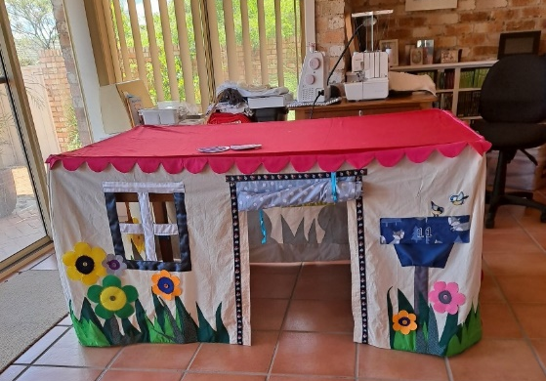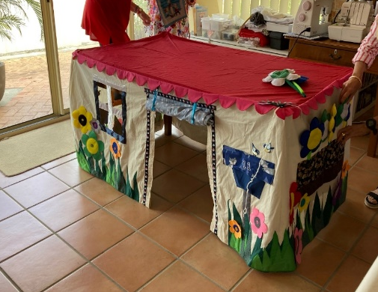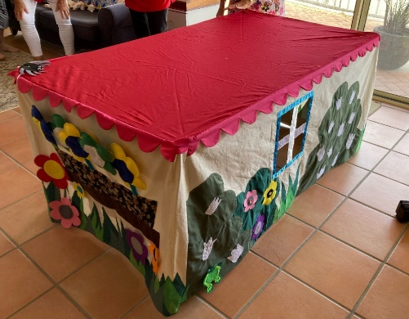

GUEST SPEAKING ENGAGEMENTS & WORKSHOP VISITS

WBFE is still very popular and in high demand. Sue, Di & Dave are become “old hands” on the speaker circuit. This is very important as it both promotes the excellent work that the Group does and acknowledges the wonderful work done by all the Volunteers.

February
- Presentations were given to:
- New Lambton Sewing Group. We had some generous fabric donations from this session.
- Merewether View Club.
- New Lambton Probus. We gained a new organisation to supply blankets to from this event as one of the ladies took our brochure and gave it to the Christ Church Cathedral representative.

DISTRIBUTIONS (Di Ebert)

The 2023 year has started out as busy as 2022 ended. Already we have packed / delivered over 500 blankets. This year I am breaking down the numbers between the WBFE made, woollen & crochet blankets.

I have been in contact with all the organisation on our list to remind them about WBFE and to see if there is any way we can support them in 2023.

We provided 31 blankets plus beanies etc to Christ Church Cathedral, a newly acquired organisation resulting from our recent talk to the New Lambton Probus Club. This will likely be an ongoing monthly delivery. The Cathedral provides a 3 course luncheon (for approx. 70 guests) fortnightly for the homeless, people living in cars and victims of abuse. Students from Newcastle Grammar do the serving. They are very happy to receive anything WBFE can provide.

We Help Ourselves (WHO’s) in Cessnock has again requested 200 blankets. We have already provided them with 100 WBFE blankets as well as number of crochet blankets, beanies and gloves. The remainder will be delivered over the next 2 months.

We also provided 50 crochet blankets to an Aboriginal Mission in Deniliquin.

The 5 Organisations that we provide ongoing regular Blankets deliveries in 2023 are:

Food Not Bombs  Support for the homeless around Hamilton Station | Fortnightly | 10 Blankets  (until the cooler months)
STRAS Belmont Hospital  Supports patients transitioning to Aged Care | Monthly  (from May) | 10 Crochet Blankets
Mum’s Cottage  Family Support organisation in Homesville | Monthly | 30 Blankets
We Care Connect Wyong  Support for children living in poverty across the Central Coast | Monthly | 40 – 50 Blankets
We Care Connect Thornton  Support for children living in poverty across the Hunter | Monthly | 10 – 20 Blankets

Just a reminder that the packed bags in the “Good 360 Room” have been counted and nothing should be added to these bags. If there are any items for a specific organisation please leave them on the “Blanket Room” table with a note so I can include them in the records.

Thanks
Di Ebert

VOLUNTEER FEEDBACK

My name is Christine Kable. I am part of the Wednesday group and I thoroughly enjoy our mornings together. I can’t remember when I joined Warm Blankets but I have been receiving emails from Sue for a few years.

I was a Textiles and Design and Home Science teacher. As a child I enjoyed sewing with bits and pieces on Mum’s treadle sewing machine and I have loved sewing and appreciating fabrics ever since.

After I gave up teaching, I lived in Japan and I recycled kimono and kasuri (Japanese indigo dyed fabric). I gave away the things that I had made until I was asked to hold an exhibition. After four exhibitions I packed away the machine for a few years, but I still enjoyed textiles. I got the machine out again to sew for Boomerang Bags and Warm Blankets For Everyone and not many days go by without me sewing. (During Covid I taught myself to sew and read the subtitles of movies and dramas.)

Please keep contributing to Warm Blankets.
Christine
CUSTOMER FEEDBACK

Friends With Dignity
Hi Di
A very belated thank you for the delivery last week. It is already being handed out to our clients.
The curtains were amazing too. We are tackling our biggest ever sanctuary in the area this week. Mum and 7 kids. We knew we needed curtains, and our volunteer took the bag down from you and has all but one window covered (literally). given that each family member will receive a quilt and a blanket, I may be contacting you again sooner rather than later. Thanks for your support, and please pass on our thanks to your volunteers.

Elizabeth
Friends With Dignity (FWD)
27/2/23

This is how Friends with Dignity have set up the rooms using the WBFE Blankets and donated curtains. Very Spectacular!

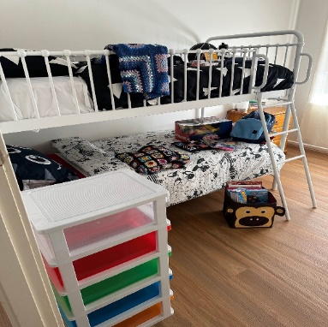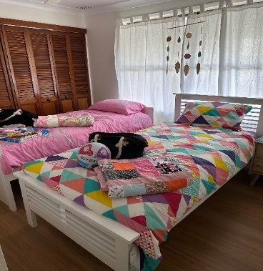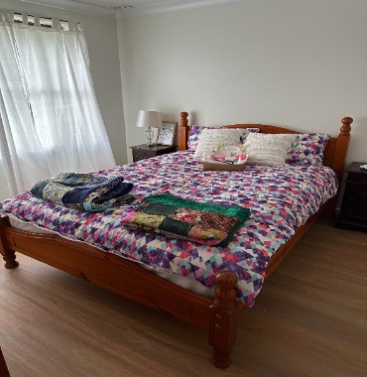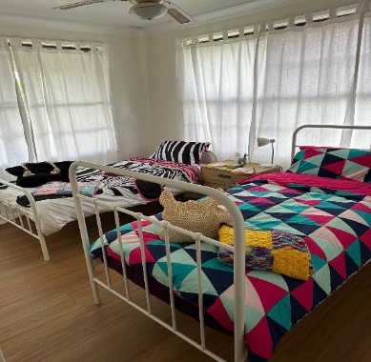

We Care Connect – Thornton
We Care Connect launched our Hunter program at the end of September, 2022. Over the last six months, we have seen incredible community support with magnificent donations of preloved clothing, cots, prams and car seats, and we have a team over 40 regular volunteers who sort, pack and prepare bundles to go out to disadvantaged children. We are seeing an increasing demand for our service and sadly we’re continually reminded just why a service like ours needs to exist.
Next month, we will reach the bittersweet milestone of supporting 1,000 Hunter children with everyday essentials. We cannot do this without a village of community supporters to provide these essentials for children living in poverty.

