Amelia-Nottoway Technical Center News 12/18/2020
ANTC STUDENT SPOTLIGHT!
Emily Hodge, NHS Senior
Cosmetology II
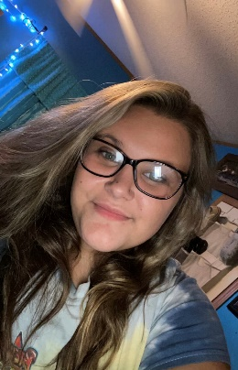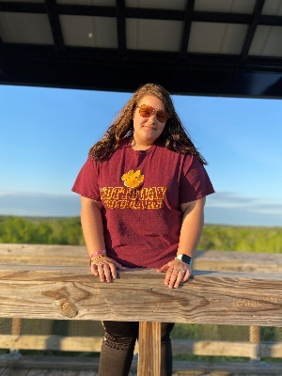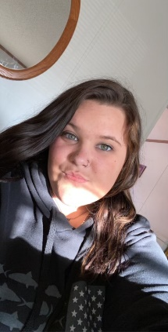
What brought you to ANTC? I was brought to ANTC by a very close friend, she told me a little about it and it seemed interesting.
What is your dream job? My dream job would be to become a nurse, and do hair on the side.
What is your favorite class that you have taken so far? Why? My favorite thing I have taken so far would be Cosmetology. I love doing hair and learning new things about hair.
What is the best advice you have been given by your instructor at ANTC? One piece of advice I have gotten from my teacher would be always do your best and never give up.
What is your favorite memory at ANTC? My favorite memory at ANTC would be when we went to the State Fair, and doing things in the salon.
What was the first feeling you had when you attended ANTC? The first feeling I had when I got to ANTC would have been everybody at ANTC is very respectful and caring.
What words of wisdom do you have for other students? If I had to give one piece of advice for other students it would be always do your work and don’t take this opportunity for granted!
ANTC ALUMNI HIGHLIGHT!
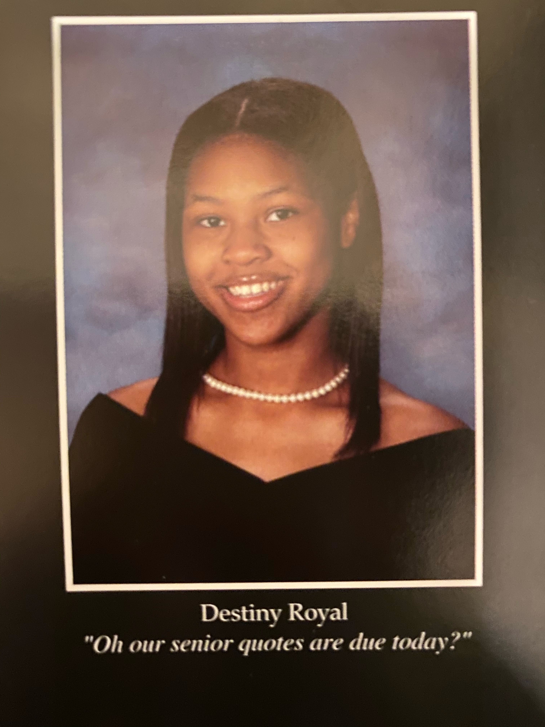
Destiny Royal
High School: Amelia County High School 2020
ANTC Program: Medical Assistant

Celebration
Congratulations to ACHS 2020 graduate Sara (Leann) Clarke for being placed on the Ultimate Medical Academy Dean’s List for achieving a CGPA of 4.0! When asked about her accomplishment and her major she stated, “Medical Billing and Coding, I wouldn’t have gotten here without the best Medical Assistant teacher in the world.” Leanne and Mrs. Vronek, YOU ROCK!
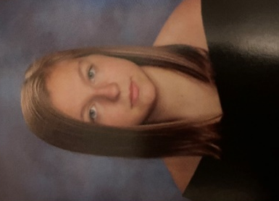
Congratulations to Imani Crawley for passing her Theory Cosmetology Exam on December 11, 2020! Imani is a 2020 Graduate of ACHS and was unable to take her State Board Exam due to COVID-19! HOWEVER, on Tuesday, December 8, 2020, Imani to participate in a review session with Mrs. Rajah at ANTC to prepare her to take the exam! Imani and Mrs. Rajah, YOU ROCK!!!
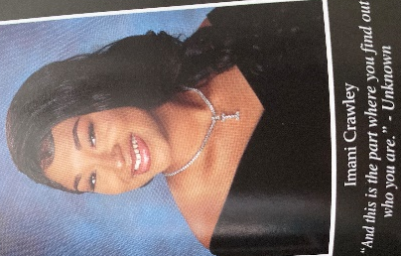
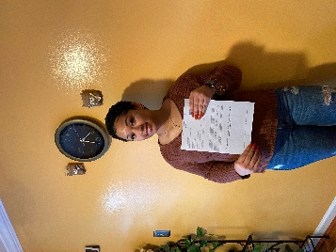

Staff Spotlight: Ms. Arlene Robertson
Current Position: Secretary, ANTC

Previous Positions: Teacher’s Assistant: CPS and NMS; School Counselor Secretary: NHS

Hobbies: Reading, crossword puzzles, watching television, and just being alone for a little quiet time when the opportunity presents itself.

Other Interest: I am a member of New Bethel Baptist Church, Crewe, VA where I am a member of the Usher’s Ministry and serve as Church Clerk. I am an active member of the Nottoway Democratic Committee, Nottoway County NAACP Political Action Chair and branch secretary, assistant secretary of the Nottoway Civic League, member and Past Worthy Matron of Evergreen-Benjamin Chapter Order of Eastern Stars of Virginia, and is currently serving by appointment of the Nottoway County Board of Supervisors to the Piedmont Senior Resources Board. I have a great love of traveling, especially cruising.
Family: My loving family includes two children; my daughter Kim and my son James, Jr., 8 grandchildren, and 3 great-grandchildren. I love spending quality time with my family making memories with them.

State Board Perm!!!
Program: Cosmetology I & II
Amelia County High School, Cumberland High School, and Nottoway High School

Skills: Cosmetology I – Performing Roller Set
Cosmetology II – Performing State Board Perm

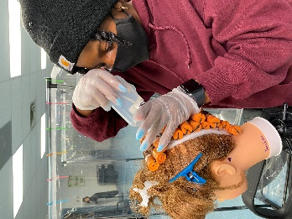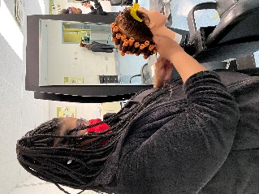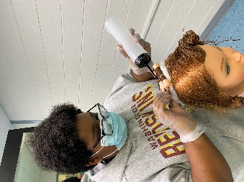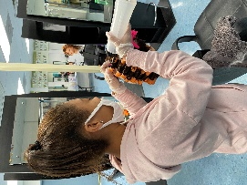
Roller Set!!!
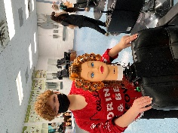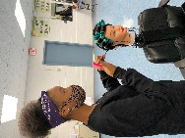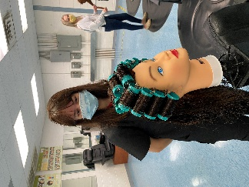
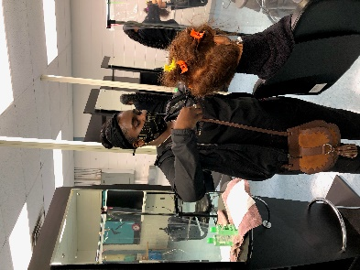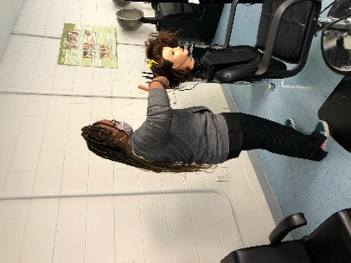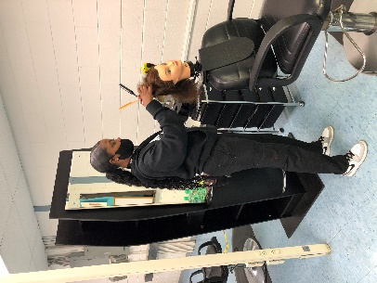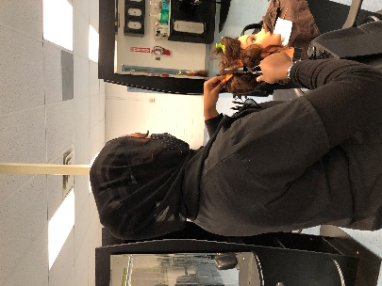

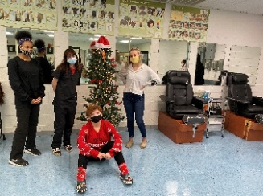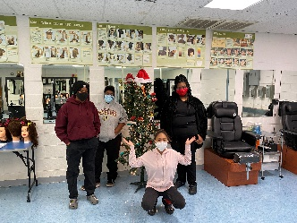
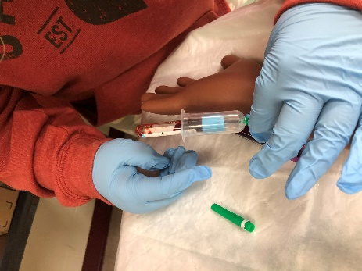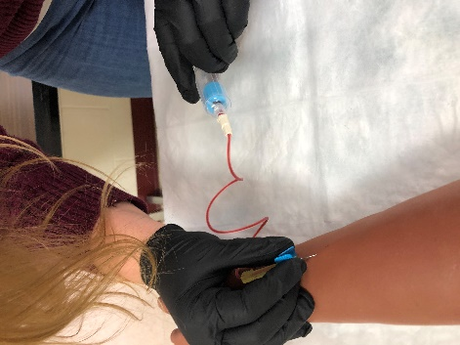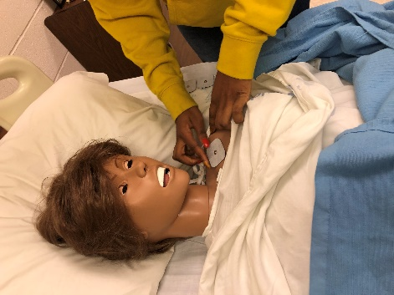
Current Program Feature: Medical Assistant I & II
Amelia County High School & Nottoway High School

Skills: Skills Exam

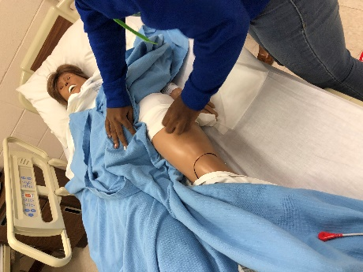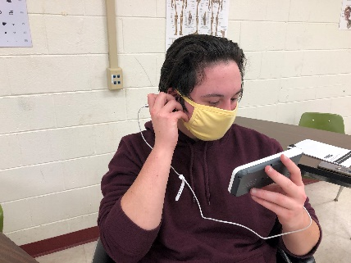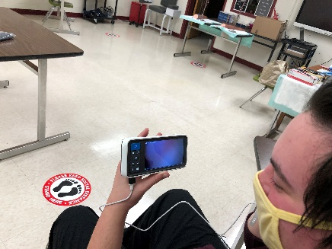
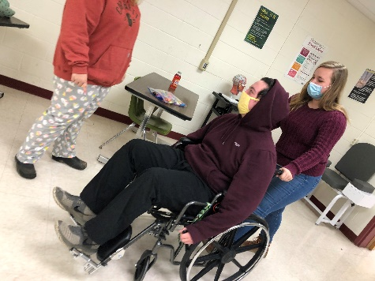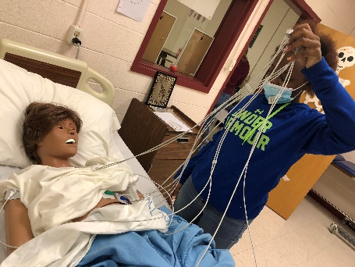
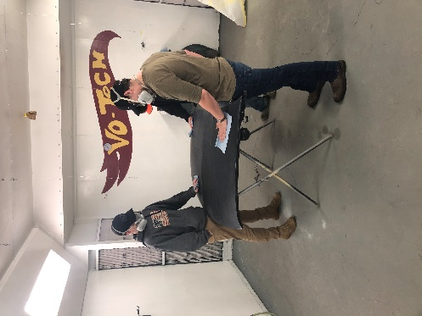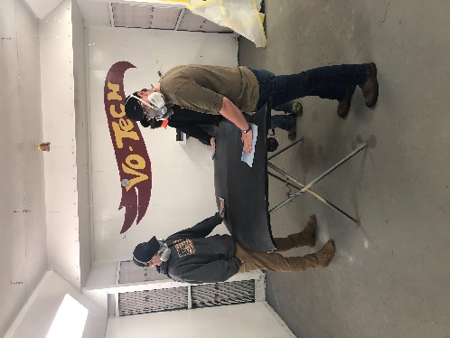
Program: Auto Body I & II
Amelia County High School & Nottoway High School

Skills: Blocking and Shaping Filler

