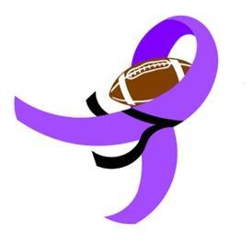 **Flags for the Cure**

**14th Annual Flag Football Tournament**

Dear Friends:

Acreage Flags for the Cure is proud to announce its 14th annual flag football tournament to take place January 7th through January 10th, 2021.

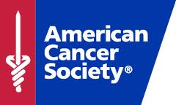

**Benefitting: American Cancer Society**

The American Cancer Society is the nationwide, community-based, voluntary health organization dedicated to eliminating cancer as a major health problem by preventing cancer, saving lives, and diminishing suffering from cancer, through research, education, advocacy, and service. Together with our millions of supporters, the American Cancer Society (ACS) saves lives and creates a world with less cancer and more birthdays by helping people stay well, helping people get well, by finding cures, and by fighting back.

## **Flags for the Cure**

We are a group of volunteers who are committed to creating a safe, family friendly, exciting environment in which players can participate in a sport that they love. By doing so, we give girls, boys, women, men as well as their families and friends an opportunity to contribute to helping those in our community who need it most. The highlight of our event is the ceremony where all gather to recognize those currently in the fight against cancer, support the valiant survivors of cancer, remember those who lost the battle, and applaud the ever important caregivers.

In January 2020, our 13th year, we hosted 45 teams comprised of 450 players. Together they helped raise $30,000 to bring our grand total raised to $302,000.

Thank you in advance for your consideration and support. TOGETHER, WE CAN MAKE A DIFFERENCE! More information about us can be found at flagsforthecure.com

With Sincere Thanks,

Tournament Director

Keith Shivers

(561) 358-1933

flagsforthecure@gmail.com

We respectfully request your assistance in helping us reach our goal. Your tax-deductible contribution can be made in several ways:

* Merchandise for raffle
* On Site Vendor
* Monetary donation (Please make checks payable to Acreage Flags for the Cure)

Your donation may be made at the levels listed below.

|  |  |  |
| --- | --- | --- |
| Level | Donation | Receives |
| **Bronze** | $100 | Name announced as sponsor during the tournament |
| **Silver** | $500 | Above benefit PLUS: Sponsor name on the back of tournament jerseys + name on event banner. |
| **Gold** | $1000 | All above benefits PLUS: Plaque |
| **Field Sponsor** | $2000 | All above benefits PLUS: Your own banner and 10 x 10 booth space |
| **Event Sponsor** | $5000 | All above benefits PLUS:  Name recognition as Event Sponsor throughout the tournament, top name on event banner, name on front & back of jerseys |

**Acreage Flags for the Cure**

**Sponsorship Form**

Federal Tax ID#: 85-8012544861C-2

**Sponsorship Information:**

Important: Please print clearly and check your spelling!

**Company Name:**

_____________________________________________________

______________________________________________________

**Company Address:**

______________________________________________________

______________________________________________________

#### Phone Number:

#### _____________________________________________

**Donation Information:**

**Gift Certificate or Item:** __________________________________

**Value of Above: $**________________________________________

#### And/or

**Check Number: ______________Amount: _______________**