Little Lanes

Administering Medication Policy
If a child attending Little Lanes requires medication of any kind, their parent or carer must complete a Permission to administer medicine form in advance. Staff at the Club will not administer any medication without such prior written consent.
Ideally children should take their medication before arriving at the Club. If this is not possible, children will be encouraged to take personal responsibility for their medication, if appropriate. If children carry their own medication (eg asthma inhalers), the Club staff will offer to keep the medication safe until it is required. Inhalers must be labelled with the child’s name.
Prescription medication
Little Lanes staff will normally only administer medication that has been prescribed by a doctor, dentist, nurse or pharmacist. If a medicine contains aspirin we can only administer it if it has been prescribed by a doctor. All prescription medication provided must have the prescription sticker attached which includes the child’s name, the date, the type of medicine and the dosage.
Non-prescription medication
If a child requires a non-prescription medication to be administered, we will consider this on a case by case basis after careful discussion with the parent or carer. We reserve the right to refuse to administer non prescription medication. Non-prescription medicine does not require a GP prescription before Out of School Club can administer. [Delete this paragraph if not applicable for your club.]
Procedure for administering medication
A designated staff member will be responsible for administering medication or for witnessing self-administration by the child. The designated person will record receipt of the medication on a Medication Log, will check that the medication is properly labelled, and will ensure that it is stored securely during the session.
Before any medication is given, the designated person will:
- Check that the Club has received written consent
- Take steps to check when the last dosage was given
- Ask another member of staff to witness that the correct dosage is given.
When the medication has been administered, the designated person must:
- Record all relevant details on the Record of Medication Given form
- Ask the child’s parent or carer to sign the form to acknowledge that the medication has been given.
When the medication is returned to the child’s parent or carer, the designated person will record this on the Medication Log.
If a child refuses to take their medication, staff will not force them to do so. The manager and the child’s parent or carer will be notified, and the incident recorded on the Record of Medication Given.
Specialist training
Certain medications require specialist training before use, eg Epi Pens. If a child requires such medication the manager will arrange appropriate training as soon as possible. It may be necessary to absent the child until such training has been undertaken. Where specialist training is required, only appropriately trained staff may administer the medication.
Changes to medication
A child’s parent or carer must complete a new Permission to Administer Medication form if there are any changes to a child’s medication (including change of dosage or frequency) and the Medication Log must be updated
Long term conditions
If a child suffers from a long term medical condition the Club will ask the child's parents to provide a medical care plan from their doctor, to clarify exactly what the symptoms and treatment are so that the Club has a clear statement of the child's medical requirements.

This policy was adopted by: Cheri Garratt | Date: February 2022
To be reviewed: February 2023 | Signed:  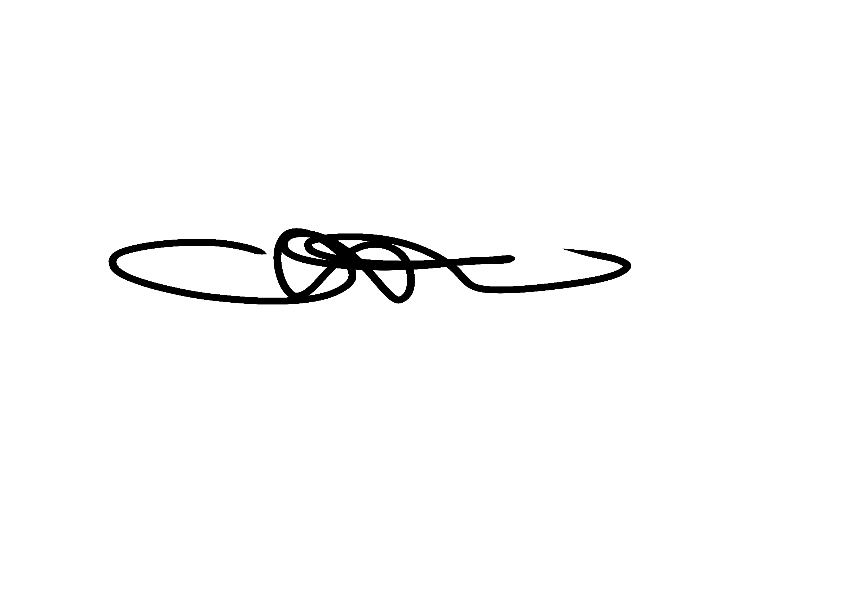

Written in accordance with the Statutory Framework for the Early Years Foundation Stage (2021): Safeguarding and Welfare Requirements: Health [3.45-3.47]

