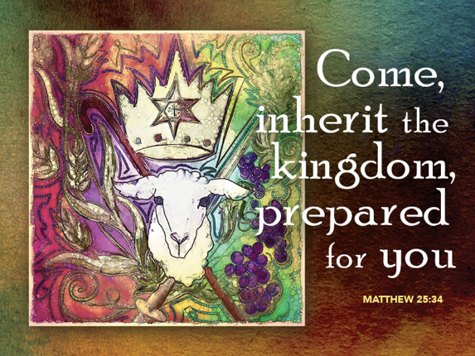
Judgment Day
Matthew 25:31-46
Christ The King Sunday
November 26, 2017

Grace and peace, from God our Father and from our Lord and King, Jesus Christ. Amen.
This morning, we celebrate the last Sunday of the church year, a Sunday in which we honor Jesus Christ as King. It is a day to remember through the power of the Holy Spirit, God calls us to acknowledge Jesus, and Jesus alone, is worthy to be our Lord, the King of Kings and Lord of Lords who will judge the world in righteousness, in Grace, and in Mercy.
Our Gospel lesson for this morning is one of the most influential and I dare say misunderstood teachings of Jesus in the entire New Testament. This Gospel has been the basis for more Christian Bullying than any other text. Taken at face value as it’s translated in most English Bibles it’s hard to come to any conclusion other than unless you feed the hungry, cloth the naked, and visit the sick and those in prison, you will burn in the eternal fires of hell. The issue is, when have you done enough of those things to satisfy your minimum requirement to be invited to Jesus’ right hand and into Heaven. Can you be certain you’ve done enough? Many a preacher has laid a heavy dose of guilt on their congregation pointing out all the hungry, homeless, sick, and imprisoned who are still unserved. How many of us still believe that when we die we appear before the pearly gates where Saint Peter stands, holding the keys. He recites the list of everything you’ve done, the good, the bad, and the ugly. Usually, that’s when I wake up from my nightmare,
never getting to know the answer if he’s going to unlock the gate or not. There’s a story about a young couple that was tragically killed in a car accident one day before their wedding. When St Peter welcomed them into heaven he asked if there was anything he could do to make their eternity more enjoyable. They asked if there was any possibility they might be married since they had died just before their wedding day. St Peter said of course he would make all the arrangements. A hundred years goes by and they run into St Peter again. Again, St Peter assures them he’s working on their wedding. Another hundred years goes by and they meet St Peter once again. This time when they ask about their wedding, St Peter said all the arrangements had been made the day after their arrival in heaven. The only problem is they’re waiting for a minister to arrive…
All my life I’ve thought the moral of today’s Gospel story was that we should do everything we can to help the poor, the homeless, and those who are disadvantaged in life and if you do enough you get to heaven, if you don’t, well you go to that other place, where it’s real hot and the host isn’t very nice. The reason this story is interpreted so legalistically is because of a misinterpretation of who the people are that are gathered around the throne of God in heaven and who are the least of these that they either helped or they did not help. Our Bible says it’s “the Nations” gathered around God’s throne. The Greek word translated as “Nations” is the word ethnos. Every other place where Matthew uses the word in
his Gospel it’s translated as the Gentiles. The Gentiles is Matthew’s way of saying those other people, “them.” Matthew’s world is divided into us and them. Us is the Jews, the non-Hebrew people who lived among the Jews and loved God, and the Christian believers. Everyone else belongs in the them column. Matthew refers to them as the Gentiles or Ethnos… Armed with that little bit of context, we can see this isn’t the Judgment day of the whole world, but rather only the judgment of the non-believers. In addition, I want you to remember Matthew’s Church was a Church under persecution. So, the “least of these” Jesus refers to are not all poor and disadvantaged, but rather the the brothers and sisters of Christ are the Church.
So, this Gospel describes the fate the people we call today, the “Nones”. The Nones are the people today who answer survey questionnaires about religion by saying they have none… Jesus isn’t trying to scare you and me into working harder to enter heaven. He assumes we’re already doing what we can in that area. Rather, this story is directed to the Nones. Imagine you’re a member of Matthew’s congregation back in the first century. The moment you believed and first uttered the words Jesus is risen! He is risen indeed, alleluia! Your life was changed, and not for the better. Your family disowned you, your boss fired you and you no longer are able to even buy food or necessities at the market. You’ve become one of the unloved of society. You’re now one of the least of these, the brothers and
sisters of Jesus. If it weren’t for the kindness and compassion of some of those ethnos, Gentile, nones you’d be starving to death. Those are the sheep in Jesus’ little parable. The goats, well they’re the ones who deny you the right to work or who refuse to sell you the necessities of life simply because you’re a Christ follower. In this light the parable of judgment just might bring you some degree of comfort, knowing that those others would get what’s coming to them in the end…
If all we had to go on was this story, there really would be no Good News. This story talks of what’s known as works righteousness. There’s no Grace as far as I can see anywhere in here. You either work for the betterment of the poor and downtrodden or you get thrown out of the kingdom. The only bit of Good News I can find is that nothing in this story applies to us. We’re the believers, the faithful, the followers of Jesus Christ. The sheep and the goats are those who either don’t know about Jesus or do know about him and reject him as the Lord and King of their lives.
Today is the last Sunday of the Christian year, when annually we are reminded that Jesus is not only Lord and Savior, He is King—he is the sovereign before whom all the peoples of the earth will be gathered for judgment. Those who have known him, named him, and served him will find themselves numbered among the sheep. Within the fold there will be some who have no idea what they are doing there. They were Christ’s servants unaware. Will they be astounded?
Yes, they will, but then again, won’t we all? Who of us believers want to take our faith and our works and lay them before the judge? Who of us does not want to plead for the grace and mercy of God?
Christ is King; he is the sovereign of all life, and the one we will meet on judgment day, regardless of what we have called him. The gospel is about more than the forgiveness of sins; it is about a transformed life, about being freed from sin as we live in newness of life as the people of God. Belief is the first step. Faith without works is dead faith and of no good to God or to our neighbors. We who have come to understand our status in God’s Kingdom is due entirely to God’s free gift of grace are given the opportunity and challenge to welcome that grace of God as it engages our lives to empower and change them so that at the end of the day, we are serving not ourselves, but the King. After all, would Jesus expect anything less from us than he expects of the nones?
In closing I have this breaking news from heaven. It seems heaven is becoming overcrowded and St Peter has had to find a way to weed out more on the candidates trying to get through the pearly gates. So, after much thought he’s implementing his new achievement based system starting today. This report has just come in about the first man to come to the gates under St Peter’s new system. He was told he needed 100 points to get in and he was asked to give an account of all his good works to see if he could reach the 100 points needed to get into heaven. So, the man said he was a lifelong Christian. St Peter said great, that’s worth 10 points. The man said he had worked every Friday at the FISH Pantry feeding the hungry. St Peter was again excited for the man and awarded him 5 more points. The man said he was faithful to his wife and never cheated on her. He was awarded 1 more point. Now he was getting worried. He racked his brain for every good work he could think of all the way back to his childhood when he helped that little old lady across the street. When he had exhausted every last thing he could think of, his total was 47 points. Finally, sad and dejected the man said, “At this rate the only way I’m getting into heaven is by the grace of God!” At that moment the pearly gates opened wide and St Peter invited the man into the eternal paradise prepared for all those who trust in the promise of Jesus Christ.
May you be comforted knowing without doubt your eternal fate is assured and you are already numbered among the righteous by grace, through faith in God’s only Son, Jesus Christ our King. Amen.

