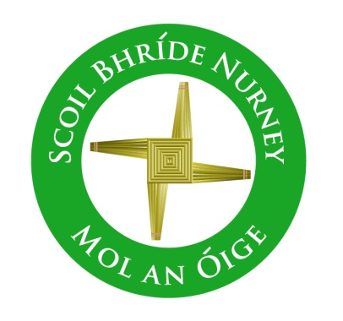
Scoil Bhríde,
Nurney,
Principal – Vinny Thorpe
Dep. Principal – Catherine Owens

County Kildare.
Te/Fax: (045)526767
Email: sbnurney@gmail.com
www.nurneyns.com
Roll no: 16345A

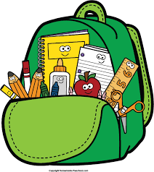
6th Class 2021 – 2022
Additional requirements

- Items to be purchased and labelled by parents in advance of September 2021:
(We have also indicated the ‘likely’ costs of these required items at best value stores)
- 2 x large Pritt sticks (labelled with name) (€1.99 each)
- Sharpener and rubber (99 cent each)
- 3 good quality handwriting pencils (50 cent each)
- 2 highlighters (99 cent each)
- 2 red and 2 blue pens (bic) (50 cent each)
- 1 packet of colouring pencils/Twistable crayons (labelled) (€3.49)
- Maths set (including compass, protractor etc. make sure protractor is filled with no hole in middle) (€2.49)
- 10 x exercise copies (88 pages) (€2.99 for 10)
- 5 x maths copies (88 pages) (€1.99 for 5)
- 1 x pair of scissors (clearly labelled) (€1)
- 1 x A4 scrapbook (50 pages) (€2.49)
- 1x A4 Sketchpad (€2.99)
- 1xA4 Manuscript for handwriting (€1.80)

- €35 to be paid to class teacher or online by mid-September 2021 (if paying by cash/cheque this should be in a sealed envelope with your child’s name and class printed clearly on it)
This amount will be allocated as follows:
- Art and craft €15
- Photocopying €8
- Homework Journal €3.50
- Class novel €6
- Assessment tests €2.50
Please label all of your child’s belongings, stationery, uniform and tracksuit tops, coats etc.
Books will be provided under our Book Rental Scheme for those who have fully paid up and will be in your child’s classroom in September. Please impart to your child the importance of taking care of these books as any damage to Book Rental Books will be charged to you at the end of the school year.

Thank you for your co-operation and looking forward to a great year ahead!
___________________
Class Teacher

