Work Experience/Teaching Practice Policy
2015+
Board of Management Scoil Bhríde Nurney
2015+
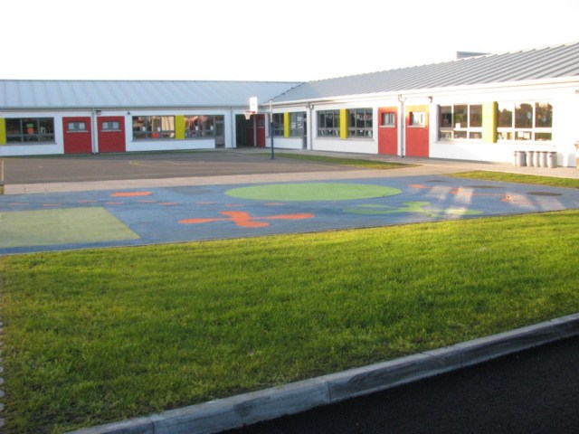

Scoil Bhríde

Work Experience/Teaching Practice Policy

The Board of Management and staff of Scoil Bhríde Nurney are willing to provide opportunities of work experience for students from the wider school community. The following are the procedures under which this work experience can take place.

- Places for both work experience and teaching practice will be given on a priority basis to former pupils of the school
- Places for both work experience and teaching practice will be given to former pupils of the school based on the applying pupil’s school behaviour records and reports. This will be based on both the principal’s and deputy principal’s professional opinion and professional discretion.
- While we are happy to accept students for both work experience and teaching practice, the needs of our pupils are our priority and places will always be allocated with the needs of the children in mind.
- Students must be fully insured while in the school by their respective college or school
- The Principal and staff will endeavour to ensure that the time spent in the school by the student is beneficial and a positive learning experience
- Students must at all times be respectful of all members of staff, Board of Management, parents and pupils - their actions and language while in the school must be exemplary and of a professional nature at all times
- Students will be provided with copies of policies which are deemed necessary and appropriate for their work within the school and are expected to co-operate with the general rules, procedures and organisational policies of the school
- Students should be willing to follow the instruction/guidance of the Principal, Deputy Principal, secretary or whichever staff member has been designated to supervise their duties
- All matters pertaining to the staff, Board of Management, Parents Council, pupils or parents within the school community must be treated with the utmost confidentiality. Any breach of this requirement will be seen as a serious matter and your work experience may be terminated.
- Any breaches of discipline observed among the pupils must be reported to one of the teaching staff and not dealt with by the student themselves
- The pupils and staff will be expected to treat students on work experience programmes with respect at all times
- All supervisors of work experience students, who visit the school, including teaching practice supervisors, will be expected to adopt a positive and respectful attitude towards their students, in keeping with the school ethos of providing a positive learning and working environment.
- Duties can range from classroom assistant to office assistant to helping with any other task that is deemed suitable by the teacher, office staff or Principal
- If a student wishes to leave the workplace during the school day he/she must seek permission from the Principal in advance
- Scoil Bhríde Nurney reserves the right to contact the college of the work experience student in order to ascertain whether that student is suitable for a placement in a primary school
- All students must sign a work experience/teaching practice agreement in advance of starting (see below) and a confidentiality agreement in advance of starting (see below). The work experience/teaching practice agreement can be terminated at any time at the discretion of the Principal/Board of Management
- A timetable will be drawn up for each student but he/she will be expected to be flexible in how they work
- Any absences must be notified in advance to the school
- The dress code is ‘smart casual’. Please bear in mind that visible tattoos, body piercings or bare midriffs may not be perceived as a reflection of professionalism.
Work Experience/Teaching Practice Agreement

I agree to participate in a work experience programme in Scoil Bhríde Nurney on the following dates: ___________________________________________________________.

I agree to be in the school by _______ am and to remain until at least ______ pm each day.

I agree to perform whatever duties are assigned to me to the best of my ability.

I have read the Welcome Information Sheet provided by the school.

I understand the requirements in relation to my duties, the school’s dress code and the importance of maintaining confidentiality.

I also understand that breaching these requirements will be seen as a serious matter and that in some circumstances my work experience may be terminated.

Signed: _____________________ Work Experience Student

Date: ____________

Confidentiality Agreement

Our school is very much part of the local community. We pride ourselves on the number of outside visitors we have to the school and the positive feedback we receive about the friendly atmosphere and positive ethos at Scoil Bhríde Nurney. As with all places of work, people will express opinions and make judgements as they see fit. This agreement is intended to help you understand how to protect the friendly and agreeable atmosphere we have, whilst also being aware of the need for professionalism. It is important to respect and recognise the trust that is placed in you when you are invited into our school community as a visitor.

I understand that during my time at Scoil Bhríde Nurney...

- I must ensure that anything I overhear, anything I am told or anything I ascertain in the line of my duties, is not repeated or shared with anybody who should not be party to that information. I will keep confidential any information heard, read or shared between staff members, outside agencies and parents/carers regarding a child or the child’s family. In brief, anything heard in school stays in school and must go no further.

- I will not post confidential information regarding children, staff members or parents on social networking sites such as Facebook and Twitter. I will not contribute to discussions or conversations on social networking sites regarding the school and anyone associated with it.

- I must ensure that anything I hear that raises questions about the professionalism of someone working at the school is immediately passed on to the Principal or Deputy Principal.

- I must ensure that if I notice anything of concern regarding a child, or if a child reports anything of concern to me, I will notify the designated person for child protection.

- I must ensure that conversations of a sensitive nature regarding children or adults take place in a private space.

- I must ensure that paperwork regarding children, parents or members of staff is not left on display at any time. Similarly, any paperwork that holds information of a personal or sensitive nature and that is no longer required, must be sent for shredding.

- I will at all times be fully aware that staff and volunteers may well have connections (both family and friends) within the school and may overhear conversations of a sensitive nature.

- I will uphold the good name of Scoil Bhríde Nurney in discussions both inside and outside school.

Signed: .......................................................................................................................................................................

Print name: ................................................................................................................................................................

Date: ..................................................................

Ratification of Work experience / Teaching Practice Policy

This policy was adopted by the Board of Management on _________________

Signed: _________________________ Signed: __________________________
Chairperson of Board of Management Principal

Date: __________________________ Date: __________________________

Date of next review: __________________

