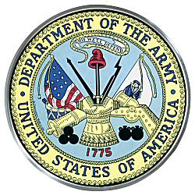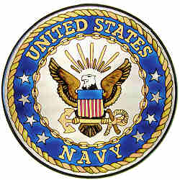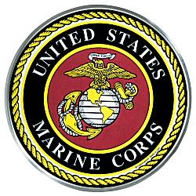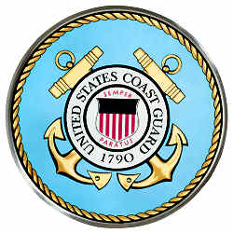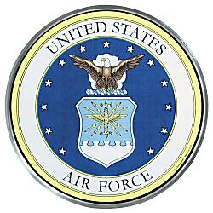


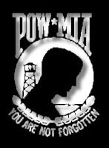
FOURTH ANNUAL CANDLELIGHT VIGIL
PRESENTED BY THE
NKY #5 BLUE STAR MOTHERS of AMERICA
&
U.S. MARINE RIDERS ASSOCIATION, INC.
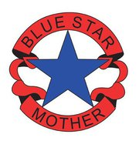
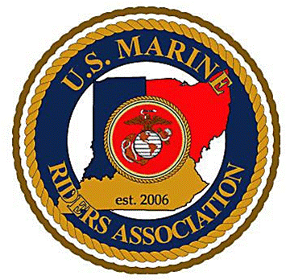
UNTIL THEY ALL COME HOME

*NATIONAL POW/MIA RECOGNITION DAY 09/21/12*

WE WILL OBSERVE ON *SEPTEMBER 22ND 2012, 7 P.M.*

FLORENCE GOVERNMENT CENTER
8100 Ewing Drive
Florence, KY 41042

SPECIAL DEDICATION WILL BE HELD IN HONOR OF THE 108 KENTUCKY FALLEN WARRIORS FROM THE
WAR ON TERRORISM
FOR ADDITIONAL INFORMATION PLEASE CALL 859-371-8520 OR EMAIL lorenefriedman@insightbb.com

