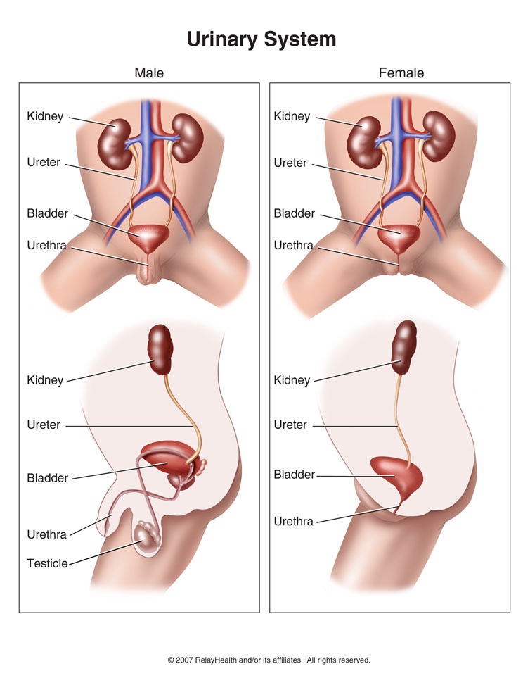



Urinary Tract or Bladder Infections:
To prevent them use the following daily:
- Probiotics (Shaklee Optiflora) … probiotics represent 70% of the power of our immune system

- Garlic … acts as a natural anti-bacterial, natural anti-fungal, and helps to keep bacteria and funguses in check on a daily basis

- Vitamin C … strengthens the immune system in its daily fight against bacteria

- Shaklee NutriFeron ... used daily strengthens the immune system in its daily fight against bacteria. (If you get an infection, double the usual amount until the infection is gone.)

If a person feels an infection starting:
- Shaklee DR … acts like a natural antibiotic … it should be used daily, like an antibiotic for 10 days. Then stop. If the infection is not gone, then do a repeat of a second 10 days.

- Triple Garlic & Vitamin C until the infection is gone.

- Drink RAW, unsweetened cranberry juice

If an antibiotic has been used:
It has destroyed all the good bacteria in the bowel. Therefore:
- Optiflora must be used to replace the good bacteria. Start by tripling the usual amount for the first 10 days.

- Shaklee DR … take this at the same time as the antibiotic. Then take for a week afterward ... then stop for 3 days and then follow a rotation of 4 days on and 3 days off for one month to help keep bacteria at bay until the probiotic level in the bowels has been replaced to a reasonable level by using Optiflora consistently daily.

- Take maintenance levels Garlic and Vitamin C ... daily.

If you are very prone to bladder or urinary tract infections, you might want to use the “Infection Bomb” ... see attached:
The Infection Bomb (Canadian Version)
By Stan Pullium, Shaklee Distributor
It is from dealing with many people with various types of infections over the years that I developed my "Infection Bomb" that many of you have heard of and many of you have used -- which I have seen to be very effective against any kind of infection in the body:
… the flu
… strep throat
… prostate infections
… kidney/bladder infections
… very severe uterine infection
… nasal and ear infections
… vaginal yeast infections
… as well as Epstein Barr / chronic fatigue / fibromyalgia.

It has worked against all of these. Many of these infections had gone on for months or even years. Many of these folks had taken multiple so-called "antibiotics" and spent huge amounts of money on doctors. Some had serious reactions to these so-called "antibiotics," i.e., rashes, hair loss, impotence in men, etc.
Everyone of them saw a difference within 2-3 days of being on my "Bomb." And the infections were generally completely gone within a week to two weeks. Most of the infections were gone in just a few days, but long established infections may take a couple of weeks or more.
This is the "Infection Bomb":
- You take 6 Sustained Release C, 1 Garlic, and 1 NutriFeron every two hours (waking hours only). The key is the C -- you just have to keep enough going into your system continuously to "blast" the infection out of there. The Garlic and NutriFeron give further very important immune support. (Linus Pauling who received the Nobel Prize for his work on vitamin C, said a healthy adult needs 5 grams a day, and if you are sick, you may need 15 grams or more.)

- Adding 5 Alfalfa each time will make it even more effective.

- If you will drink the Shaklee DR as a tea a couple times a day also, it will speed the process up. I heat up a mug of Shaklee Get Clean Water, and drop in Shaklee DR (and 2 Stomach Soothing Complex from Shaklee U.S., if you have it.) If the water is good and hot, you don't need to crush them; they'll dissolve completely within about 3 min. Then I add a spoon of honey and a tablespoon or two of Shaklee Lemon/Lime Performance drink powder. This makes a very tasty tea (echinacea is quite earthy) . You can pour it over ice or sip it hot.

Along with knocking out any infection very quickly, you may experience other "side benefits." The only "side effect" is that, lots of vitamin C may loosen your bowels initially -- but that won't be harmful in any way. Just drink plenty of water.
For those who've had "antibiotics,"
- I recommend taking about 9 DTX and at least 3-4 Herb-Lax for a few days.
- And drink 8-10 glasses of water per day.
- Also 8 hours after you have taken your last antibiotic, it is critical to REPOPULATE the intestinal tract with good bacteria (this good bacteria represents at least 70% of your immune system)
… take 4 Optiflora Pearls and the usual amount of Optiflora Powder (for one week)
… then take 3 Optiflora Pearls and the usual amount of Optiflora Powder (for the second week)
… then take 2 Optiflora Pearls and the usual amount of Optiflora Powder (for the third week)
… then stay on 1 Optiflora Pearl and the usual amount of Optiflora Powder (for the fourth, and ongoing weeks)

We have used this "infection bomb" on our children and ourselves for years, and it has played a major part in our children never having been to the doctor for sickness in their entire lives.

