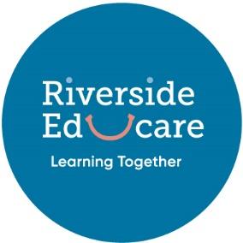
Riverside Educare

Sick or soiled children cleaning procedure

- Ensure area affected is attended to or isolated. Use solution of Janola and water to disinfect area (making sure the solution is at least 0.1% concentration)
- Prepare nappy change / tub area, put on disposable gloves, have towel ready.
- Remove clothing while communicating with child
- Bag soiled clothing securely
- Sit or stand child in tub, use shower nozzle which pulls out, to clean as needed
- Dispose of nappy (if wearing one), gloves and wipes – bucket under cupboard in nappy change room
- Wipe down changing mat and tub with disinfectant and paper towels
- Towels and flannels that have been used are to be soaked in a solution of Janola and water to disinfect before washing. (making sure the solution is at least 0.1% concentration)
- Wash hands and remove child if sick to isolated area (Office / meeting room if staffed). Parent to be rung immediately to pick child up. If soiled, clothe child and return to play area
- Record if parent or caregiver was required to pick child up in phone record register.

Never leave a child unattended

Date Reviewed: July 2020

