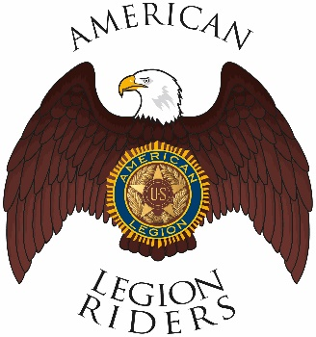

American Legion Riders Chapter 3, Hanford, CA
Minutes for November 9, 2021
Meeting called to order: The meeting was called to order @ 6:34pm. Prayer, Pledge of Allegiance and Preamble was said.
Officers Present: Director James Landolt, Vice-Director Frank Pightling, Secretary David Darrow, Judge Advocate Pat O'Brien, Sgt-At-Arms Jack Alford, Chaplain Filly Reynolds, Road Captain Robert Stover. Excused: Treasurer Geni Lefler

Members Present: Sheri O’Brien, Gustie Compton, Jon Bailey, Scott Day, Kathleen McClary, Dan Rushing
Guests Present:
Review of Minutes: Motion to accept minutes for October 12, was proposed by Robert Stover, and seconded by Frank Pightling and ratified by members.
Committee Reports: None
Treasurer's Report:
Chaplain Report: Thanks to everyone who attended Filly’s friend’s service
Unfinished/Old Business:
8am Veterans Hall on the 11th of November to help load the chairs.
11th of November post 100 parade Fox and F St. in Lemoore at 5:15
Post 3 paid for Hanford Christmas Parade need to reimburse post $25.
Need members help decorating float on the 21st of November 1010 East Lacey.
Flag up your bikes for the Christmas Parade.
New Business:
Convention will be hosted by Chapter 229 28, 29 and 30 of April. Check for hotel rooms now.
Motion Host 2 families for Thanksgiving and Christmas set aside $500 to purchase Visa gift cards and give them to the NAS Lemoore Chaplain, $250 per family. Motion by Frank Pightling and seconded by Jon Baily and ratified by the members.

Motion to accept Gustie Compton as a chapter member made by Jon Baily and seconded by Robert Stover and ratified by the members.

December hunt for Santa 9am 3rd Saturday
January 2022 fog run 9am 3rd Saturday
10th, 11^{th,} and 12th of June is the legacy run dates
Good of the Riders:
Remember to ride safe
Meeting adjourned 7:40

