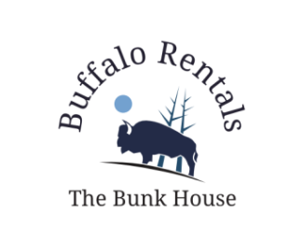
Hello,

We are contacting you in regards to the recent Covid-19 health mandate that was issued on Saturday March 28, 2020, by Governor Dunleavy. Here at The Bunk House we take our standards of hygiene and cleanliness very seriously. Already in place, we have policies intended to prevent and address the transfer of viruses and germs. These policies range from basic handwashing hygiene to cleaning product specifications, to guest’s rooms and common area cleaning procedures. However, with the current health crisis, we will be taking additional steps to help ensure the safety of our guests and our employees. The following measures will be taken:

Guests Rooms:
- The Bunk House will adhere to the recommended cleaning and disinfecting protocols to clean rooms thoroughly after guests depart, and before the next guests arrive.
- There will be particular attention paid to high-touch areas i.e. door knobs, faucets, surfaces, etc.
- For the safety of our staff, for short term stays (less than five days) daily maid service is cancelled until further notice
- For stays longer than five days, maid service will be provided once a week.
  - This will include: disinfecting the bathroom, disinfecting all surfaces, and providing a fresh set of sheets and towels, left in plastic bag in guests’ rooms.
- Guests are responsible for taking out their trash. There will be large trash cans and a dumpster where bags can be disposed of.
- Guests will need to be responsible for bagging up their dirty sheets, towels, and bathmats so the maids can collect and sanitize them. Linens must be bagged by our guests, and left by the door. If not, our maids will not collect them, or leave new linens in the room.

Public Spaces:
- Public spaces will be sanitized on a daily basis.
- There will again be a focus on high-touch areas i.e. counter tops, door knobs, arms of chairs, public bathrooms, coffee pot handles or dispensers, etc.

Behind the Scenes Spaces:
- The spaces where staff work will have an increased amount of cleaning as well – there will be a focus on high touch areas like entrances, laundry rooms, and staff offices.

We at The Bunk House are taking this health crisis seriously and are, to the best of our ability, taking the recommended measures to protect our staff and guests. Thank you for understanding, and working with us to prevent the spread of this virus. We appreciate you, and your business very much.

Stay safe,
Vanessa Wiggins
Manager
Buffalo Rentals: The Bunk House

