Week 1 of Advent: The Annunciation
According to tradition, the Angel Gabriel first appeared to Mary while she was drawing water from the well and then Mary went to her home where the Annunciation took place.
Throughout its history there has been only one well in Nazareth. An aqueduct brings the spring water to an ornamental fountain located just below St. Gabriel Church.

Click on the link for more information on St. Gabriel Church and Mary’s Well.

DEVOTIONAL: The Annunciation- Announcement of the Birth of Jesus (Luke 1:26–38)

In the sixth month of Elizabeth's pregnancy, God sent the angel Gabriel to Nazareth, a town in Galilee, to a virgin pledged to be married to a man named Joseph, a descendant of David. The virgin's name was Mary.

A few thoughts to ponder:
- What does it mean to be in a state of sanctifying grace?
- Mary was conceived without sin and was “full of grace.” Ask Mary to help you grow in holiness.
- Imagine Mary prayerfully repeating the name of Jesus, accepting and trusting what she had been told. Consider how you can grow in trust.
- Meditate on the many titles given to Mary.
- Mary, by giving her fiat, became the new Ark of the Covenant and the spouse of the Holy Spirit. Listen to and act on the inspirations of the Holy Spirit.
- Meditate on how Mary was chosen above all women but her only desire was to glorify God.
- Consider how you can be more generous.

Things to Do:
- Make a spiritual communion this week.
- Receive the Sacrament of Reconciliation before Christmas.
- Read more on the Virtue of Trust.
- Dress appropriately at church and teach your children/ grandchildren what is appropriate.
- Donate to a Pro-Life pregnancy center.
- Practice humility by helping someone secretly, without their knowledge.

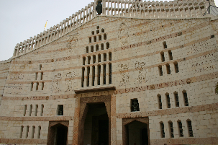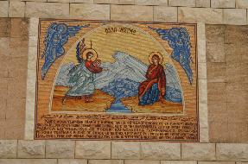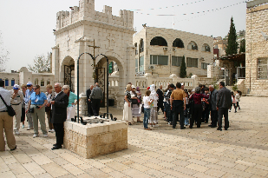

Week 2 of Advent: The Visitation (Luke 1: 39-40, 46-55)

Site of the home of Zechariah and Elizabeth. We walked up a steep hill and it was on the top of the
hill.

In those days Mary arose and went with haste into the hill country, to a city of Judah, and entered the house of Zechariah and greeted Elizabeth. When Elizabeth heard the greeting of Mary, the child leaped in her womb, and Elizabeth was filled with the Holy Spirit and she exclaimed with a loud cry: “blessed are you among women and blessed is the fruit of your womb!” And why is this granted to me, that the Mother of my Lord should come to me? For behold, when the voice of your greeting came to my ears, the child in my womb leaped for joy. And blessed is she who believed that there would be a fulfillment of what was spoken to her from the Lord.” Mary remained with her for about 3 months, then returned home.

Mary's Song of Praise: The Magnificat
And Mary said, “My soul magnifies the Lord, and my spirit rejoices in God my Savior, for he has looked on the humble estate of his servant. For behold, from now on all generations will call me blessed; for he who is mighty has done great things for me, and holy is his name. And his mercy is for those who fear him from generation to generation. He has shown strength with his arm; he has scattered the proud in the thoughts of their hearts; he has brought down the mighty from their thrones and exalted those of humble estate; he has filled the hungry with good things, and the rich he has sent away empty. He has helped his servant Israel, in remembrance of his mercy, as he spoke to our fathers, to Abraham and to his offspring forever.”

A few thoughts to ponder:

Ask Our Mother of Wisdom to help you grow in this virtue to urgently bring Christ to others.
What can I do to bring Christ into the world?
How do you recognize Christ in others?
How can you grow in the virtue of faith and open yourself to the riches of God’s grace?
Meditate on how God is loving you and making His goodness known to you today.
What can I do to promote peace in my community and around the world?

Things to Do:

Pray over your Christmas cards and send with the Virgin and Child stamp.
Call a relative or friend you have not heard from in a while.
Be a Secret Santa to someone and offer prayers instead of gifts.
Donate your extra coats, hats and gloves to a local charity.
